
Insurance
Business Solution Mapping Document

Contents
Contents 1
Functional Specification Document (FSD) Sign Off 4
1. Introduction 6
2. Version History 7
3. Insurance Process Flow 8
3.1 Loan Journey 8
3.2 Non-Loan Journey 0
3.3 Policy Renewal 2
3.4 Policy Extension 4
3.5 Policy Cancellation 0
4. Access Right Metrics 1
5. Lead Creation 2
5.1 Lead Data Entry 2
5.2 Follow-Up details 9
5.3 Follow-up Queue 12
6. Customer Creation 0
6.1 Header 1
6.2 Basic Details 4
6.2.1 Individual 4
6.2.2 Corporate 12
6.3 Contact Details 0
6.4 Identification Details 0
6.5 Additional Details 0
6.5.1 Vehicle Details 0
6.5.2 Medical Equipment 5
6.5.3 Solar Equipment 11
6.5.4 Travel Details 17
6.5.5 House Details 23
6.5.6 Medical Questionnaire 31
6.6 Insurance Details 36
6.6.1 Insurance Details Checker 42
7. Inbox 0
7.1 Document Checklist 0
7.2 Policy Update 2
7.2.1 Policy Issuance Checker 5
8. NFH Due List 0
8.1 Policy Update 0
8.2 Claims 3
8.2.1 Death Claim 3
8.2.2 Claim History 12
8.3 Policy Renewal 21
8.3.1 NFHI Renewal List 21
8.3.2 Policy Renewal Checker 25
8.4 Policy Extension 25
8.4.1 Policy Extension Checker 28
8.5 Policy Cancellation 29
8.6 Payment Summary 34
8.6.1 Payment Teller Screen – List 38
8.7 Customer 360 45
9. Insurance Chart of Account 52
10. Reports & Templates 53
11. Required Document Checklist 53
12. System Assumptions and Pre-requisites 53
13. Digital Integration 54
14. Stage Completion Rules 54
15. Interface Touchpoints 54
16. SMS Templates 55

Functional Specification Document (FSD) Sign Off

Client Name | National Finance House (Bahrain)

Software Licensed | Kiya.ai Insurance System

Document Name | FSD_Sign off – Insurance_V 1.6

Milestone Signed Off | FSD_Sign off – Insurance_V 1.6

Original Signed Off | 31-07-2024

We certify that, the above-mentioned milestone is completed. The business users have given confirmation on the same.

For, Kiya.ai

Name | Designation | Signature
Alpesh Bhatt | Project Manager
Nimit Arya | BA
Yogesh Vidhate | BA

For, National Finance House, Bahrain

Name | Designation | Signature
Hussain Eid | Head of Enterprise PMO (EPMO) and Information Technology (IT)
Aqeel Almeshal | Project Manager
Naheed Najaf | Marketing & Insurance Manager
Ali Redha | Head of Retail
Ahmed Alalawi | Head of Finance

Introduction
This is the Scope document prepared for Implementation of Kiya.ai’s Insurance Solution at NFH.

For Kiya.ai

Prepared By | Approved By

For NFH

Name | Designation | Signature

We have reviewed this document and agree that the same is in line with what has been demonstrated, discussed, and finalized between Kiya.ai Team and NFH IT and Business Teams. We agree that this document overrides any other documents that have been shared previously.

Version History

Version No. | Date | Created By | Reviewed By | Comments / Changes
V_1.6 | 27-10-2025 | Mr. Yogesh Vidhate Mr. Nimit Arya

Insurance Process Flow

Loan Journey
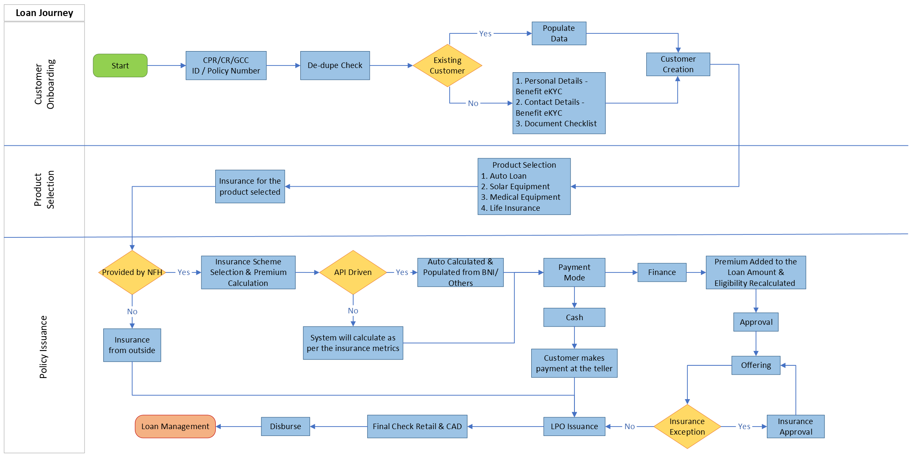

Non-Loan Journey
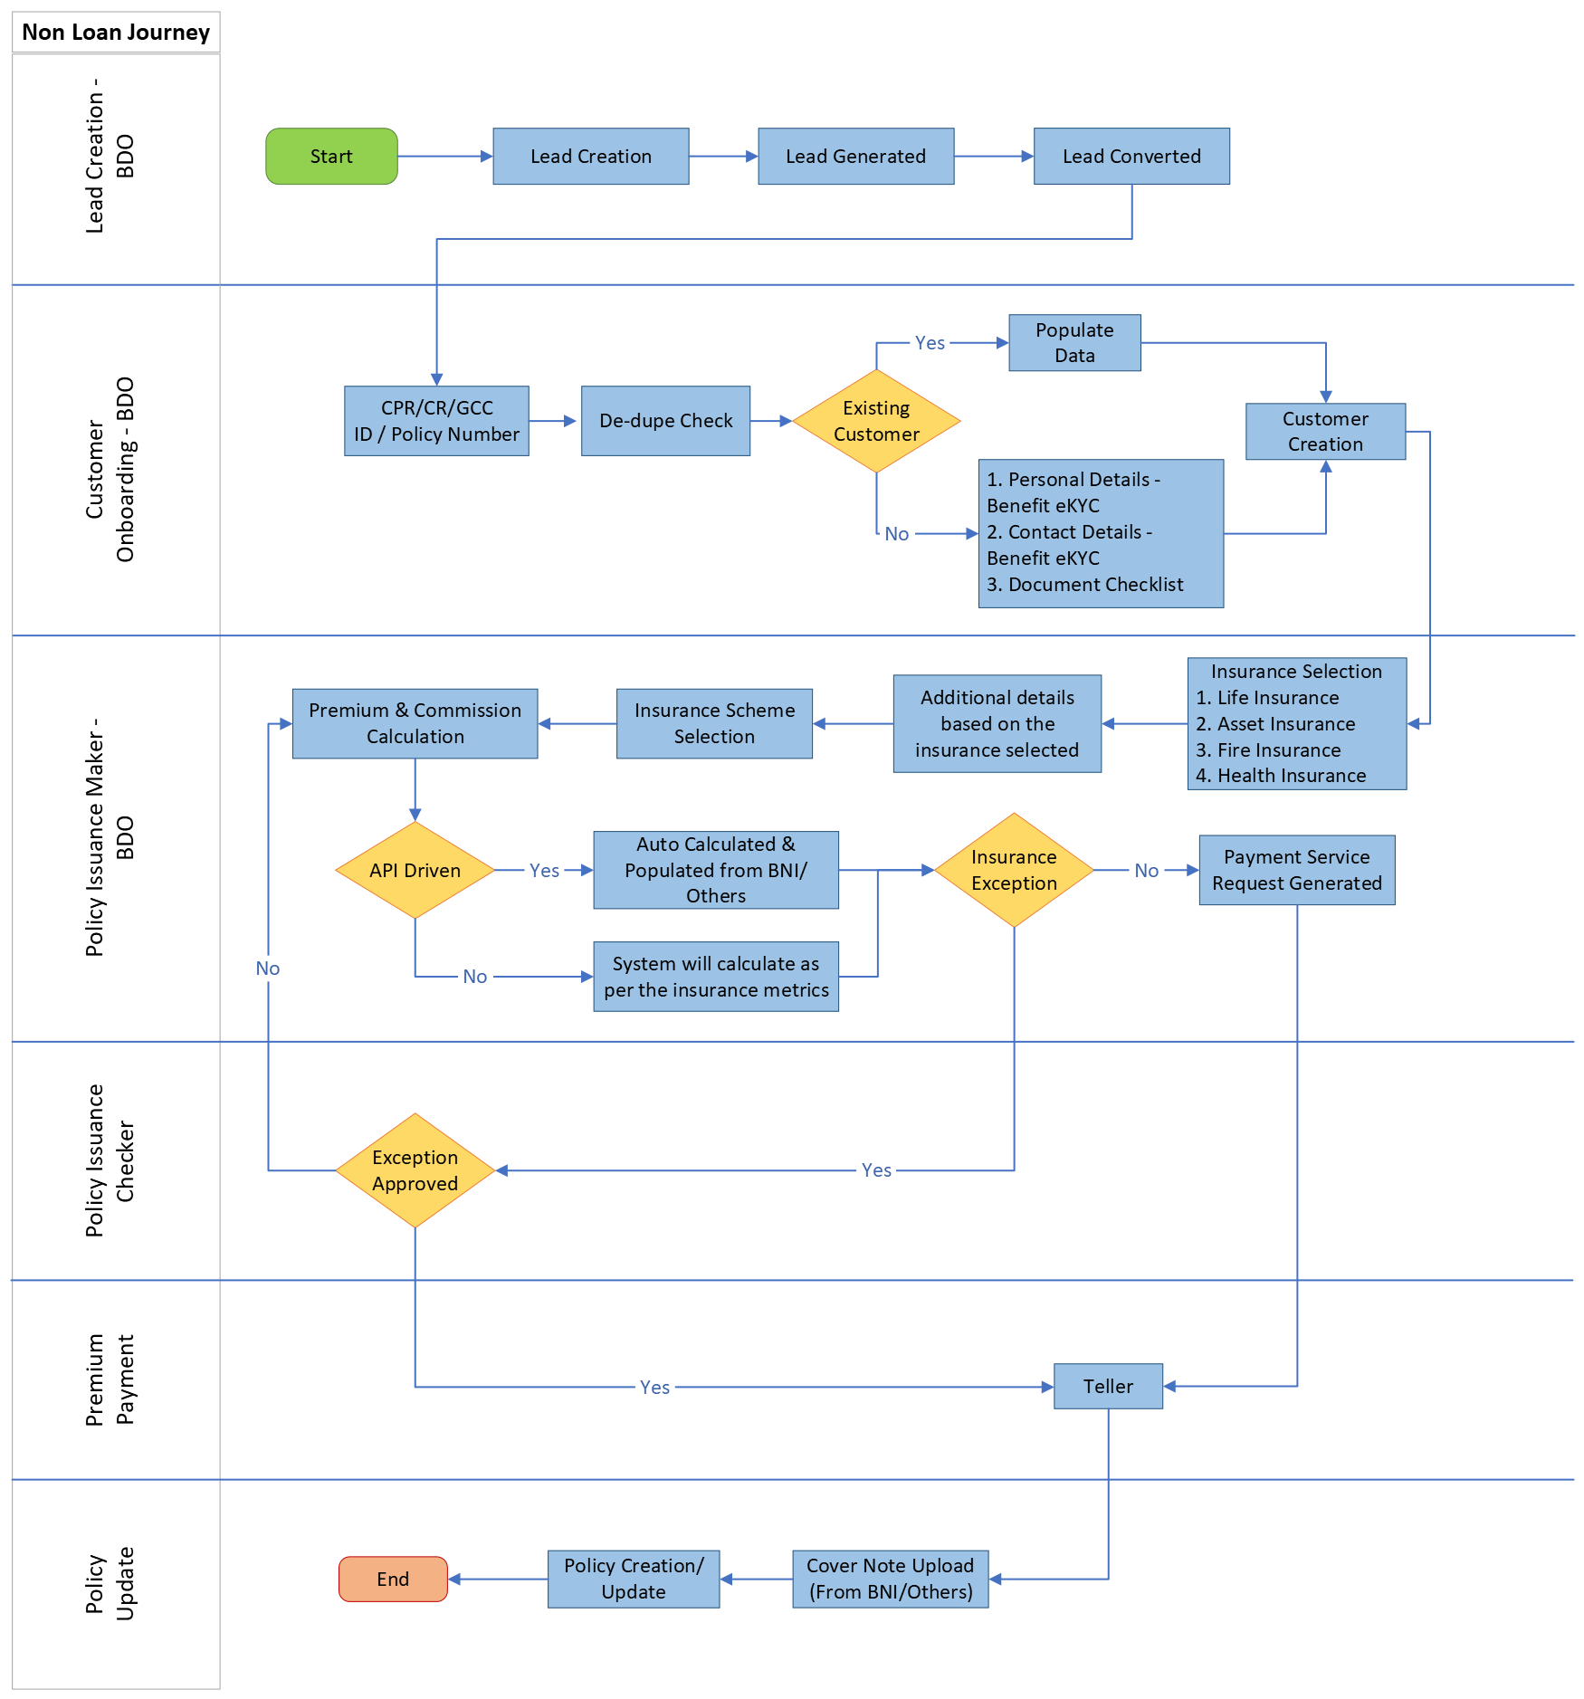

Policy Renewal
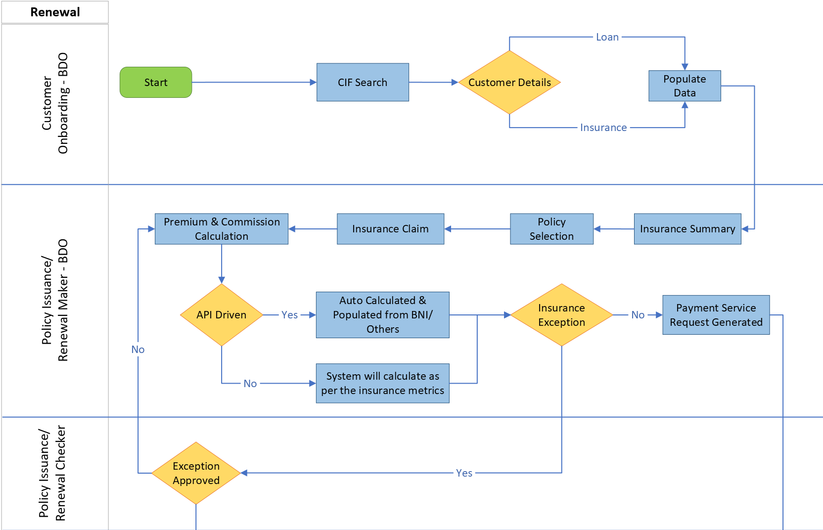
Figure 3:Policy Renewal Flow

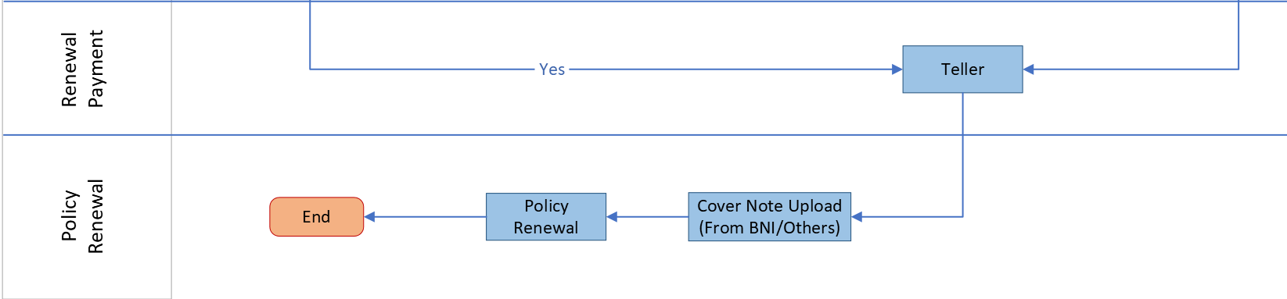

Policy Extension
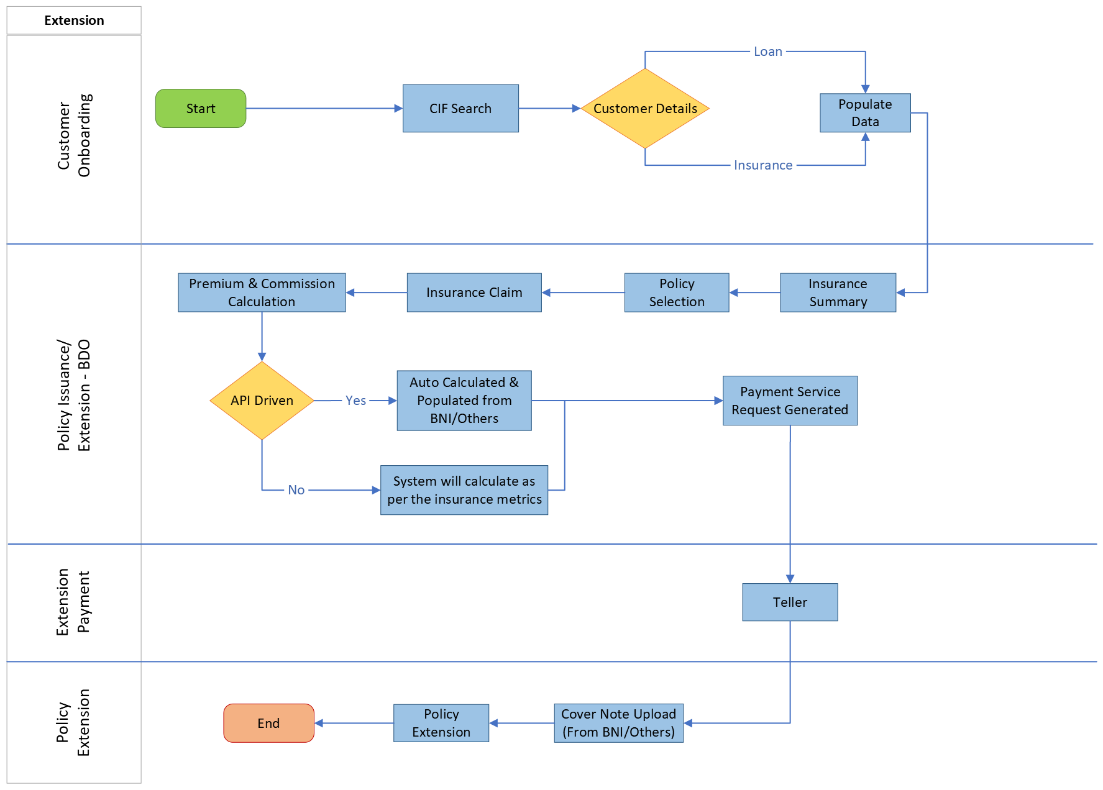

Policy Cancellation
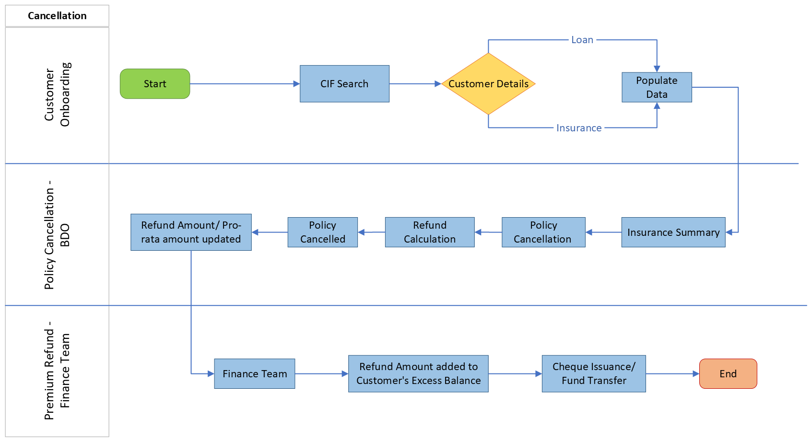

Access Right Metrics

The following image displays the Access Rights in the organization:

Role | Add/ Create | Edit/ Update | View | Authorize | Delete
Maker
Checker

Lead Creation

Lead Data Entry
This feature will let the user to create a lead by capturing the basic details of the customer, it will also allow to convert the lead into an application coming from various source of channels like call centre, mobile application, website, and branches.

The following screen serves as the Lead Queue, where users can view all existing insurance leads and initiate the creation of new leads as required:

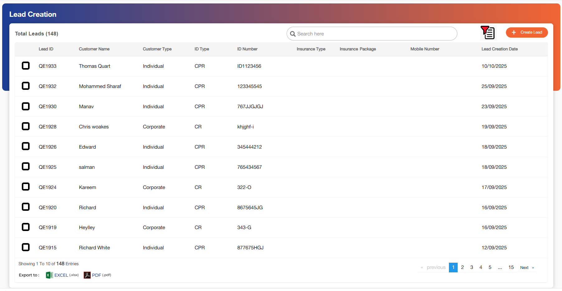

Field Name | Field Type | Mandatory Y/N | Data Type / Length | Lookup Key / Master Name | Possible Values | Field Description
 |  |  |  |  |  | Remarks/ Validation
Checkbox | Checkbox | NA | NA | NA | NA | The user will select the required leads to be converted to application
Lead ID | Read-only | NA | NA | NA | NA | System generated lead ID is displayed here.
Customer Name | Read-only | NA | NA | NA | NA | Displays the full name of the customer.
Customer Type | Read-only | NA | NA | NA | NA | Displays the type of the customer.
Insurance Type | Read-only | NA | NA | NA | NA | Displays the type of the insurance selected by the customer.
ID Type | Read-only | NA | NA | NA | NA | Displays the ID type of customer.
ID Number | Read-only | NA | NA | NA | NA | Displays the ID number of the customer.
Lead Creation Date | Read-only | NA | NA | NA | NA | Displays the date on which the lead was created.
Insurance Type | Read-only | NA | NA | NA | NA | Displays the insurance type of the lead
Insurance Package | Read-only | NA | NA | NA | NA | Displays the package selected
Mobile Number | Read-only | NA | NA | NA | NA | Displays the customer mobile number
Follow-up Date | Read Only | NA | DATETIME | NA | NA | Displays the latest follow-up date.
Action Buttons
 | Button | Y | Button | NA | NA | Advance Filter option allows users to filter on below criteria:  1.Lead ID  2.Customer Name  3.Customer Type  4.Insurance Type  5.ID Type  6.ID Number  7.Application Date  8.Follow-up Date
Create Lead | Button | Y | Button | NA | NA | Allows the users to create new lead. On selecting multiple leads, this button will be visible to convert multiple selected leads to application.

- A “Create Lead” button will be located at the top-right corner of the screen.
- Clicking this button opens the Lead Creation screen, where users can enter new lead details and submit them.
- When users hover over any lead, users will have option to View details and convert to application buttons.
- Excel and PDF Icons will be provided at the top-right area of the lead list screen.
- Users can click these icons to download the current list of leads in the respective formats:
- Excel Export: Generates a .xlsx file containing all visible columns and filters applied.
- PDF Export: Creates a PDF version of the lead list in a printable layout.
- Exported data will reflect the current view, including active filters or sorting preferences.
- The user can select multiple leads to be converted to an application, on selection of any lead, the convert to application button will be visible on the screen.

Following screen will be displayed once the user clicks on “Create Lead” button:

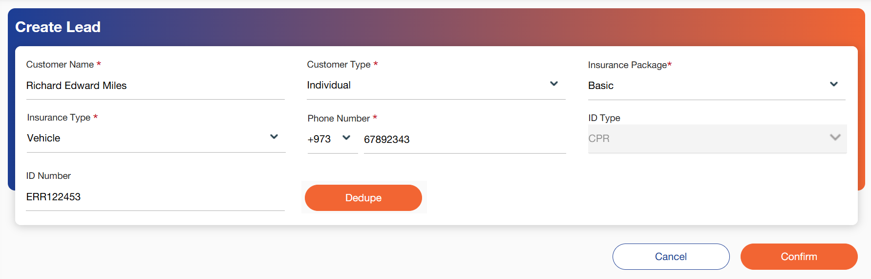

Below mentioned are the details specific to the information being displayed above:

Field Name | Field Type | Mandatory Y/N | Data Type / Length | Lookup Key / Master Name | Possible Values | Field Description
 |  |  |  |  |  | Remarks/ Validation
Customer Name | Text Box | Y | VARCHAR / 20 | NA | NA | This field allow users to enter the name of the customer.
Customer Type | LOV Drop Down | Y | VARCHAR / 25 |  | - Individual  - Corporate | Users can select the type of the customer.
Insurance Package | LOV Drop Down | Y | VARCHAR / 20 |  | 1.Basic  2.Premium  3. Gold | Users can select the package of insurance.
Insurance Type | LOV Drop Down | Y | VARCHAR / 20 |  | - Life Insurance  - Health Insurance | Users can select the type if the insurance.  -In case of Basic, the users can select only one type of insurance.  -In case of Premium/Gold package the insurance type will auto populate based on configuration.
Phone Number | Numeric | Y | INT / 15 | NA | NA | Users can capture the contact number of the customer.  - Country code “+973” will be auto populated
ID Type | Read Only | N | VARCHAR | NA | - CPR  - CR | Auto populates based on the selection of customer type.  - If Corporate than CR, If retails than CPR.
ID Number | Text Box | N | NVARCHAR | NA | NA | Users can capture the ID number of the customer
Dedupe | Button | Y | Button | NA | NA | The user will require to run dedupe check of the customer.  This dedupe will be done with the NFHI database and not from NFH core database.
Action Buttons
Cancel | Button | Y | Button | NA | NA | Allows the users to cancel the lead.
Confirm | Button | Y | Button | NA | NA | Allows the users to confirm lead and save data.

Once the user clicks on confirm, a message: “Lead xxx has been added to the system.”, will be displayed and users will be redirected to lead queue.

Once a lead is created and displayed in the Lead Queue, users will have the ability to view detailed information about the lead by hovering over the lead in the lead queue. This functionality allows users to quickly access all relevant lead data without navigating away from the main queue.

Users can also directly move to “Convert to Application” from lead queue hover.

Field Name | Field Type | Mandatory Y/N | Data Type / Length | Lookup Key / Master Name | Possible Values | Field Description
 |  |  |  |  |  | Remarks/ Validation
Edit | Action Button | NA | NA | NA | NA | Users can edit the lead by clicking on this button.
Cancel Deal | Action Button | NA | NA | NA | NA | Users can cancel the lead by clicking on this button.
Follow-Up | Action Button | NA | NA | NA | NA | Users can follow-up with the customer by clicking on this button.
Convert to Application | Action Button | NA | NA | NA | NA | Users can click on this button which will allow users to capture more details of the customer.

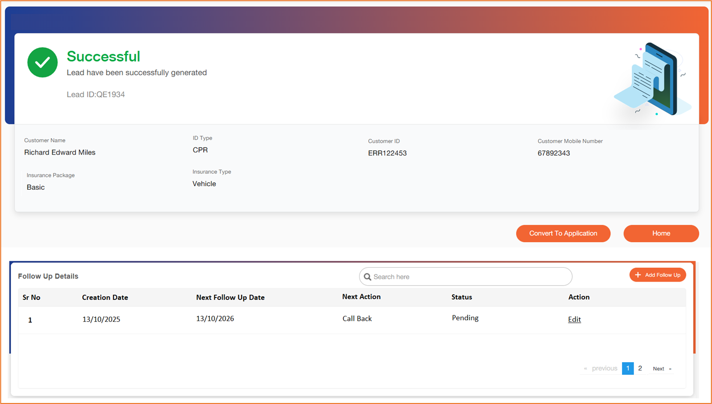

Quick Quote
This feature will let the user compare multiple insurance products based on the matrix.

Follow-Up details
Once a lead has been successfully created, users will have the ability to initiate and record follow-ups with the customer. This ensures that all communication and activity related to the lead is tracked within the system.

All follow-ups made with the customer will be displayed in a structured format under the Follow-Up Details List, accessible from the Lead Details screen.
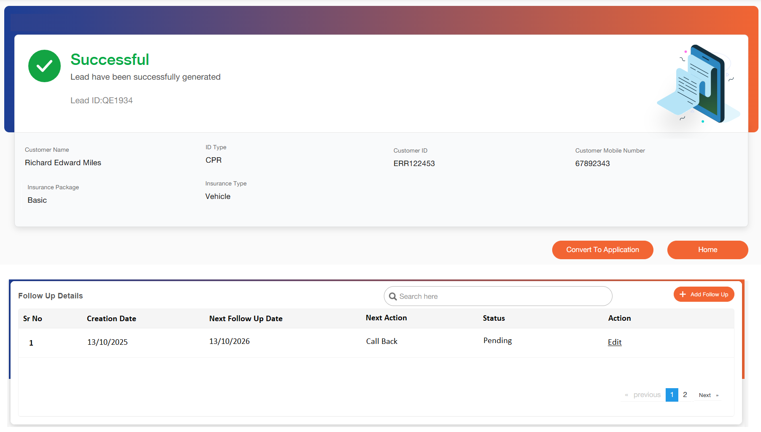

Field Name | Field Type | Mandatory Y/N | Data Type / Length | Lookup Key / Master Name | Possible Values | Field Description
 |  |  |  |  |  | Remarks/ Validation
Call | Action Button | NA | NA | NA | NA | Integration will allow users to call customer.
Follow-up Details | Action Button | NA | NA | NA | NA | Allow users to capture the details of how follow up was made.

Once the user clicks on +Add Follow Up, below screen will be made visible:

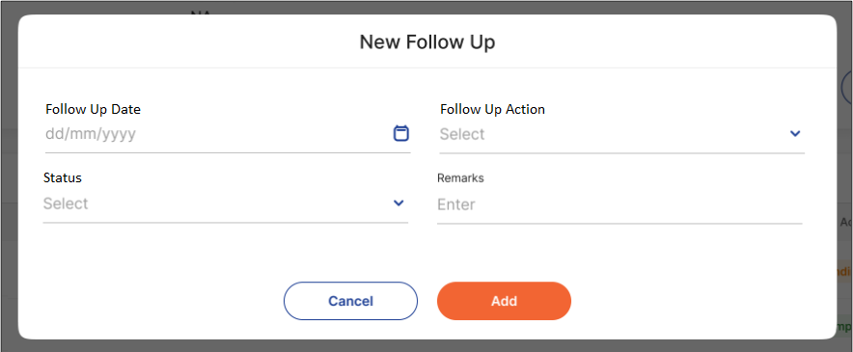

Field Name | Field Type | Mandatory Y/N | Data Type / Length | Lookup Key / Master Name | Possible Values | Field Description
 |  |  |  |  |  | Remarks/ Validation
Follow Up Date | Date | Yes | Calendar | NA | NA | Users can enter when the next follow-up date will be scheduled.
Follow Up Action | Dropdown | Yes | VARCHAR / 20 | NA | - Call Back Later  - Awaiting Customer Response  - Not Interested  - Close Lead | Allow users to capture the details of the follow up action which is to be taken.
Status | Dropdown | Yes | VARCHAR / 20 | NA | - Completed  - Pending | User will update the follow Up status.
Remarks | Field | No | VARCHAR / 20 | NA | NA | Users can enter their remarks.

- Note: If a follow-up has been added and the follow-up date has been captured by the user, the case will be automatically transferred to the Follow-Up queue.

Follow-up Queue
The Follow-Up Queue will contain all cases for which a Next Follow-Up Date has been specified in the Follow-Up Details screen.
Queue Criteria:
- A case will be included in the Follow-Up Queue only if:
  - A follow-up record has been added by the user.
  - The Follow-Up Date has been captured and saved successfully.
- The queue will dynamically display only those cases where the Follow-Up Date falls within the next 30 calendar days from the current system date (i.e., the date of access).
- Cases with a Next Follow-Up Date beyond 30 days will not appear in this queue until they fall within the 30-day window.
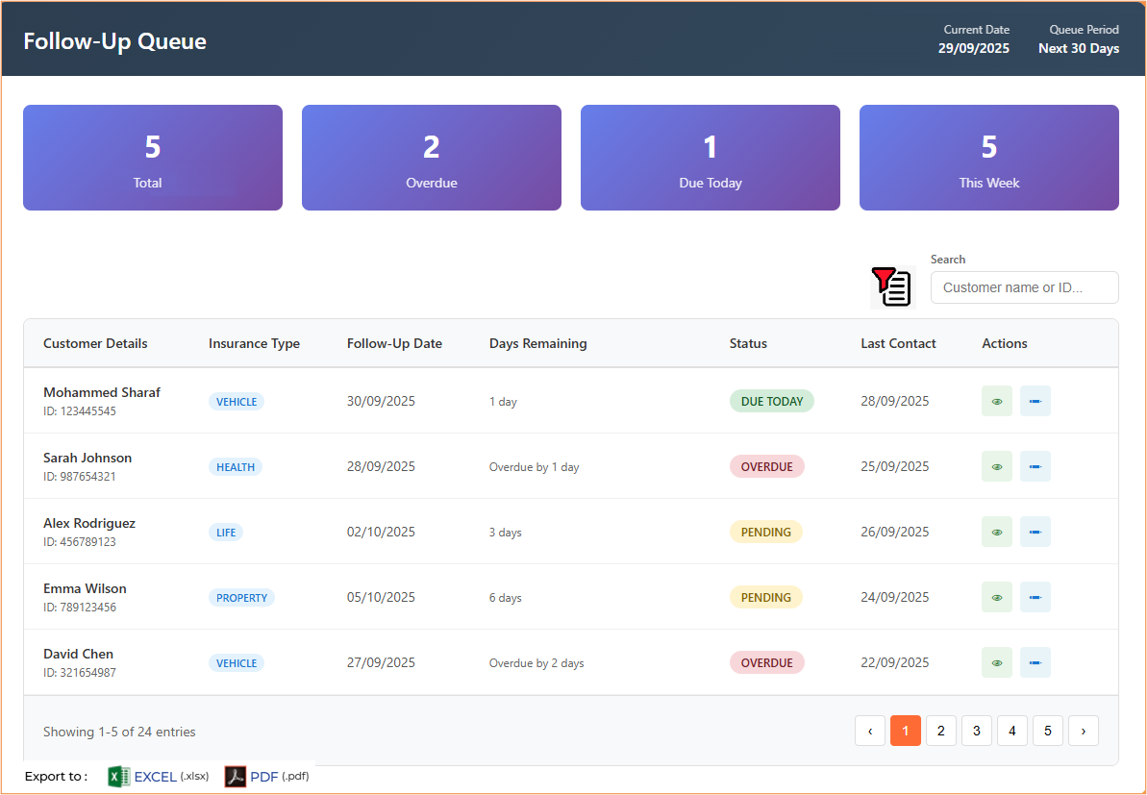

Field Name | Field Type | Mandatory Y/N | Data Type / Length | Lookup Key / Master Name | Possible Values | Field Description
 |  |  |  |  |  | Remarks/ Validation
Total Cases | Read-only | NA | NA | NA | NA | Displays the number of total follow ups in the follow up queue.
Overdue | Read-only | NA | NA | NA | NA | Displays the number of today overdue follow up’s in the queue.
Due Today | Read-only | NA | NA | NA | NA | Displays the number of follow up’s that are today on the business date.
This Week | Read-only | NA | NA | NA | NA | Displays the number of cases that are due for follow-up in the week.
Customer Details | Read-only | NA | NA | NA | NA | Displays the name and ID of the customer.
Insurance Type | Read-only | NA | NA | NA | NA | Displays the type of insurance the customer has opted for.
Follow-up Date | Read-only | NA | NA | NA | NA | The system will display the Follow-Up Date, indicating the specific date on which the user is expected to contact the customer for follow-up.
Days Remaining | Read-only | NA | NA | NA | NA | Displays the days remaining to contact the customer.
Status | Read-only | NA | NA | NA | NA | Displays Status.  1.Overdue  - Indicates cases where the Follow-Up Date has passed, and the user has not yet completed the follow-up action.  - These cases require immediate attention.  2.Due Today  - Displays cases that are scheduled for follow-up on the current system date (i.e., today).  - These are the cases the user is expected to act on today.  3.Pending  - Refers to cases for which a Next Follow-Up Date has been set, but the follow-up action is still outstanding.  - These cases may be scheduled for a future date beyond today.  4.Pending Today  - Displays cases that are both:  - Scheduled for follow-up today, and  - Yet to be contacted by the user.  - This is a subset of Due Today cases with no follow-up action recorded.
Last Contact Date | Read-only | NA | NA | NA | NA | Displays the date on which the customer was last contacted.
Action Button
Advance Filter | Read-only | NA | NA | NA | NA | Allow users to search on below parameters:  1.Insurance Type  2.Status  3.Customer Name  4.Customer ID  5.Last Contacted
Edit | Action Button | NA | NA | NA | NA | Allow users to edit and capture the follow up details. The screens will be like points discussed in 5.2.
View | Action Button | NA | NA | NA | NA | Allow users to view record.

Customer Creation
This stage is for customer onboarding where all details of the customer from basic to insurance are captured. Additional details are dependent on the insurance selected.
In case of an existing customer whether it is an insurance customer or a loan customer the details are fetched and auto populated by the system wherever applicable.

Users can hover over an existing lead in the Lead Queue, upon which a 'Convert to Application' button will be displayed. Selecting this option allows the user to initiate the conversion of the lead into an insurance application.

- Note: If users are unable to complete the application and need to exit before submission, the application will be automatically moved to the “Inbox”. The current Stage of the application will be clearly displayed in the Inbox for easy tracking and follow-up. Please refer to point no. 7 for detailed information on the Inbox view and its functionalities.
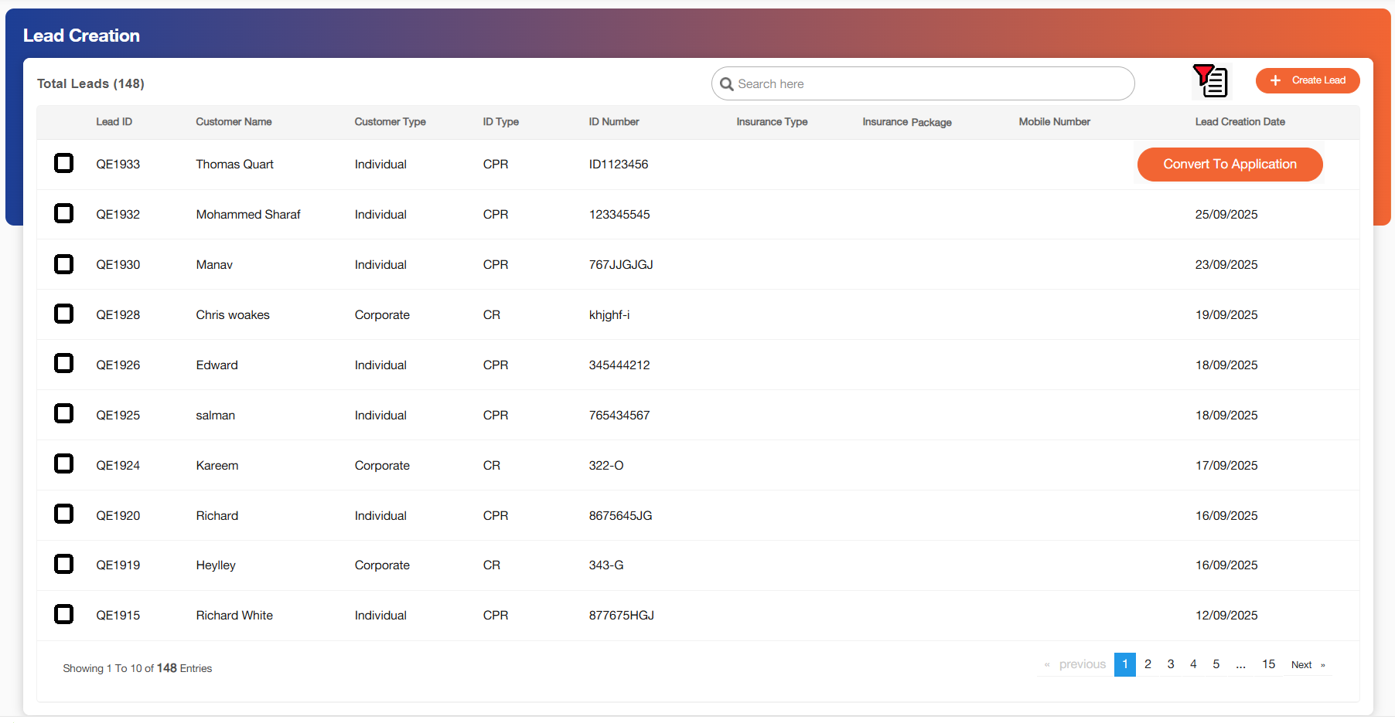

Inbox

Once the user clicks on 'Convert to Application' and the application is successfully created, it shall be available for viewing under the 'Inbox' section.

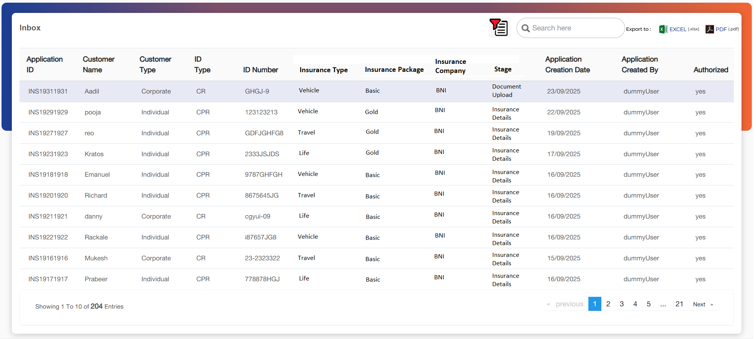

Field Name | Field Type | Mandatory Y/N | Data Type / Length | Lookup Key / Master Name | Possible Values | Field Description
 |  |  |  |  |  | Remarks/ Validation
Application ID | Read-Only | NA | NA | NA | NA | Displays the system generated application ID once the application is successfully created.
Customer Name | Read-Only | NA | NA | NA | NA | Displays the name of the customer.
Customer Type | Read-Only | NA | NA | NA | NA | Displays the customer type.
ID Type | Read-Only | NA | NA | NA | NA | Displays the ID type of the customer.
ID Number | Read-Only | NA | NA | NA | NA | Displays the ID number of the customer.
Insurance Type | Read-Only | NA | NA | NA | NA | Displays the insurance type of the application.
Insurance Package | Read-Only | NA | NA | NA | NA | Displays the insurance package applicable for the application.
Insurance Company | Read-Only | NA | NA | NA | NA | Displays the insurance company of the application.
Stage | Read-Only | NA | NA | NA | 1.Application: Basic Details  2. Application: Contact Details  3. Application: Identification Details  4. Application: Insurance Details  5.Application: Additional Details  6.Document Checklist  7.Policy Update | Displays the stage at which the application is pending.  Once the user clicks on the hyperlink the users will be redirected to the stage where the application is currently on.
Application creation Date | Read-Only | NA | NA | NA | NA | Displays the date on which the application was successfully created.  -In case where application is not created this filed will display “-“
Application created by | Read-Only | NA | NA | NA | NA | Displays the creation date of the application.  -In case where application is not created this filed will display “-“
Authorized | Read-Only | NA | NA | NA | NA | Displays the checker approval, if all the approvals are done than it will display as “Yes”
Action Buttons
Advanced Filter | Button | Y | Button | NA | NA | Allows the user to filter through below parameters:  1.Application ID  2.Customer Name  3.Customer Type  4.ID Type  5.ID Number  6.Stage  7.Authorized  8.Application creation date  9.Application created by.

When a user clicks on an application, the application status shall be displayed in the top-right corner of the screen, indicating that the application has been successfully converted.

Header

The header section will be visible on all the individual customer related screens. This header will provide information of the customer for whom the user is working upon. The details in the screen will be visible as and when they are available in the system.

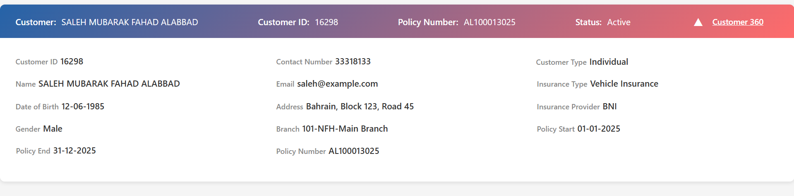

Field Name | Field Type | Data Type / Length | Mandatory (Yes/No) | LookUp Key / Master Name | Possible Values | Field Description / Remarks
Customer | Text | VARCHAR(100) | Yes | N/A | N/A | Displays the full name of the customer. Shown in collapsed view and editable in expanded view if required.
Customer ID | Text | VARCHAR(20) | Yes | N/A | N/A | Unique identifier of the customer. Displayed in both collapsed and expanded views.
Policy Number | Text | VARCHAR(20) | Yes | N/A | N/A | Shows the active policy number associated with the customer. Collapsed view shows the primary policy;
Status | Text | VARCHAR(20) | Yes | STATUS_MASTER | Active, Lapsed, Cancelled, Expired | Current status of the customer’s insurance policy. Shown in collapsed view.
Date of Birth | Date | DATE | No | N/A | N/A | Customer’s date of birth. Shown in expanded view.
Gender | Text | VARCHAR(10) | No | GENDER_MASTER | Male, Female, Other | Customer’s gender. Shown in expanded view.
Customer Type | Text | VARCHAR(20) | Yes | CUSTOMER_TYPE_MASTER | Individual, Corporate | Type of customer. Shown in expanded view.
Contact Number | Text | VARCHAR(20) | No | N/A | N/A | Customer primary contact number. Shown in expanded view.
Email | Text | VARCHAR(50) | No | N/A | N/A | Customer email address. Shown in expanded view.
Address | Text | VARCHAR(200) | No | N/A | N/A | Customer’s full address. Shown in expanded view.
Branch | Text | VARCHAR(50) | Yes | BRANCH_MASTER | List of Branches | Branch associated with the customer. Shown in expanded view.
Insurance Type | Text | VARCHAR(50) | Yes | INSURANCE_TYPE_MASTER | Vehicle, Health, Life, etc. | Type of insurance policy. Shown in expanded view.
Insurance Provider | Text | VARCHAR(50) | Yes | INSURANCE_PROVIDER_MASTER | List of providers | Insurance company providing the policy. Shown in expanded view.
Policy Start Date | Date | DATE | Yes | N/A | N/A | Start date of the policy. Shown in expanded view.
Policy End Date | Date | DATE | Yes | N/A | N/A | End date of the policy. Shown in expanded view.
Customer 360 Link | Link / Button | URL | Yes | N/A | N/A | Link to the full Customer 360 dashboard. Present in both collapsed and expanded views for quick navigation.
Toggle Header | Button | N/A | Yes | N/A | N/A | Allows collapsing and expanding the header. Changes icon from down-arrow to up-arrow when toggled.

Basic Details
The Basic Detail section enables the user to record essential information such as the applicant's name, ID type, ID number, residential status, etc. The applicant's ID and mobile number undergo verification by the user. The details displayed on this screen are retrieved from the basic details captured during lead creation and triggering the eKYC or Sijilat interface.

Individual
This screen allows the user to capture the personal details of the customer which are fetched from the benefit eKYC interface. The fields are also open to manual capturing of information in case interface is not triggered.

Following screen will be displayed once the user clicks on Customer Creation Menu:
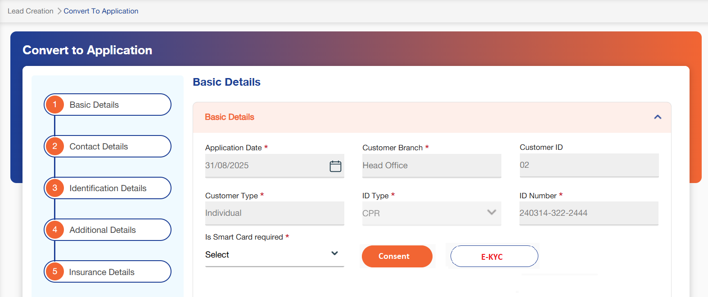
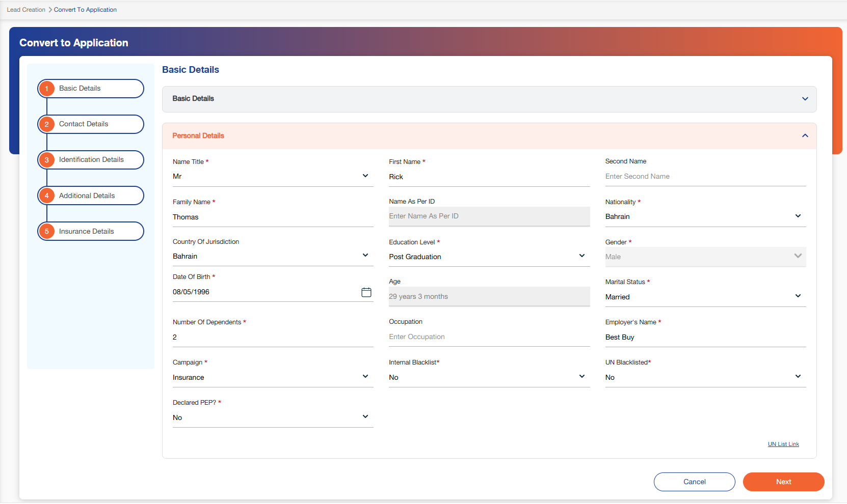

Below mentioned are the details specific to the information being displayed above:

Field Name | Field Type | Mandatory Y/N | Data Type / Length | Lookup Key / Master Name | Possible Values | Field Description
 |  |  |  |  |  | Remarks/ Validation
Basic Details
Application Date | Read Only | NA | DATETIME | NA | NA | Displays the lead creation date.
Customer Branch | Read Only | Y | NVARCHAR / 15 | NA | NA | The system shall display the branch name where the lead was created. The branch information shall be derived and stored based on the branch associated with the user’s username, as maintained in the master data.
Customer ID | Read Only | NA | INT / 02 | NA | NA | Displays the customer ID entered during lead creation.
Loan Account Number | Dropdown | NA | NVARCHAR / 20 | NA | NA | In cases where the insurance is to be issued for NFH loans, the lead will be created automatically, and the corresponding loan number will be available to choose from the dropdown.  - However, if the insurance is issued by NFHI, this field will remain blank.
Customer Type | Read Only | Y | NVARCHAR / 20 | NA | NA | Displays the customer type entered during lead creation.
Policy Status | Read Only | NA | VARCHAR / 10 | NA | NA | Displays “Active” during application creation.
Customer Risk Rating | Read Only | NA | NVARCHAR / 10 | NA | NA | This data will be fetched via the eKYC interface.
ID Type | Master Dropdown | Y | VARCHAR / 20 | POITYPE_IND | NA | Displays the customers ID Type of the customer captured during lead creation.
ID Number | Text Box | Y | NVARCHAR / 25 | NA | NA | Displays the customers ID number of the customer captured during lead creation.
Smart Scan Required? | LOV Dropdown | Y | VARCHAR / 03 | 53 | - Yes  - No | The user will select Yes or No from the drop-down values if Smart Card is required.  - On the selection of "Smart Card Required?" as Yes, it will allow the user to scan the ID type selected.  - The data will be extracted using the card reader functionality and populated in the further related fields of Basic Details screen.
Consent | Button | Y | NA | NA | NA | The user will click on this button to open consent section or a popup to capture consent for e-kyc.  This structure will be same as the one followed in LOS application.
Personal Details
Name Title | LOV Drop Down | Y | NVARCHAR / 20 | SALUTATION | - MR  - OTH  - MRS | Allow users to select the salutation of the customer.
First Name | Text Box | Y | VARCHAR / 10 | NA | NA | Allow users to capture the customer’s first name.  - In scenarios where Ekyc interface is triggered the first name will get auto populated.
Second Name | Text Box | N | VARCHAR / 10 | NA | NA | Allow users to capture the customer’s second name.  - In scenarios where Ekyc interface is triggered the second name will get auto populated.
Family Name | Text Box | Y | VARCHAR / 10 | NA | NA | Allow users to capture the customer’s family name.  - In scenarios where Ekyc interface is triggered the family name will get auto populated.
Name As Per ID | Read Only | N | VARCHAR / 100 | NA | NA | Upon fetching the details of the customer through the provided POI and ID number, it will display the Name of the customer as per the official records.  - Name as per the ID type which is fetched via the interface should have a validation to match with the name entered, else it should give a system alert before moving ahead.
Nationality | LOV Drop Down | Y | NVARCHAR / 20 | NATIONALITY_LIST | - Indian  - USA  - Bahrain | Allow users to capture the nationality of the customer.  - In scenarios where Ekyc interface is triggered the nationality will get auto populated.
Country Of Jurisdiction | LOV Dropdown | N | VARCHAR / 20 | NA | 1.India  2.USA  3.Bahrain | System will display the country of jurisdiction based on the nationality selected
Education Level | LOV Drop Down | Y | VARCHAR / 25 | EDULVL | - Diploma  - Graduate | This field allow users to select the education level of the customers.
Gender | LOV Drop Down | Y | VARCHAR / 10 | GENDER | - Female  - Male  - Others | Allow users to capture the gender of the customer.  - In scenarios where Ekyc interface is triggered the gender will get auto populated.
Date of Birth | Date | Y | Calendar | NA | NA | Allow users to capture the date of birth of the customer.  - In scenarios where Ekyc interface is triggered the date of birth will get auto populated.
Age | Read Only | NA | INT / 02 | NA | NA | System calculates based on date of birth provided by the customer.  - Auto populated by the system in years and months format.  E.g. – 25 years 6 months
Marital Status | LOV Drop Down | Y | NVARCHAR / 10 | MARITALSTATUS | - Single  - Married  - Widowed | Allow users to capture the marital status of the customer.  - In scenarios where Ekyc interface is triggered the marital status will get auto populated.
No. Of Dependents | Numeric | Y | INT / 02 | NA | NA | Users can capture the number of dependants.
Occupation | Text Box | N | VARCHAR / 20 | NA | NA | Users can capture the occupation of the customer.
Employer’s Name | Text Box | N | VARCHAR / 25 | NA | NA | Users can capture the employer’s name of the customer.
Campaign | LOV Dropdown | Y | VARCHAR / 20 | NA | 1.Walk in Inquiry  2.Branch Promotion  3.Digital Marketing Campaign  4.Refferal Program  5.Bahrain Insurance Week | Users can select the campaign.
Internal Blacklist | LOV Dropdown | Y | VARCHAR / 20 | NA | 1.Yes  2.No | Users can select if the customer is blacklisted internally.  - If the customer is marked as blacklisted, the system should not allow users to proceed with the application.
UN Blacklist | LOV Dropdown | Y | VARCHAR / 20 | NA | 1.Yes  2.No | Users can select if the customer is blacklisted by the UN.  - If the customer is marked as blacklisted, the system should not allow users to proceed with the application.
Declared PEP? | LOV Drop Down | N | VARCHAR / 03 |  | - Yes  - No | Users can select if the customer is a politically exposed person.
Verified By API | Checkbox | NA | Checkbox | NA | NA | System will mark the checkbox as checked if data is fetched from interface.  - The user will not be able to check this box if API is not triggered
UN List Link | Button | NA | Button | NA | NA | Link to access the UN List website will be provided to the users.
Action Buttons
Fetch | Button | Y | Button | NA | NA | Allows the user to fetch relevant details when Smart Card is required  In case “Is Smart Card required” is Yes, the button will be disabled until a file is uploaded, once the file is uploaded relevant details will be fetched using the card reader functionality.
Benefit eKYC | Button | Y | Button | NA | NA | Allows the user to fetch details from benefit eKYC.
Cancel | Button | Y | Button | NA | NA | Allows the user to go back to the lead queue.
Next | Button | Y | Button | NA | NA | Allows the user to go to the next screen.

Corporate
This screen allows the user to capture the personal details of the customer which are fetched from the Sijilat interface. The fields are also open to manual capturing of information in case interface is not triggered.

Following screen will be displayed once the user clicks on Customer Creation Menu:

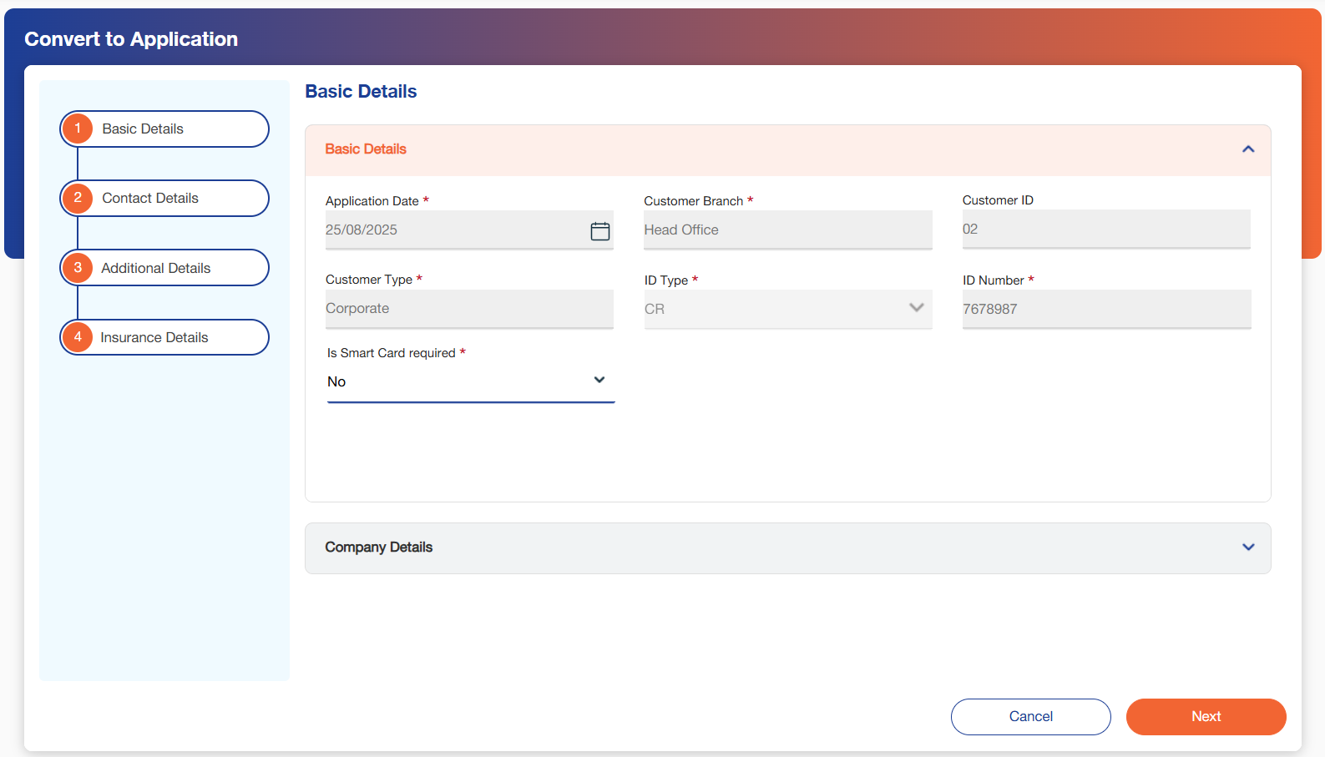
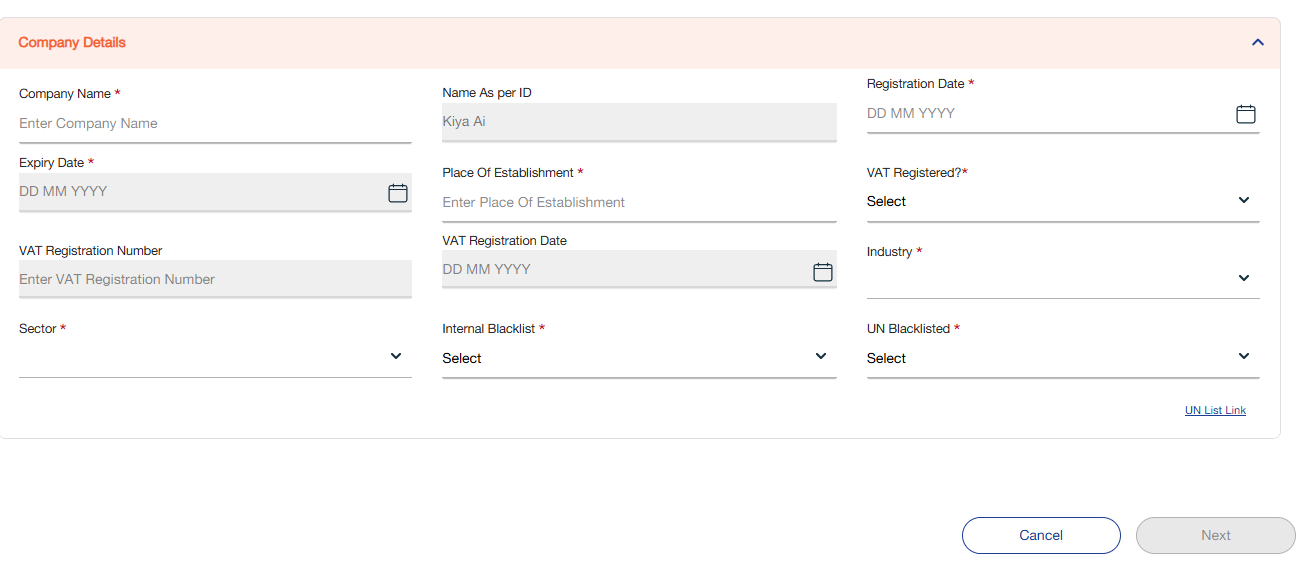

Below mentioned are the details specific to the information being displayed above:

Field Name | Field Type | Mandatory Y/N | Data Type / Length | Lookup Key / Master Name | Possible Values | Field Description
 |  |  |  |  |  | Remarks/ Validation
Basic Details
Application Date | Read Only | NA | DATETIME | NA | NA | Displays the lead creation date.
Customer Branch | Read Only | Y | NVARCHAR / 15 | NA | NA | The system shall display the branch name where the lead was created. The branch information shall be derived and stored based on the branch associated with the user’s username, as maintained in the master data.
Customer ID | Read Only | NA | INT / 02 | NA | NA | Displays the customer ID entered during lead creation.
Customer Type | Read Only | Y | NVARCHAR / 20 | NA | NA | Displays the customer type entered during lead creation.
ID Type | Master Dropdown | Y | VARCHAR / 20 | POITYPE_IND | NA | Displays the customers ID Type of the customer captured during lead creation.
ID Number | Text Box | Y | NVARCHAR / 25 | NA | NA | Displays the customers ID number of the customer captured during lead creation.
Smart Scan Required? | LOV Dropdown | Y | VARCHAR / 03 | 53 | - Yes  - No | The user will select Yes or No from the drop-down values if Smart Card is required.  - On the selection of "Smart Card Required?" as Yes, it will allow the user to scan the ID type selected.  - The data will be extracted using the card reader functionality and populated in the further related fields of Basic Details screen.
Company Details
Company Name | Text Box | N | VARCHAR / 10 | NA | - NA | Users can enter the name of the company of the customer.
Name As Per ID | Read Only | N | VARCHAR / 25 | NA | NA | Upon fetching the details of the company through the provided ID number, it will display the Name of the company as per the official records.  - Name as per the ID type which is fetched via the interface should have a validation to match with the name entered, else it should give a system alert before moving ahead.
Registration Date | Calendar | Y | DATETIME | NA | NA | Details will be fetched through the interface.  - Users can also capture and input information in case the interface is not triggered.
Expiration Date | Calendar | Y | DATETIME | NA | NA | Details will be fetched through the interface.  - Users can also capture and input information in case the interface is not triggered.
Place Of Establishment | Text Box | Y | VARCHAR / 20 | NA | NA | Details will be fetched through the interface.  - Users can also capture and input information in case the interface is not triggered.
VAT Registered? | LOV Drop Down | N | VARCHAR / 25 | NA | - Yes  - No | Users can select if the company is VAT Registered.
VAT Registration Number | Text Box | N | NVARCHAR / 10 | NA | NA | This filed will only be visible to the users in case VAT registered is selected as “Yes”.  - Details can also be fetched through the interface.
VAT Registration Date | Date | N | Calendar | NA | NA | This filed will only be visible to the users in case VAT registered is selected as “Yes”.  - Details can also be fetched through the interface.
Industry | LOV Drop Down | Y | VARCHAR / 20 |  |  | The users can select the industry associated with the company.
Sector | LOV Drop Down | Y | VARCHAR / 20 |  |  | The users can select the sector associated with the company.
Internal Backlist | LOV Dropdown | Y | VARCHAR / 20 | NA | 1.Yes  2.No | Users can select if the customer is blacklisted internally.  - If the customer is marked as blacklisted, the system should not allow users to proceed with the application.
UN Blacklist | LOV Dropdown | Y | VARCHAR / 20 | NA | 1.Yes  2.No | Users can select if the customer is blacklisted by the UN.  - If the customer is marked as blacklisted, the system should not allow users to proceed with the application.
UN List Link | Button | NA | Button | NA | NA | Link to access the UN List website will be provided to the users.
Action Buttons
Fetch | Button | Y | Button | NA | NA | Allows the user to fetch relevant details when Smart Card is required  In case “Is Smart Card required” is Yes, the button will be disabled until a file is uploaded, once the file is uploaded relevant details will be fetched using the card reader functionality.
Cancel | Button | Y | Button | NA | NA | Allows the user to go back to the lead queue.
Next | Button | Y | Button | NA | NA | Allows the user to go to the next screen.

- Note: CPR/CR details, along with the image of the CPR/CR ID, should be fetched via API and displayed on the document upload screen. The fetched image should be stored and made available as part of the document upload process.

Contact Details
This screen allows the user to capture contact information which contains of the address and contact details, these details are fetched by triggering the benefit eKYC or Sijilat interface. These fields are also open for manual entry in case the user does not want to trigger the interface.

Following screen will be displayed once the user clicks on Next on Basic details screen:

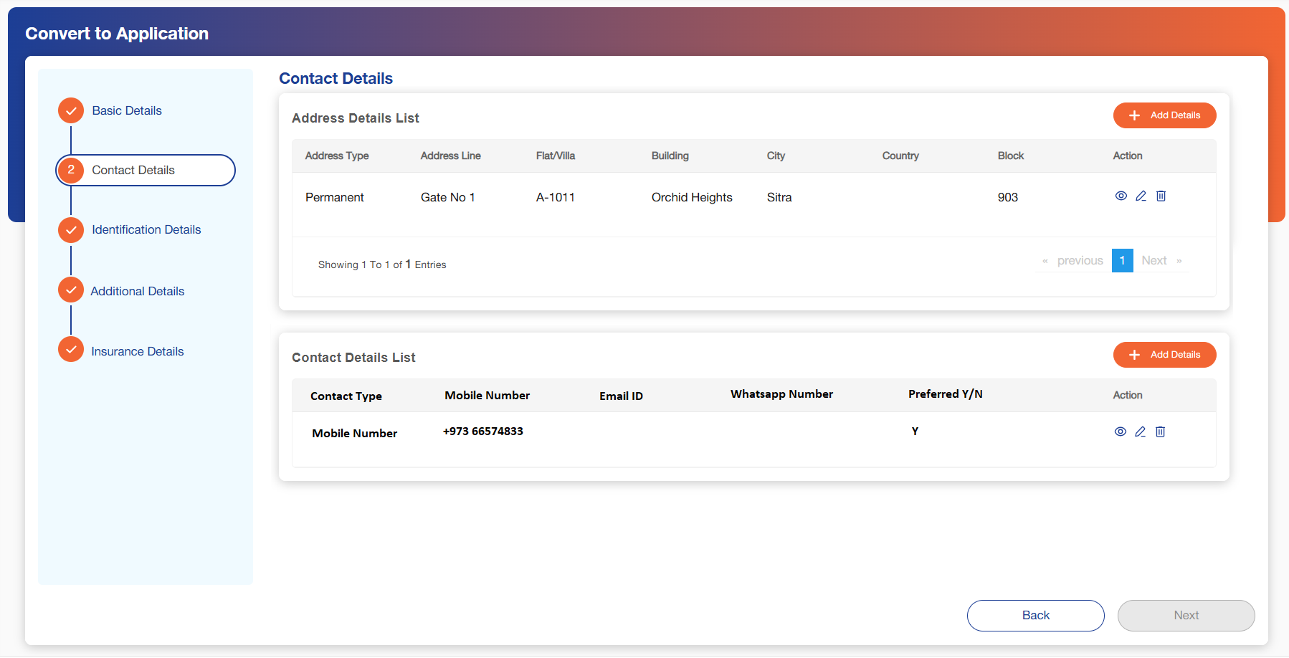

Below mentioned are the details specific to the information being displayed above:

Field Name | Field Type | Mandatory Y/N | Data Type / Length | Lookup Key / Master Name | Possible Values | Field Description
 |  |  |  |  |  | Remarks/ Validation
Address Details
Address Type | Read Only- List View | NA | NA | NA | NA | The system shall display the saved data under the 'Contact Details – Add Details' screen, allowing users to review and update previously entered information.  - This information can also be viewed in case the interface has been triggered.
Address Line | Read Only- List View | NA | NA | NA | NA | The system shall display the saved data under the 'Contact Details – Add Details' screen, allowing users to review and update previously entered information.  - This information can also be viewed in case the interface has been triggered.
Flat/Villa | Read Only- List View | NA | NA | NA | NA | The system shall display the saved data under the 'Contact Details – Add Details' screen, allowing users to review and update previously entered information.  - This information can also be viewed in case the interface has been triggered.
Building | Read Only- List View | NA | NA | NA | NA | The system shall display the saved data under the 'Contact Details – Add Details' screen, allowing users to review and update previously entered information.  - This information can also be viewed in case the interface has been triggered.
City | Read Only- List View | NA | NA | NA | NA | The system shall display the saved data under the 'Contact Details – Add Details' screen, allowing users to review and update previously entered information.  - This information can also be viewed in case the interface has been triggered.
Country | Read Only- List View | NA | NA | NA | NA | The system shall display the saved data under the 'Contact Details – Add Details' screen, allowing users to review and update previously entered information  - This information can also be viewed in case the interface has been triggered.
Block | Read Only- List View | NA | NA | NA | NA | The system shall display the saved data under the 'Contact Details – Add Details' screen, allowing users to review and update previously entered information.  - This information can also be viewed in case the interface has been triggered.
Contact Details
Contact Type | Dropdown | Y | VARCHAR / 10 | NA | 1.Mobile Number  2.Whatsapp  3.Email ID | Users can select the contact Type to be captured.
Mobile Number | Text Box | N | Numeric/ 8 | NA | NA | Thie field will be used to capture the the Mobile Number, if Contact Type selected as Mobile Number.  This field shall display the mobile number captured during lead creation as an initial entry. Users shall have the option to edit and update the mobile number if necessary
Email ID | Text Box | N | VARCHAR / 50 | NA | NA | Allows the user to add the email ID of the
WhatsApp Number | Text Box | N | Numeric/ 8 | NA | NA | Thie field will be used to capture the the Mobile Number, if Contact Type selected as WhatsApp.
Preferred (Y/N) | Dropdown | Y | VARCHAR / 10 | NA | 1.Yes  2.No | The user will select if this contact will be the preferred contact.  If the user tags this contact as Preferred, the system to set all other contacts of the same contact type as N.
Action Buttons
Add Details | Button | Y | Button | NA | NA | Allow users to capture contact details.
 | Button | Y | Button | NA | NA | Allow users to view saved record under contact details.
 | Button | Y | Button | NA | NA | Allow users to edit saved record under contact details.
 | Button | Y | Button | NA | NA | Allow users to delete saved record under contact details.
Back | Button | Y | Button | NA | NA | Allows the user to go back to the basic details screen.
Next | Button | Y | Button | NA | NA | Allows the user to go to the next screen.

Upon clicking the 'Add Details' button, a pop-up screen shall be displayed, allowing users to capture and enter address details.

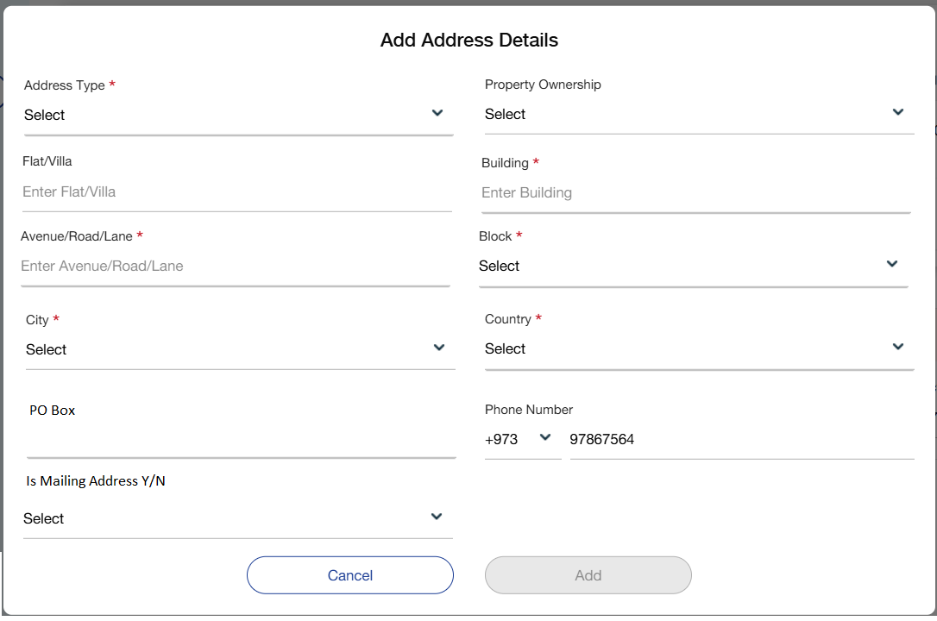

Below mentioned are the details specific to the information being displayed above

Field Name | Field Type | Mandatory Y/N | Data Type / Length | Lookup Key / Master Name | Possible Values | Field Description
 |  |  |  |  |  | Remarks/ Validation
Address Type | Dropdown | Y | VARCHAR / 20 | NA | - Office  - Permanent  - Residential  - Mailing | Allow users to select the address type.
Property Ownership | Dropdown | Y | VARCHAR / 20 | NA | 1. Owned  2.Council Tenant  3.Homeowner with Mortgage  4.Living with Parents | Users can select the property ownership details of the customer.
Flat/Villa | Field | Y | VARCHAR / 20 | NA | NA | Users can capture the flat/villa details of the customer.
Building | Field | N | VARCHAR / 20 | NA | NA | Users can capture the building details of the customer.
Avenue/Road/Lane | Field | Y | VARCHAR / 20 | NA | NA | Users can capture the avenue/road/lane details of the customer.
Country | Dropdown | Y | VARCHAR / 20 | NA | Bahrain | Users can select the country of the customer.
City | Dropdown | Y | VARCHAR / 20 | NA | 1.Manama  2.Sitra  3.Muharraq  4.Isa Town | Users can select the city.
Block | Dropdown | Y | VARCHAR / 20 | NA | 1.746  2.903  3.916  4.922  5.933 | Users can select the block.
PO Box | Text Box | N | Numeric/ 6 | NA | NA | Users can enter the PO Box number of the users.
Is Mailing Address | Dropdown | Y |  | NA | 1.Yes  2.No | The user will select if the address is mailing address of the customer. This can only be one address, if selected as Yes, all other addresses will be tagged as “No” on save.
Phone Number | Text Box | N | Numeric/ 8 | NA | NA | This field shall display the mobile number captured during lead creation. Users shall have the option to edit and update the mobile number if necessary
Action Buttons
Cancel | Button | Y | Button | NA | NA | Allows the user to go back to the contact details screen.
Add | Button | Y | Button | NA | NA | Allows the user to save the details.

- Note: For insurance related to NFH loans, address details should be fetched from the NFH database. Users should have the option to review and edit the fetched address information before final submission.

Upon clicking the 'Add Details' button, a pop-up screen shall be displayed, allowing users to capture and enter contact details.
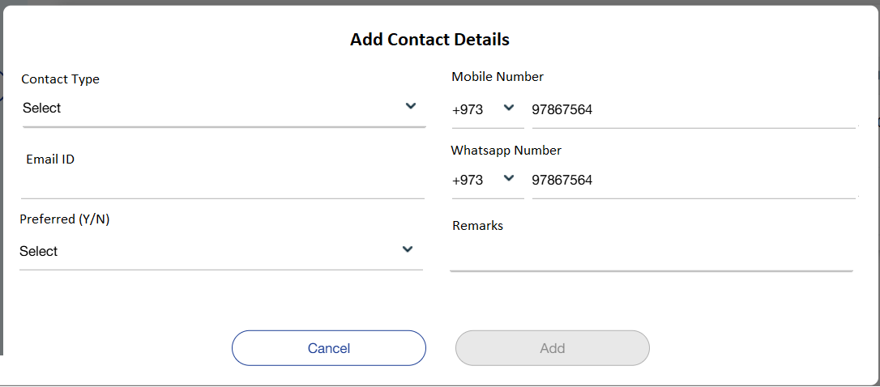

Below mentioned are the details specific to the information being displayed above

Field Name | Field Type | Mandatory Y/N | Data Type / Length | Lookup Key / Master Name | Possible Values | Field Description
 |  |  |  |  |  | Remarks/ Validation
Contact Type | Dropdown | Y | VARCHAR / 10 | NA | 1.Mobile Number  2.Whatsapp  - 3.Email ID | Users can select the contact Type to be captured.
Mobile Number | Text Box | N | Numeric/ 8 | NA | NA | Thie field will be used to capture the the Mobile Number, if Contact Type selected as Mobile Number.  This field shall display the mobile number captured during lead creation as an initial entry. Users shall have the option to edit and update the mobile number if necessary
Email ID | Text Box | N | VARCHAR / 50 | NA | NA | Allows the user to add the email ID of the
WhatsApp Number | Text Box | N | Numeric/ 8 | NA | NA | Thie field will be used to capture the the Mobile Number, if Contact Type selected as WhatsApp.
Preferred (Y/N) | Dropdown | Y | VARCHAR / 10 | NA | 1.Yes  2.No | The user will select if this contact will be the preferred contact.  If the user tags this contact as Preferred, the system to set all other contacts of the same contact type as N.
Action Buttons
Cancel | Button | Y | Button | NA | NA | Allows the user to go back to the contact details screen.
Add | Button | Y | Button | NA | NA | Allows the user to save the details.

Identification Details
This screen allows the user to capture identification details which contains of the Identification information, these details are fetched by triggering the benefit eKYC or Sijilat interface. These fields are also open for manual entry in case the user does not want to trigger the interface.

Following screen will be displayed once the user clicks on Next on contact details screen:

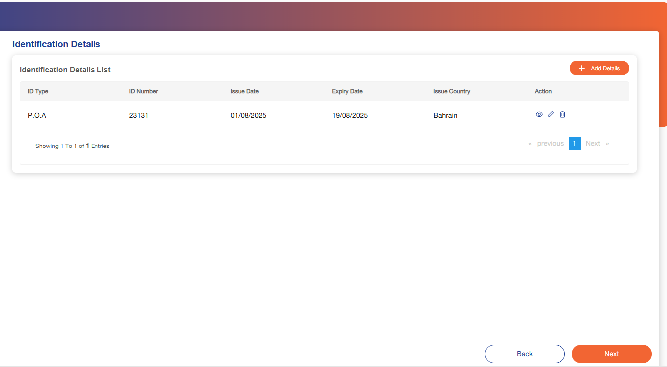

Below mentioned are the details specific to the information being displayed above

Field Name | Field Type | Mandatory Y/N | Data Type / Length | Lookup Key / Master Name | Possible Values | Field Description
 |  |  |  |  |  | Remarks/ Validation
ID Type | Read-Only- List View | NA | NA | NA | NA | Displays the ID type of the customer captured during lead creation.
ID Number | Read-Only- List View | NA | NA | NA | NA | Displays the ID type of the customer captured during lead creation.
Issue Date | Read-Only- List View | NA | NA | NA | NA | Displays the issue date of the ID Captured for the ID.  - Fetched using interface.
Expiry Date | Read-Only- List View | NA | NA | NA | NA | Displays the issue date of the ID Captured for the ID.  - Fetched using interface.
Issue Country | Read-Only- List View | NA | NA | NA | NA | Displays the issue date of the ID Captured for the ID.  - Fetched using interface.
Action Buttons
Add Details | Button | Y | Button | NA | NA | Allow users to capture contact details.
 | Button | Y | Button | NA | NA | Allow users to view saved record under contact details.
 | Button | Y | Button | NA | NA | Allow users to edit saved record under contact details.
 | Button | Y | Button | NA | NA | Allow users to delete saved record under contact details.
Back | Button | Y | Button | NA | NA | Allows the user to go back to the basic details screen.
Next | Button | Y | Button | NA | NA | Allows the user to go to the next screen.

When users click on “Add details”, below screen will pop-up:

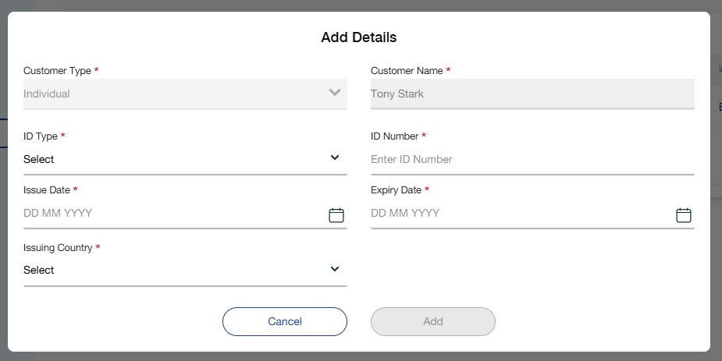

Below mentioned are the details specific to the information being displayed above

Field Name | Field Type | Mandatory Y/N | Data Type / Length | Lookup Key / Master Name | Possible Values | Field Description
 |  |  |  |  |  | Remarks/ Validation
Customer Type | Read-only | NA | NA | NA | NA | Displays the type of the customer saved during lead creation.
Customer Name | Read-only | NA | NA | NA | NA | Displays the type of the customer saved during lead creation.
ID Type | Dropdown | Y | VARCHAR / 20 | NA | 1.CR  2.CPR | Users can select the ID type.  -The ID type and ID Number entered during lead creation will be displayed here.
ID Number | Field | Y | VARCHAR / 20 | NA | NA | Users can capture the ID number.
Issue Date | Date | Y | Calendar | NA | NA | Users can capture the issue date of the ID.
Expiry Date | Date | Y | Calendar | NA | NA | Users can capture the expiry date of the ID.
Issue Country | Read-Only- List View | NA | NA | NA | NA | Displays the issue date of the ID Captured for the ID.  - Fetched using interface.
Action Buttons
Add Details | Button | Y | Button | NA | NA | Allow users to capture contact details.
 | Button | Y | Button | NA | NA | Allow users to view saved record under contact details.
 | Button | Y | Button | NA | NA | Allow users to edit saved record under contact details.
 | Button | Y | Button | NA | NA | Allow users to delete saved record under contact details.
Back | Button | Y | Button | NA | NA | Allows the user to go back to the basic details screen.
Next | Button | Y | Button | NA | NA | Allows the user to go to the next screen.

- Note: The 'Identification Details' screen shall be displayed only for individual customers. For corporate customers, this screen will not be shown. Upon capturing the contact details, corporate customer flows shall proceed directly to the 'Insurance Details' screen.

Additional Details
Based on the insurance type or package selected, the system automatically generates the corresponding entries in the details grid. The user must then provide the required information in the relevant fields to complete the insurance application. This ensures that all necessary details, including coverage specifics and applicable rates, are accurately captured for the next stage.

When the user clicks Edit on a specific entry in the grid, the system opens the corresponding detail screen based on the selected insurance type. The user is then required to input all applicable information for each insurance type listed in the grid before proceeding. Once completed, the application can move to the next stage, where insurance premium details are calculated and captured.

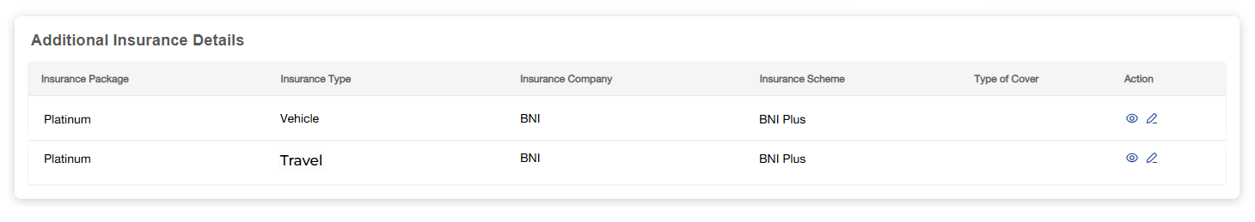

Vehicle Details
This screen allows the user to capture all the vehicle details if asset/vehicle insurance was selected in the insurance type.

Following screen will be displayed once the user clicks on Next:

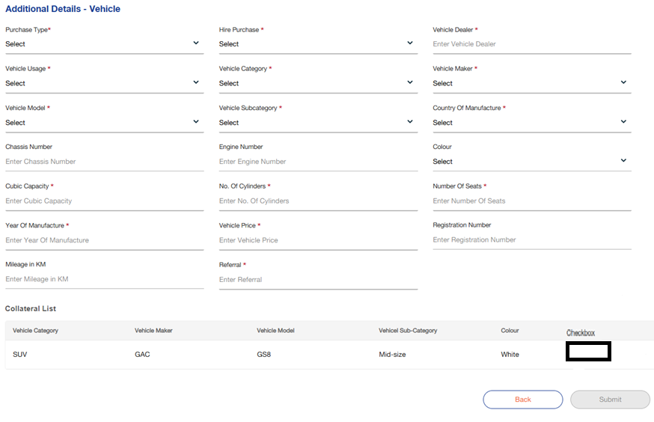

Below mentioned are the details specific to the information being displayed above:

Field Name | Field Type | Mandatory Y/N | Data Type / Length | Lookup Key / Master Name | Possible Values | Field Description
 |  |  |  |  |  | Remarks/ Validation
Purchase Type | Dropdown | Y | VARCHAR / 03 |  | 1.New  2.Used | User can select the purchase type.
Hire Purchase | LOV Drop Down | Y | VARCHAR / 03 |  | - Yes  - No | The user selects if it’s a hire purchase
Vehicle Dealer | Drop Down | Y | VARCHAR / 20 | NA | NA | The user can select the vehicle dealer.
Vehicle Usage | Drop Down | Y | VARCHAR / 03 |  | 1. Private  2. Commercial  3. Sports | The user can select the vehicle usage.
Vehicle Category | Drop Down | Y | VARCHAR / 03 |  | 1. Motor  2. Electric | The users can select the vehicle category.
Vehicle Maker | Drop Down | Y | VARCHAR / 10 | NA | Toyota | The user can select the vehicle maker
Vehicle Model | Drop Down | Y | NVARCHAR / 20 | NA | Corolla | The user adds the vehicle model  - Vehicle model is depended upon the maker selected
Vehicle Subcategory | Drop Down | Y | NVARCHAR / 10 | NA | - SUV  Sedan | The user selects the vehicle subcategory  - Vehicle subcategory is depended upon the model selected
Country of Manufacture | Drop Down | Y | VARCHAR / 10 | Country Master | NA | The user selects the country of manufacture  - Country of manufacture is depended upon the maker selected
Chassis Number | Numeric | N | INT / 10 | NA | NA | The user can capture the chassis number
Engine Number | Numeric | N | INT / 10 | NA | NA | The user can capture the engine number
Colour | Text Box | N | VARCHAR / 20 | NA | NA | The user captures the colour of vehicle
Cubic Capacity | Text Box | Y | NVARCHAR / 10 | NA | NA | The user can capture the cubic capacity of the engine.
No. of Cylinders | Text Box | Y | NVARCHAR / 10 | NA | NA | The user adds the number of cylinders in the vehicle.
Number of Seats | Numeric | Y | INT / 10 | NA | NA | The user captures the number of seats in a vehicle.
Year of Manufacture | Numeric | Y | INT / 04 | NA | NA | The user adds the year of manufacture of the vehicle.
Vehicle Price | Numeric | Y | FLOAT / 20 | NA | NA | The user enters the value of the asset which is sum insured.  - This price will be inclusive of VAT
Registration Number | Text Box | N | INT / 10 | NA | NA | This filed will be editable in case of used asset.
Mileage in KM | Text Box | N | INT / 02 | NA | NA | The user captures the mileage of the vehicle in kilometres.  - Will be editable in case of used asset
Referral | Text Box | N | NVARCHAR / 10 | NA | NA | Users can add the referral if any.
Collateral List
Vehicle Category | Read Only | NA | NA | NA | NA | Displays the vehicle category based on selected loan account number and customer ID.
Vehicle Maker | Read Only | NA | NA | NA | NA | Displays the vehicle category based on selected loan account number and customer ID.
Vehicle Model | Read Only | NA | NA | NA | NA | Displays the vehicle category based on selected loan account number and customer ID.
Vehicle Subcategory | Read Only | NA | NA | NA | NA | Displays the vehicle category based on selected loan account number and customer ID.
Colour | Read Only | NA | NA | NA | NA | Displays the vehicle category based on selected loan account number and customer ID.
Checkbox | Checkbox | NA | Button | NA | NA | Users should be able to select the vehicle for which the insurance is to be issued. Upon selection (via checkbox), the corresponding vehicle details should automatically populate under the "Additional Details - Vehicle" section.
Action Buttons
Back | Button | Y | Button | NA | NA | Allows the user to go back to the insurance detail screen.
Submit | Button | Y | Button | NA | NA | Allow user to submit the application.

- Note: If Loan Number is selected under Basic Details, the system should display a checkbox list of associated vehicles/collateral for the user to select. Upon selection, the corresponding vehicle/collateral details should automatically populate in the Vehicle Details section.

Medical Equipment

This screen allows the user to capture all the equipment details if medical equipment insurance was selected in the insurance type.

Following screen will be displayed once the user clicks on Next:

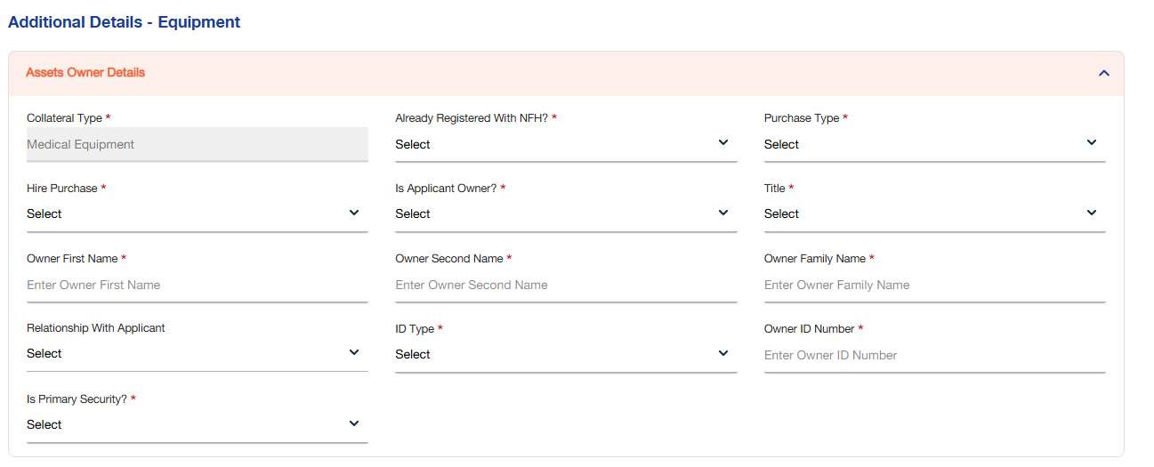
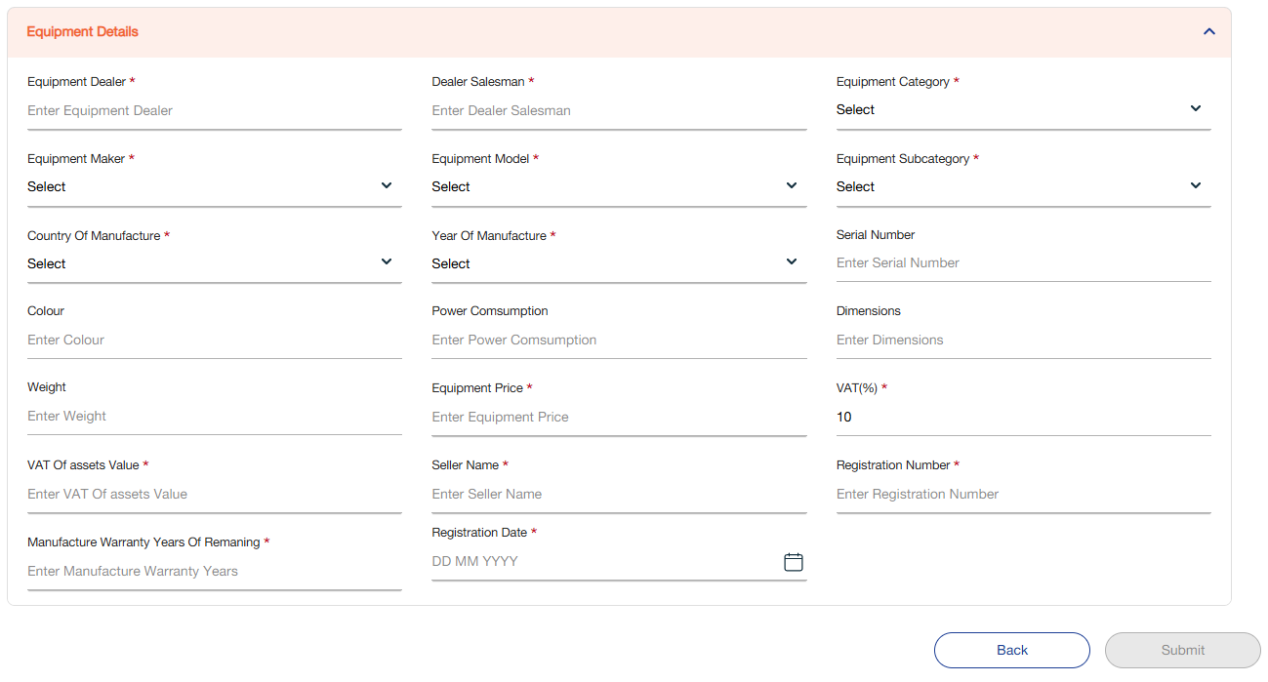

Below mentioned are the details specific to the information being displayed above:

Field Name | Field Type | Mandatory Y/N | Data Type / Length | Lookup Key / Master Name | Possible Values | Field Description
 |  |  |  |  |  | Remarks/ Validation
Asset Owner Details
Collateral Type | Read-Only | NA | VARCHAR / 25 | Collateral Config master | Medical Equipment | Auto fetched as per the product selected
Already Registered With NFH? | Drop Down | Y | VARCHAR / 03 |  | - Yes  - No | User can select of the collateral is already registered with NFH.
Purchase Type | LOV Drop Down | Y | VARCHAR / 10 |  | - New  - Existing | The user can capture the purchase type.
Hire Purchase | LOV Drop Down | Y | VARCHAR / 03 |  | - Yes  - No | The user selects if it’s a hire purchase
Is Applicant Owner? | LOV Drop Down | Y | VARCHAR / 03 | NA | - Yes  - No | If HP selected as NO, user will select if applicant is owner or not  If HP selected as yes above, this field will be unediatble and the owner name will be National Finance House by default.
Title | LOV Drop Down | Y | VARCHAR / 10 | NA | - Mr.  - Mrs. | If selected “Is Applicant Owner” as No, then the user will capture the owner details.
Owner First Name | Text Box | Y | VARCHAR / 20 | NA | NA | If selected “Is Applicant Owner” as No, then the user will capture the owner details.
Relationship With Applicant | Drop Down | N | VARCHAR / 05 | RELWITHAPPL | - Self  - Parent | If selected “Is Applicant Owner” as No, then the user will capture the owner details.
ID Type | Drop Down | Y | NVARCHAR / 10 | NA | NA | If selected “Is Applicant Owner” as No, then the user will capture the owner details.
Owner ID Number | LOV Drop Down | Y | DATETIME | NA | NA | If selected “Is Applicant Owner” as No, then the user will capture the owner details.
Is Primary Security? | LOV Drop Down | Y | VARCHAR / 10 | NA | - Primary  - Secondary | The user selects if it is a primary security.
Equipment Details
Equipment Dealer | Dropdown | Y | VARCHAR / 20 | NA | NA | The user can capture the equipment dealer.
Dealer Salesman | Text Box | Y | VARCHAR / 20 | NA | NA | Users can capture the dealer salesman.
Equipment Category | Drop Down | Y | VARCHAR / 10 | NA | 1.Inverter  2.Battery Storage | Users can select the equipment category.
Equipment Maker | LOV Drop Down | Y | VARCHAR / 10 | NA |  | Users can select the equipment maker
Equipment Model | LOV Drop Down | Y | NVARCHAR / 20 | NA |  | User can add the equipment model  - Equipment model is depended upon the maker selected
Equipment Subcategory | LOV Drop Down | Y | NVARCHAR / 10 | NA |  | User selects the equipment subcategory  - Equipment subcategory is depended upon the model selected
Country of Manufacture | LOV Drop Down | Y | VARCHAR / 10 | Country Master | NA | User selects the country of manufacture  - Country of manufacture is depended upon the maker selected
Year of Manufacture | Numeric | Y | INT / 10 | NA | NA | User can add the year of manufacture of the equipment
Serial Number | Numeric | N | INT / 10 | NA | NA | Users can add the serial number.
Colour | Text Box | N | VARCHAR / 20 | NA | NA | Users can capture the colour of equipment.
Power Consumption | Numeric | N | INT / 04 | NA | NA | Users can capture the power consumption of the equipment.
Dimensions | Numeric | N | FLOAT / 10 | NA | NA | Users can capture the dimensions of the equipment.
Weight | Numeric | N | FLOAT / 10 | NA | NA | Users can capture the weight of the equipment.
Equipment Price | Numeric | Y | FLOAT / 20 | NA | NA | Users can capture the value of the equipment which is the sum insured.
VAT (%) | Numeric | Y | FLOAT / 04 | NA | NA | The default VAT rate will be set at 10% of the asset value also it allows the user to select.
VAT of Asset Value | Numeric | Y | FLOAT / 20 | NA | NA | To be auto populated based on the VAT (%)  % consideration from the asset price based on the VAT (%) selected.
Seller Name | Text Box | Y | VARCHAR / 20 | NA | NA | Will be editable in case of used asset
Registration Number | Text Box | Y | INT / 10 | NA | NA | Will be editable in case of used asset
Manufacture Warranty Years Remaining | Text Box | Y | INT / 02 | NA | NA | Will be editable in case of used asset
Registration Date | Calendar | Y | DATETIME | NA | NA | Will be editable in case of used asset
Action Buttons
Back | Button | Y | Button | NA | NA | Allows the user to go back to the insurance detail screen.
Submit | Button | Y | Button | NA | NA | Allow user to submit the application.

Solar Equipment
This screen allows the user to capture all the equipment details if solar equipment insurance was selected in the insurance type.

Following screen will be displayed once the user clicks on Next:

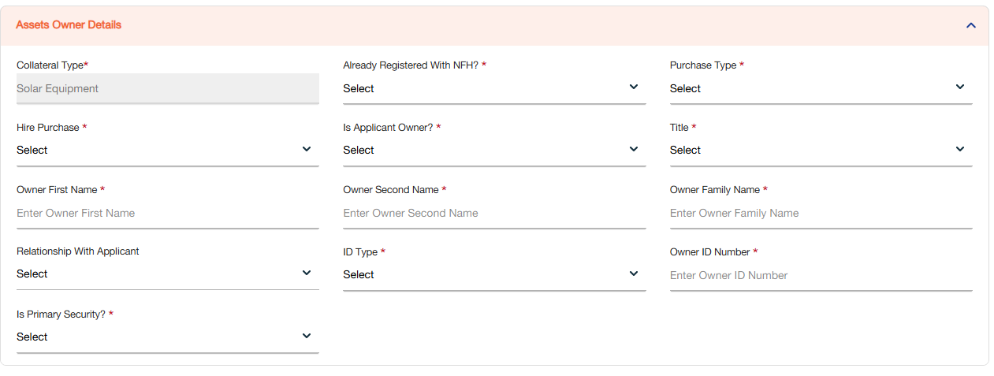
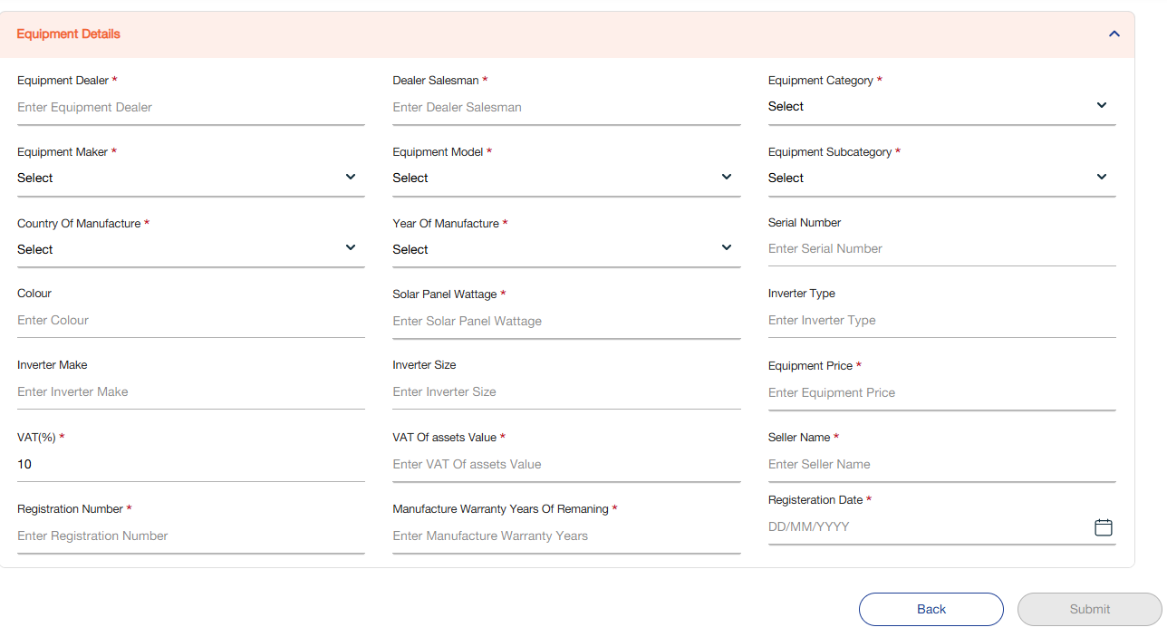

Below mentioned are the details specific to the information being displayed above:

Field Name | Field Type | Mandatory Y/N | Data Type / Length | Lookup Key / Master Name | Possible Values | Field Description
 |  |  |  |  |  | Remarks/ Validation
Asset Owner Details
Collateral Type | Read-Only | NA | VARCHAR / 25 | Collateral Config master | Solar Equipment | Auto fetched as per the product selected
Already Registered With NFH? | Drop Down | Y | VARCHAR / 03 |  | 1. Yes  2. No | User can select of the collateral is already registered with NFH.
Purchase Type | LOV Drop Down | Y | VARCHAR / 10 |  | 1. New  2. Existing | The user can capture the purchase type.
Hire Purchase | LOV Drop Down | Y | VARCHAR / 03 |  | 1. Yes  2. No | The user selects if it’s a hire purchase
Is Applicant Owner? | LOV Drop Down | Y | VARCHAR / 03 | NA | 1. Yes  2. No | If HP selected as NO, user will select if applicant is owner or not  If HP selected as yes above, this field will be unediatble and the owner name will be National Finance House by default.
Title | LOV Drop Down | Y | VARCHAR / 10 | NA | 1. Mr.  2. Mrs. | If selected “Is Applicant Owner” as No, then the user will capture the owner details.
Owner First Name | Text Box | Y | VARCHAR / 20 | NA | NA | If selected “Is Applicant Owner” as No, then the user will capture the owner details.
Owner Second Name | Text Box | Y | VARCHAR / 20 | NA | NA | If selected “Is Applicant Owner” as No, then the user will capture the owner details.
Owner Third Name | Text Box | Y | VARCHAR / 20 | NA | NA | If selected “Is Applicant Owner” as No, then the user will capture the owner details.
Relationship With Applicant | Drop Down | N | VARCHAR / 05 | RELWITHAPPL | - Self  - Parent | If selected “Is Applicant Owner” as No, then the user will capture the owner details.
ID Type | Drop Down | Y | NVARCHAR / 10 | NA | NA | If selected “Is Applicant Owner” as No, then the user will capture the owner details.
Owner ID Number | LOV Drop Down | Y | DATETIME | NA | NA | If selected “Is Applicant Owner” as No, then the user will capture the owner details.
Is Primary Security? | LOV Drop Down | Y | VARCHAR / 10 | NA | - Primary  - Secondary | The user selects if it is a primary security.
Equipment Details
Equipment Dealer | Dropdown | Y | VARCHAR / 20 | NA | NA | The user can capture the equipment dealer.
Dealer Salesman | Text Box | Y | VARCHAR / 20 | NA | NA | Users can capture the dealer salesman.
Equipment Category | Drop Down | Y | VARCHAR / 10 | NA | 1.Inverter  2.Battery Storage | Users can select the equipment category.
Equipment Maker | LOV Drop Down | Y | VARCHAR / 10 | NA |  | Users can select the equipment maker
Equipment Model | LOV Drop Down | Y | NVARCHAR / 20 | NA |  | User can add the equipment model  - Equipment model is depended upon the maker selected
Equipment Subcategory | LOV Drop Down | Y | NVARCHAR / 10 | NA |  | User selects the equipment subcategory  - Equipment subcategory is depended upon the model selected
Country of Manufacture | LOV Drop Down | Y | VARCHAR / 10 | Country Master | NA | User selects the country of manufacture  - Country of manufacture is depended upon the maker selected
Year of Manufacture | Numeric | Y | INT / 10 | NA | NA | User can add the year of manufacture of the equipment
Serial Number | Numeric | N | INT / 10 | NA | NA | Users can add the serial number.
Colour | Text Box | N | VARCHAR / 20 | NA | NA | Users can capture the colour of equipment.
Solar Panel Wattage | Numeric | Y | INT / | NA | NA | Users can capture the solar panel wattage
Inverter Type | Text Box | N | VARCHAR / 20 | NA | NA | Users can capture the inverter type
Inverter Make | Text Box | N | NVARCHAR / 20 | NA | NA | Users can capture the inverter make
Inverter Size | Numeric | N | FLOAT / 10 | NA | NA | Users can capture the inverter size
Equipment Price | Numeric | Y | FLOAT / 20 | NA | NA | Users can capture the value of the equipment which is the sum insured
VAT (%) | Numeric | Y | FLOAT / 04 | NA | NA | The default VAT rate will be set at 10% of the asset value also it allows the user to select.
VAT of Asset Value | Numeric | Y | FLOAT / 20 | NA | NA | To be auto populated based on the VAT (%)  % consideration from the asset price based on the VAT (%) selected.
Seller Name | Text Box | Y | VARCHAR / 20 | NA | NA | Will be editable in case of used asset
Registration Number | Text Box | Y | INT / 10 | NA | NA | Will be editable in case of used asset
Manufacture Warranty Years Remaining | Text Box | Y | INT / 02 | NA | NA | Will be editable in case of used asset
Registration Date | Calendar | Y | DATETIME | NA | NA | Will be editable in case of used asset
Action Buttons
Back | Button | Y | Button | NA | NA | Allows the user to go back to the insurance detail screen.
Submit | Button | Y | Button | NA | NA | Allow user to submit the application.

Travel Details
This screen allows the user to capture all the travel details if travel insurance was selected in the insurance type.

Following screen will be displayed once the user clicks on Next:

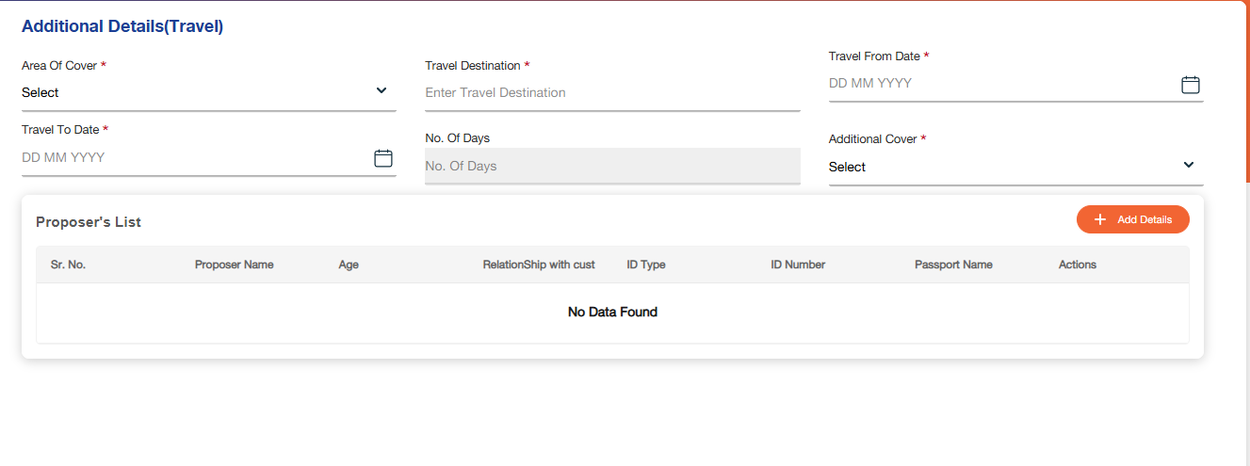

Once the user clicks on “Add Details” under Proposer’s list, below screen will be displayed to capture the information:
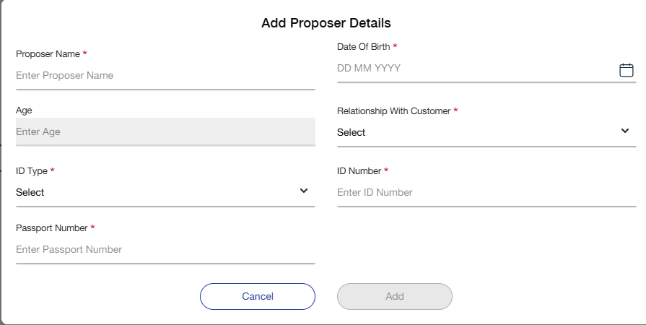

Below mentioned are the details specific to the information being displayed above:

Field Name | Field Type | Mandatory Y/N | Data Type / Length | Lookup Key / Master Name | Possible Values | Field Description
 |  |  |  |  |  | Remarks/ Validation
Travel Details
Area of Cover | Drop Down | Y | VARCHAR / 10 |  | - Worldwide  - Worldwide Excluding USA and Canada, Schengen  - Middle East | Users can select the area for which the customer required cover.
Travel Destination | Text Box | Y | VARCHAR / 10 | NA | NA | The users can capture the travel destination.
Travel From Date | Date | Y | Calendar | NA | NA | The users can capture the travel from date.
Travel To Date | Date | Y | Calendar | NA | NA | The users can select the “travel to” date.
No. of Days | Read Only | NA | INT / 02 | NA | NA | System will generate based on “travel from” and “travel to” date  - Auto populated by the system
Additional Cover | Drop Down | Y | VARCHAR / 20 |  | - Winter Sports  - Hazardous Activities | The user can select the additional cover.
Details of Proposers
Proposer’s Name | Text Box | Y | VARCHAR / 20 | NA | NA | The users can capture the proposer’s name.  - The entry for self to be auto populated from the basic details screen
Date of Birth | Calendar | Y | DATETIME | NA | NA | The users can capture the proposer’s date of birth.  - The entry for self to be auto populated from the basic details screen
Age | Read Only | NA | INT / 02 | NA | NA | System computes depending on date of birth and current date  - The entry for self to be auto populated from the basic details screen
Relationship with Customer | LOV Drop Down | Y | VARCHAR / 20 |  | - Mother  - Father  - Sister  - Brother  - Self | The users can capture the relationship of proposer with the customer  - The entry for self to be auto populated from the basic details screen
ID Type | LOV Drop Down | Y | VARCHAR / 15 |  | - CPR  - Driving License | The users can capture the ID type  - The entry for self to be auto populated from the basic details screen
ID Number | Text Box | Y | NVARCHAR / 15 | NA | NA | The users can capture the ID number of the proposer  - The entry for self to be auto populated from the basic details screen
Passport Number | Text Box | Y | NVARCHAR / 10 | NA | NA | The users can capture the passport number of the proposer  - The entry for self to be auto populated from the basic details screen
List View
Sr. No. | Read Only | NA | INT | NA | NA | Auto populated by the system based on details saved under proposer’s list.
Proposer’s Name | Read Only | NA | VARCHAR | NA | NA | Auto populated by the system based on details saved under proposer’s list.
Age | Read Only | NA | INT | NA | NA | Auto populated by the system based on details saved under proposer’s list.
Relationship with Customer | Read Only | NA | VARCHAR | NA | NA | Auto populated by the system based on details saved under proposer’s list.
ID Type | Read Only | NA | VARCHAR | NA | NA | Auto populated by the system based on details saved under proposer’s list.
ID Number | Read Only | NA | NVARCHAR | NA | NA | Auto populated by the system based on details saved under proposer’s list.
Passport Number | Read Only | NA | NVARCHAR | NA | NA | Auto populated by the system based on details saved under proposer’s list.
Action Buttons
Add | Button | Y | Button | NA | NA | Allows the user to add proposer’s details.
Cancel | Button | Y | Button | NA | NA | Allows the user to cancel and move back to additional details screen.
Back | Button | Y | Button | NA | NA | Allows the user to go back to the insurance detail screen.
Submit | Button | Y | Button | NA | NA | Allow user to submit the application.
 | Button | Y | Button | NA | NA | Allow users to view saved record under proposers list.
 | Button | Y | Button | NA | NA | Allow users to edit saved record under proposers list.
 | Button | Y | Button | NA | NA | Allow users to delete saved record under proposers list.

House Details
This screen allows the user to capture all the house details if home insurance was selected in the insurance type.

Following screen will be displayed once the user clicks on Next:

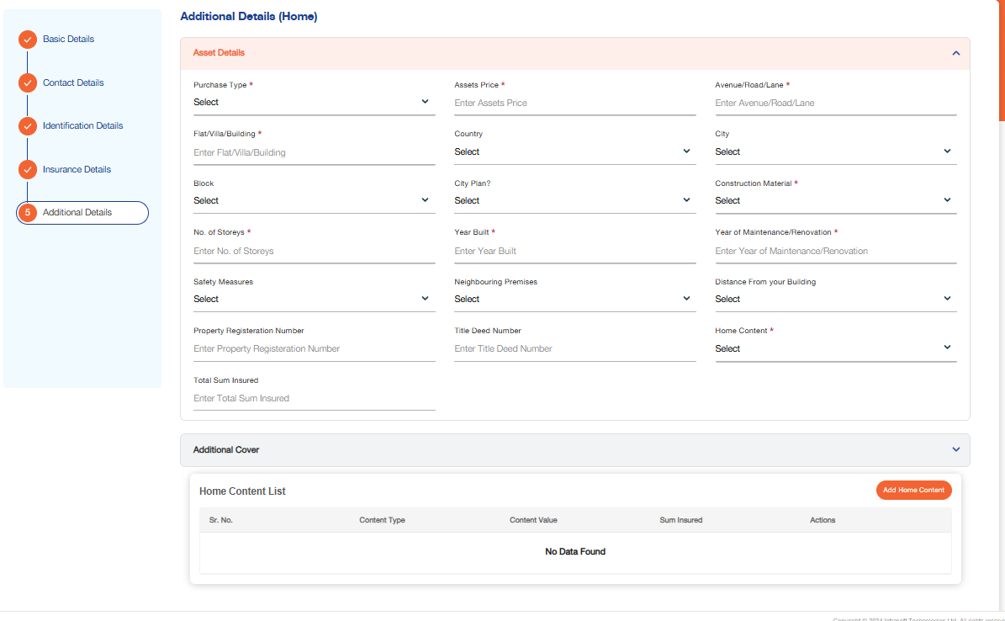

Once the user clicks on “Add Home Content” under additional cover list, below screen will be displayed to capture the information:

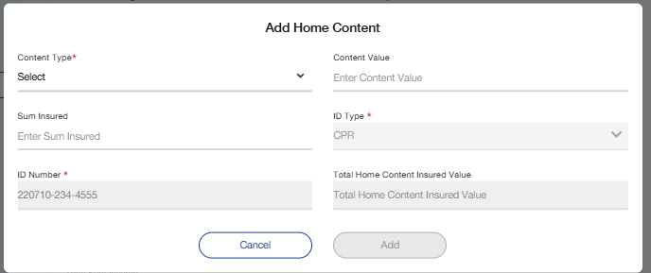

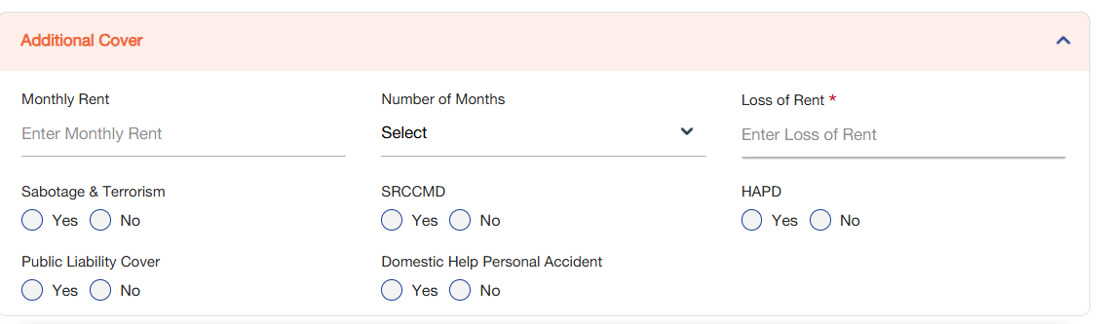

Below mentioned are the details specific to the information being displayed above

Field Name | Field Type | Mandatory Y/N | Data Type / Length | Lookup Key / Master Name | Possible Values | Field Description
 |  |  |  |  |  | Remarks/ Validation
Asset Details
Purchase Type | Drop Down | Y | VARCHAR / 20 | NA | 1.New  2.Used | Users can select the purchase type.
Asset Price | Field | Y | VARCHAR / 20 | NA | NA | Users can enter the price of the asset.
Avenue/Road/Lane | Field | Y | VARCHAR / 20 | NA | NA | Users can enter the avenue/road/lane address details of the home for which the customer is purchasing the insurance.
Flay/Villa/Building | Field | Y | VARCHAR / 20 | NA | - NA | Users can enter the Flay/Villa/Building address details of the home for which the customer is purchasing the insurance.
Country | Drop Down | Y | VARCHAR / 20 | NA | NA | Users can select the county for the address.
City | Drop Down | Y | VARCHAR / 20 | NA | NA | Users can select the city for the address.
Block | Drop Down | Y | VARCHAR / 20 | NA | NA | Users can select the block for the address.
City Plan | Drop Down | Y | VARCHAR / 20 | NA | 1.Yes  2.No | The user selects if the property is part of city plan
Construction Material | Drop Down | Y | VARCHAR / 20 |  | - Blocks and Mortar  - Wood  - Steel | The user selects the construction material of the property
No. of Storeys | Numeric | Y | INT / 02 | NA | NA | The users can capture the number of storeys in the property
Year Built | Numeric | Y | INT / 04 | NA | NA | The users can capture the year of construction
Year of Maintenance/  Renovation | Numeric | Y | INT / 04 | NA | NA | The users can capture the year of maintenance or renovation
Safety Measures | Multi-select LOV Drop Down | N | VARCHAR / 15 | NA | - Fire Extinguisher  - Smoke Detectors  - Security System  - Safe  - Fire Blanket | The users can capture the available safety measures at the property.
Neighbouring Premises | LOV Drop Down | N | VARCHAR / 25 |  | - Private Residential Buildings  - Commercial Buildings & Shops | The users can capture the neighbouring premises of the property
Distance from your Building | LOV Drop Down | N | VARCHAR / 10 |  | - Adjacent  - Separated | The users can capture the distance of the neighbouring premises from the property
Property Registration Number | Numeric | N | INT / 10 | NA | NA | The users can capture the property registration number  - Will be mandatory in case of mortgage loan
Title Deed Number | Text Box | N | NVARCHAR / 20 |  |  | The users can capture the title deed number  - Will be mandatory in case of mortgage loan
Home Content | Drop Down | Y | VARCHAR / 20 | NA | 1.Yes  2.No | The users can capture if home content is insured  - If this field is “yes” then the below fields (Home Content) will be enabled  - If the user selects “no” then the below fields and grid would be disabled
Total Sum Insured | Numeric | N | FLOAT / 20 | NA | NA | System generates as total of asset price, total home content insured value and loss of rent  - Total Sum Insured = Asset Price + Total Home Content Insured Value + Loss of Rent
Home Content
Content Type | Drop Down | N | VARCHAR / 15 |  | - Furniture  - Household Items  - Personal Effects  - Jewellery  - Watches | The users can capture the content type to be insured.
Content Value | Numeric | N | FLOAT / 20 | NA | NA | The users can capture the value of the selected content
Sum Insured | Numeric | N | FLOAT / 20 | NA | NA | The users can capture the sum insured of the selected content
ID Type | Read-Only | NA | NA | NA | NA | Displays the ID type captured during lead creation.
ID Number | Read-Only | NA | NA | NA | NA | Displays the ID number captured during lead creation.
Total Home Content Insured Value | Read Only | NA | FLOAT / 25 | NA | NA | System will generate the total home content insured value based on the values in the grid below  - This field is the total of the Sum Insured column in the grid
List View
Sr. No. | Read Only | NA | INT | NA | NA | Displays the data filled under home content.
Content Type | Read Only | NA | VARCHAR | NA | NA | Displays the data filled under home content.
Content Value | Read Only | NA | INT | NA | NA | Displays the data filled under home content.
Sum Insured | Read Only | NA | FLOAT | NA | NA | Displays the data filled under home content.
Additional Cover
Monthly Rent | Numeric | N | FLOAT / 10 | NA | NA | The users can capture the monthly rent for loss of rent.
Number of Months | Drop Down | N | NVARCHAR / 10 |  | - 1 Month  - 2 Months  - 3 Months  - 4 Months  - 5 Months  - 6 Months  - 7 Months  - 8 Months  - 9 Months  - 10 Months  - 11 Months  - 12 Months | The users can capture the number of months for loss of rent.
Loss of Rent | Numeric | N | FLOAT / 20 | NA | NA | System computes based on monthly rent and number of months  - Loss of Rent = Monthly Rent x Number of Months
Sabotage & Terrorism | Radio Button | N | Radio Button | NA | NA | The users can capture if Sabotage & Terrorism (S&T) is covered
SRCCMD | Radio Button | N | Radio Button | NA | NA | The users can capture if SRCCMD (Strike, Riot, Civil Commotion, Malicious Damage) is covered
HAPD | Radio Button | N | Radio Button | NA | NA | The users can capture if HAPD (Home Assistance & Vehicle Pickup and Delivery) is covered
Public Liability Cover | Radio Button | N | Radio Button | NA | NA | The users can capture if public liability is covered
Domestic Help Personal Accident Cover | Radio Button | N | Radio Button | NA | NA | The users can capture if domestic help personal accident is covered
Action Buttons
Add | Button | Y | Button | NA | NA | Allows the user to add proposer’s details.
Cancel | Button | Y | Button | NA | NA | Allows the user to cancel and move back to additional details screen.
Back | Button | Y | Button | NA | NA | Allows the user to go back to the insurance detail screen.
Submit | Button | Y | Button | NA | NA | Allow user to submit the application.
 | Button | Y | Button | NA | NA | Allow users to view saved record under home content.
 | Button | Y | Button | NA | NA | Allow users to edit saved record under home content.
 | Button | Y | Button | NA | NA | Allow users to delete saved record under home content.

Health Insurance
This screen allows the user to capture all the health details if health insurance was selected in the insurance type.

Following screen will be displayed once the user clicks on Next:

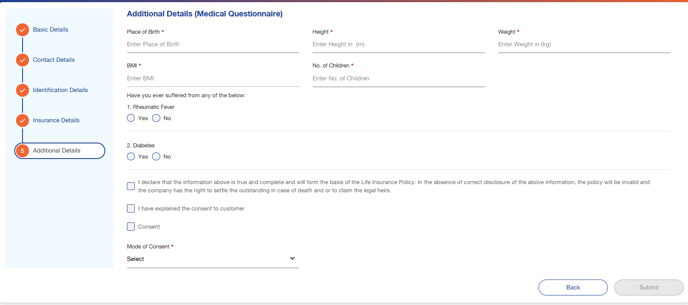

Below mentioned are the details specific to the information being displayed above:

Field Name | Field Type | Mandatory Y/N | Data Type / Length | Lookup Key / Master Name | Possible Values | Field Description
 |  |  |  |  |  | Remarks/ Validation
Place of Birth | Text Box | Y | VARCHAR / 10 | NA | NA | Users can capture the customer’s place of birth.  - The place of birth will be auto populated in case the data was fetched via the Ekyc interface.
Height | Numeric | Y | NVARCHAR / 15 | NA | NA | Users can capture the customer’s height.  - Height must be captured in meters.
Weight | Numeric | Y | NVARCHAR / 15 | NA | NA | Users can capture the customer’s weight.  - Weight must be captured in kilograms.
BMI | Numeric | Y | NVARCHAR / 2 | NA | NA | System will calculate depending on the height and weight of the customer  - BMI to be computed as weight in kilograms divided by height in meters squared
No. of Children | Numeric | Y | FLOAT / 10 | NA | NA | The system will allow users to capture the number of children associated with the customer.
Health related questions: | Radio Button | NA | VARCHAR / 03 |  | NA | Users can select if the customer has any health issue in yes/no format  - If any of these questions are answered as yes, then the user will be required to upload reports of the same in the document checklist screen.  - Medical Questionnaire is listed in Table 1.
Declaration | Checkbox | NA | Checkbox | NA | NA | User will capture customer’s declaration
Consent | Checkbox | NA | Checkbox | NA | NA | User explains the consent to the customer and captures it
Mode of Consent | LOV Drop Down | Y | VARCHAR / 20 | NA | NA | Users can select the mode of customer’s consent.
Action Buttons
Back | Button | Y | Button | NA | NA | Allows the user to go back to the insurance detail screen.
Submit | Button | Y | Button | NA | NA | Allow user to submit the application.

- Medical Questionnaire Should have below questions:

Table 1:Medical Questionnaire

Sr. No | Questions | Field Type | Possible Values
1 | Have you ever suffered from any of the below: | Dropdown | 1.Yes 2. No
2 | Rheumatic Fever | Dropdown | 1.Yes 2. No
3 | Cardiovascular Diseases | Dropdown | 1.Yes 2. No
4 | Select | Dropdown | 1.Yes 2. No
5 | High Blood Pressure | Dropdown | 1.Yes 2. No
6 | Diabetes | Dropdown | 1.Yes 2. No
7 | Rheumatoid Arthritis | Dropdown | 1.Yes 2. No
8 | Hepatitis | Dropdown | 1.Yes 2. No
9 | Tumours or Cancer | Dropdown | 1.Yes 2. No
10 | Sickle Cell Anaemia | Dropdown | 1.Yes 2. No
11 | Migraine/Headache or Suffering from a neurological disorder | Dropdown | 1.Yes 2. No
12 | Brain Diseases | Dropdown | 1.Yes 2. No
13 | Do you smoke? | Dropdown | 1.Yes 2. No
14 | Do you consume alcohol? | Dropdown | 1.Yes 2. No
15 | Have you suffered from any illness lasting for more than a week | Dropdown | 1.Yes 2. No
16 | within the last 5 years? | Dropdown | 1.Yes 2. No
17 | Are you suffering from any illness or taking any for of medication? Have you had any change in weight during last 2 years? | Dropdown | 1.Yes 2. No
18 | Have any of your blood relations suffered from any of the listed afflictions (Colon or Breast Cancer, Storke, Diabetes, Hypertension, Kidney Failure)? | Dropdown | 1.Yes 2. No
19 | Height | Field | Numeric/3
20 | Weight | Field | Numeric/3
21 | BMI | Field | Numeric/2
22 | If you answered yes to any of the above, please provide details | Field | Nvarchar/50

Insurance Details
This screen allows the user to add the insurance details of the customer like insurance type, insurance company, tenure, etc. Depending on the insurance type selected in this screen the additional details screen would be populated.

Following screen will be displayed once the user clicks on Next:
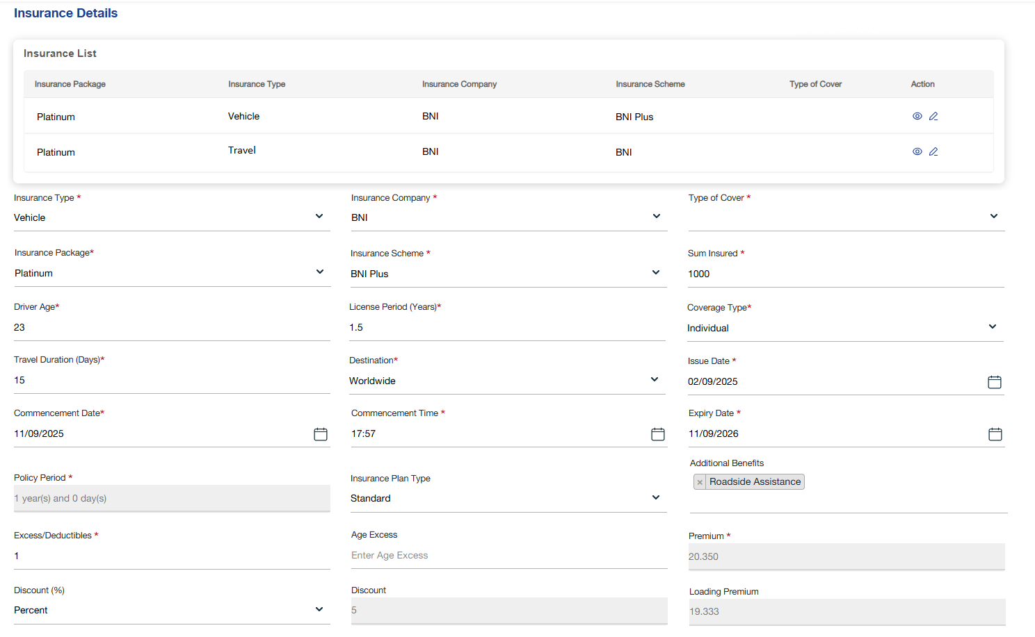

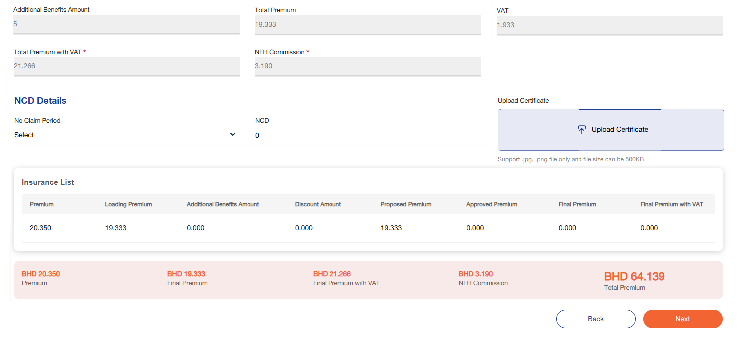

Below mentioned are the details specific to the information being displayed above:

Field Name | Field Type | Mandatory Y/N | Data Type / Length | Lookup Key / Master Name | Possible Values | Field Description, Remarks, Validation, and Calculations
Insurance Type | Dropdown | Y | VARCHAR(50) |  | Vehicle, Solar, Medical, Travel, Home | Users select the type of insurance. Auto-selected and read-only if package is chosen. Drives dynamic sections.
Insurance Company | Dropdown | Y | VARCHAR(50) |  | BNI, GU, GIG, TAK, Solidarity | Select the insurance company. Mandatory. Updates cover type options dynamically.
Insurance Package | Dropdown | Y | VARCHAR(50) |  | Gold, Platinum, Basic | Select the insurance package (combination of multiple insurance types). Creates entries in insurance details grid when lead converts to application. Mandatory.
Type of Cover | Dropdown | Y | VARCHAR(50) |  | Comprehensive, Third Party | User selects the type of cover. Dropdown values depend on selected insurance company.
Insurance Scheme | Drop Down | Y | NVARCHAR / 15 |  | NA | The users can select the insurance scheme.
Sum Insured | Number | N | DECIMAL(15,2) |  | User input | User enters the insured amount. Used in premium calculation: Base Premium = Rate × Sum Insured.
Driver Age | Number | N | INT(3) |  | 18–100 | Captures driver’s age. Must be ≥18. May influence loading premium (e.g., <25 years → 15% loading).
License Period (Years) | Number | N | DECIMAL(4,1) |  | 0–50 | Driving license validity. Impacts risk factor. Captured in increments of 0.5.
Coverage Type | Dropdown | Y (if Travel) | VARCHAR(20) |  | Individual, Family | Applicable only for travel insurance. Defines if cover is for one person or family.
Travel Duration | Dropdown | Y (if Travel) | VARCHAR(10) |  | 3, 5, 7, 14, 21, 31, 60, 90, 365 | Applicable only for travel insurance. Duration of coverage in days. Impacts premium table lookup.
Destination | Dropdown | Y (if Travel) | VARCHAR(50) |  | Worldwide, Worldwide excl. USA/Canada, Schengen | Applicable only for travel insurance. Defines coverage region. Premium varies by destination.
Issue Date | Date Picker | Y | DATE |  | User input | Policy issue date. Mandatory for every insurance type.
Commencement Date | Date Picker | N | DATE |  | User input | Policy start date. Used to calculate policy period. Optional but recommended.
Expiry Date | Date Picker | Y | DATE |  | User input | Policy end date. Defaults to 1 year after commencement date but can be edited by user.
Policy Period | Text (Read-only) | N | VARCHAR(50) |  | Auto | System-calculated. Policy Period = Expiry Date – Commencement Date.
Insurance Plan Type | Dropdown | Y | VARCHAR(20) |  | Normal, Substandard | Defines plan risk category. Substandard triggers manual entry/editing of premium.
Additional Benefits | Checkbox Group | N | MULTISELECT |  | VR, Personal Accident, Passengers Cover, RSCC, HAPD | Multi-select benefits. Impacts premium: Additional Benefits Amount = Σ (Benefit Rate × Sum Insured or Fixed Value).
Excess/Deductibles | Number | Y | DECIMAL(15,2) |  | User input | Deductible/excess amount captured manually. Printed on cover note.
Age Excess | Number | N (Vehicle only) | DECIMAL(15,2) |  | User input | Captured only for vehicle insurance. Extra deductible due to driver/vehicle age. Printed on cover note.
No Claim Period | Dropdown | N | VARCHAR(10) |  | 1–4 years | Captures years without claim (vehicle insurance only). Used in NCD calculation.
NCD Amount | Number (Read Only) | N | DECIMAL(15,2) |  | Auto | System calculates based on NCD % × Base Premium. Auto-populated.
Upload NCD Certificate | File Upload | N | FILE (.pdf, .jpg, .png) |  | User upload | Upload proof of NCD. Conditional if NCD discount is claimed.
Discount Type | Dropdown | N | VARCHAR(20) |  | No Discount, Percentage, Amount | Defines discount mode. If selected, enables Discount Value field.
Discount Value | Number | N | DECIMAL(15,2) |  | User input | Discount amount or percentage. Used in formula: Discount Amount = (BP + LP + AB) × % or Fixed Value.
Base Premium | Label (Read-only) | N | DECIMAL(15,2) |  | Auto | Auto-calculated based on company matrix and sum insured. BP = Rate × Sum Insured.
Loading Premium | Label (Read-only) | N | DECIMAL(15,2) |  | Auto | Extra premium due to higher risk (e.g., young driver, substandard plan). LP = BP × Loading %.
Additional Benefits Amount | Label (Read-only) | N | DECIMAL(15,2) |  | Auto | Premium from selected benefits. AB = Σ (Benefit Premiums).
Discount Amount | Label (Read-only) | N | DECIMAL(15,2) |  | Auto | System calculates discount from Discount Value. DA = % or Fixed Value.
Total Premium | Label (Read-only) | N | DECIMAL(15,2) |  | Auto | TP = BP + LP + AB – DA – NCD. Total before VAT.
VAT (10%) | Label (Read-only) | N | DECIMAL(15,2) |  | Auto | VAT = TP × 0.10.
Total Premium with VAT | Label (Read-only) | N | DECIMAL(15,2) |  | Auto | TPV = TP + VAT. Final payable premium.
NFH Commission (15%) | Label (Read-only) | N | DECIMAL(15,2) |  | Auto | Commission = TP × 0.15 (before VAT).

Insurance Details Checker
Upon completion of the basic insurance form by the maker, the data will be saved when user clicks on “Next Button”, and a request will be routed to the insurance checker for review and approval. The maker will only be permitted to proceed with the application once the checker has approved the submitted request.

- Note: The maker is required to fill in all the details in these sections. Upon clicking the “Next” button, if a discount is applicable, the application will be automatically routed to the insurance checker for approval.

At this stage, the following screen will be displayed to the insurance checker for review:

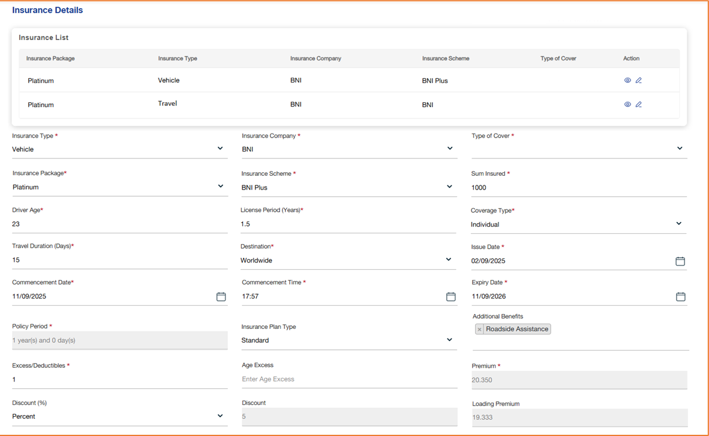
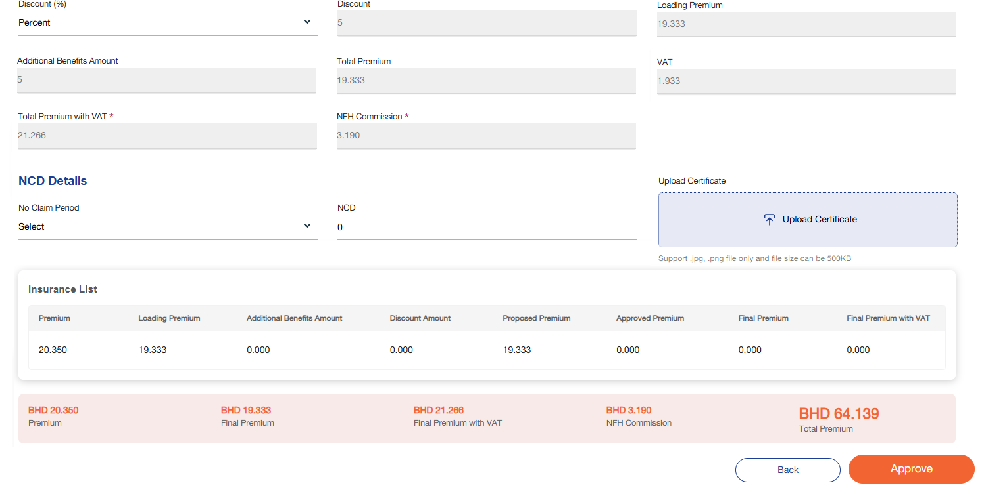

The insurance checker will receive a system-generated notification with the following message:

Notification Message: “Insurance details received for Application Number: [xxx]”

Below mentioned are the details specific to the information being displayed above:

Field Name | Field Type | Mandatory | Data Type | Lookup Key/Master Name | Possible Values | Field Description & Remarks
Insurance Type | Read-Only | NA | NA | NA | NA | User will be able to see the data filled by the maker
Insurance Company | Read-Only | NA | NA | NA | NA | User will be able to see the data filled by the maker
Type of Cover | Read-Only | NA | NA | NA | NA | User will be able to see the data filled by the maker
Insurance Scheme | Read-Only | NA | NA | NA | NA | User will be able to see the data filled by the maker
Sum Insured | Read-Only | NA | NA | NA | NA | User will be able to see the data filled by the maker
Issue Date | Read-Only | NA | NA | NA | NA | User will be able to see the data filled by the maker
Insurance Plan Type | Read-Only | NA | NA | NA | NA | Users will be able to see the insurance plan type
Commencement Date | Read-Only | NA | NA | NA | NA | User will be able to see the data filled by the maker
Commencement Time | Read-Only | NA | NA | NA | NA | User will be able to see the data filled by the maker
Expiry Date | Read-Only | NA | NA | NA | NA | User will be able to see the data filled by the maker
Policy Period | Read-Only | NA | NA | NA | NA | User will be able to see the data filled by the maker
Excess/Deductibles | Read-Only | NA | NA | NA | NA | User will be able to see the data filled by the maker
Age Excess | Read-Only | NA | NA | NA | NA | User will be able to see the data filled by the maker
Policy Benefits | Read-Only | NA | NA | NA | NA | User will be able to see the data filled by the maker
Premium | Numeric | Y | NA | NA | NA | User will be able to see the data filled by the maker; however, the checker will have the rights to edit the premium amount.
Discount (%) | Dropdown | Y | NA | NA | NA | User will be able to see the data filled by the maker; however, the checker will have the rights to edit the discount (%).
Discount | Numeric | Y | NA | NA | NA | User will be able to see the data filled by the maker; however, the checker will have the rights to edit the discount.
Total Premium | Read-Only | NA | NA | NA | NA | System calculates (Total Premium = Premium – Discount)
VAT | Read-Only | NA | NA | NA | NA | User will be able to see the data filled by the maker
Total Premium with VAT | Read-Only | NA | NA | NA | NA | User will be able to see the data filled by the maker
NFH Commission | Read-Only | NA | NA | NA | NA | User will be able to see the data filled by the maker
Insurance List
Premium | Read-Only | NA | NA | NA | NA | User will be able to see the data filled by the maker
Proposed Premium | Read-Only | NA | NA | NA | NA | User will be able to see the data filled by the maker
Approved Premium | Read-Only | NA | NA | NA | NA | Displays the premium added by the checker. In case the checker have approved directly without making any changes the same proposed premium will be displayed.
Final Premium | Read-Only | NA | NA | NA | NA | Displays the final approved premium.
Final Premium with VAT | Read-Only | NA | NA | NA | NA | Displays the final premium inclusive with VAT.
Remarks | Field | Yes | Alphanumeric/50 | NA | NA | Checker can add their remarks.
Action Buttons
Approve | Action Button | NA | NA | NA | NA | Allow users to approve a request.
Reject | Action Button | NA | NA | NA | NA | Allow users to reject a request.

Document Checklist
This feature allows users to upload and manage the required documents associated with a customer's application.
Users can proceed to the Document Checklist by selecting the desired application, upon which the corresponding Document Checklist screen will be displayed:

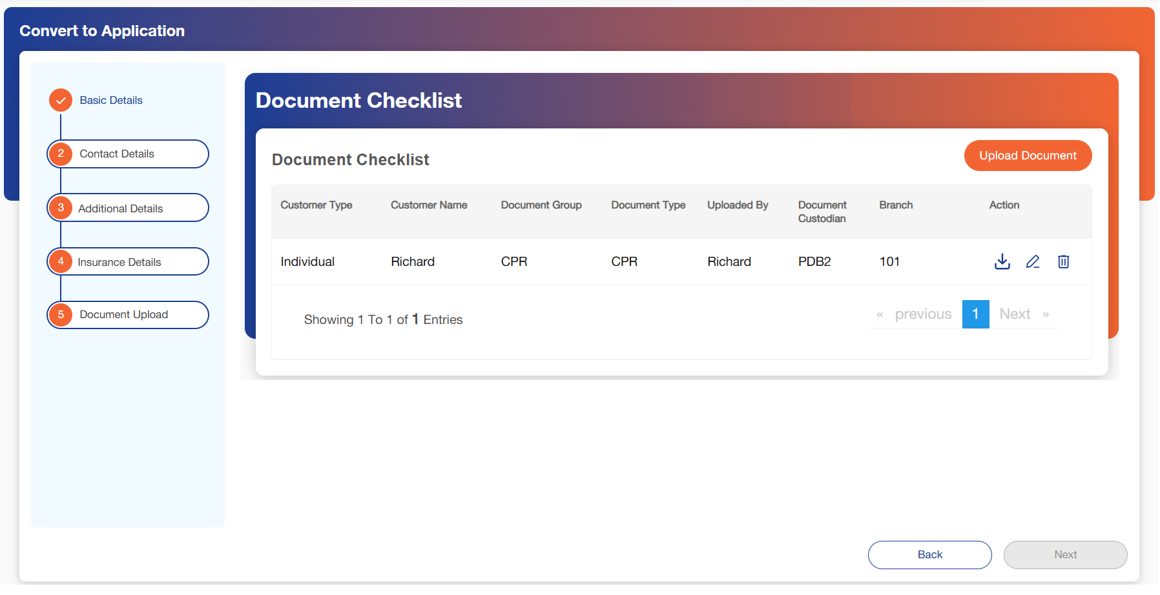

Once the user clicks on “Upload document”, below screen will pop-up:

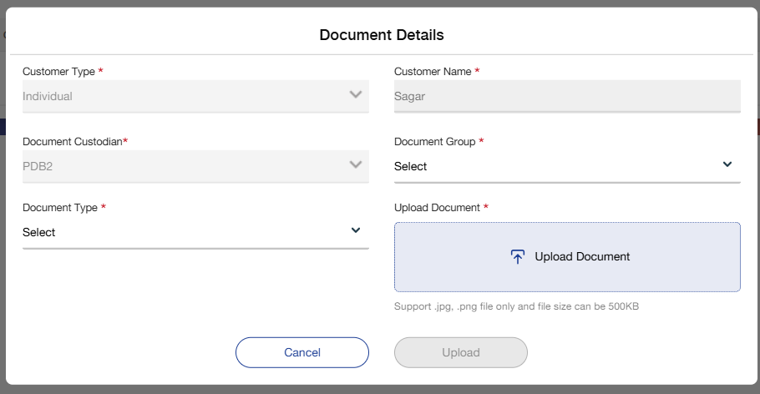

Below mentioned are the details specific to the information being displayed above:

Field Name | Field Type | Mandatory Y/N | Data Type / Length | Lookup Key / Master Name | Possible Values | Field Description
 |  |  |  |  |  | Remarks/ Validation
Customer Type | Read-only | NA | NA | NA | NA | Displays the customer type based on submitted application.
Customer Name | Read-only | NA | NA | NA | NA | Displays the customer’s name based on submitted application.
Document Custodian | Read-only | NA | NA | NA | NA | Displays the unique number generated by the system to map the documents to an application.
Document Group | Dropdown | Y | NVARCHAR /10 | NA | 1.POI  2.POA  3.Proof of income | Users can select the document group.
Document Type | Dropdown | Y | NVARCHAR /10 | NA | 1.Driving License  2.Proposal Form  3.NCD or NCB | Users can select the document type.
Upload | Icon | NA | NA | NA | NA | Users can click on this icon and upload any document available in their system.
Action Button
Cancel | Button | NA | Button | NA | NA | Allow users to move to inbox screen.
Upload | Button | NA | Button | NA | NA | Allow users to save and upload the document to DMS.

Policy Issuance Maker

Once the required documents have been uploaded and the policy number has been received from the vendor, users can click on the 'Policy Update' button, upon which the corresponding screen will be displayed:

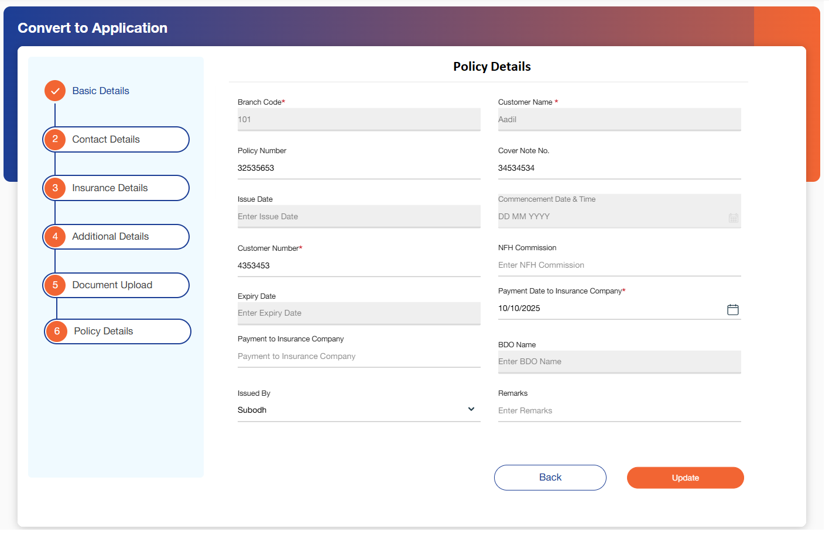

Below mentioned are the details specific to the information being displayed above:

Field Name | Field Type | Mandatory Y/N | Data Type / Length | Lookup Key / Master Name | Possible Values | Field Description
 |  |  |  |  |  | Remarks/ Validation
Branch Code | Read-Only | NA | NA | NA | NA | Displays the branch code corresponding to the branch where the application was created.
Customer Name | Read-only | NA | NA | NA | NA | Displays the customer’s name based on submitted application.
Policy Number | Field | Y | NVARCHAR / 15 | NA | NA | Users can enter the policy number provided by the vendor.
Cover Note No. | Field | Y | NVARCHAR / 15 | NA | NA | Users can enter the cover noter number provided by NFH to the customer.
Issue Date | Read-Only | NA | NA | NA | NA | Displays the issue date fetched through interface.
Commencement Date & Time | Read-Only | NA | NA | NA | NA | Displays the Commencement Date & Time fetched through interface.
Customer Number | Field | Y | NVARCHAR / 15 | NA | NA | Users can enter the unique customer number provided by NFH.
NFH Commission | Field | Y | NVARCHAR / 15 | NA | NA | Users can enter the commission amount.
Expiry Date | Read-Only | NA | NA | NA | NA | Displays the expiry date fetched through interface.
Payment date to insurance company | Date | Y | Calendar | NA | NA | Users can capture the date on which the payment was made to the insurance company.
Payment to insurance company | Numeric | Y | NVARCHAR / 5 | NA | NA | Users can capture the amount paid to the insurance company.
BDO Name | Read-Only | NA | NA | NA | NA | Displays the name of the BDO fetched through interface.
Issued By | Drop-down | Y | NVARCHAR / 5 | NA | NA | Users can select the issuer.
Remarks | Filed | N | NVARCHAR / 15 | NA | NA | Users can add there comments and remarks if any.
Action Button
Cancel | Button | NA | Button | NA | NA | Allow users to move to inbox screen.
Update | Button | NA | Button | NA | NA | Allow users to save the data.
Submit | Button | NA | Button | NA | NA | Allows user to submit for approval on save of data.

Policy Issuance Checker
Once the maker user clicks on 'Update', the application will be routed to the Policy Issuance Checker for final review and approval

Below screen will be made visible to the checker:

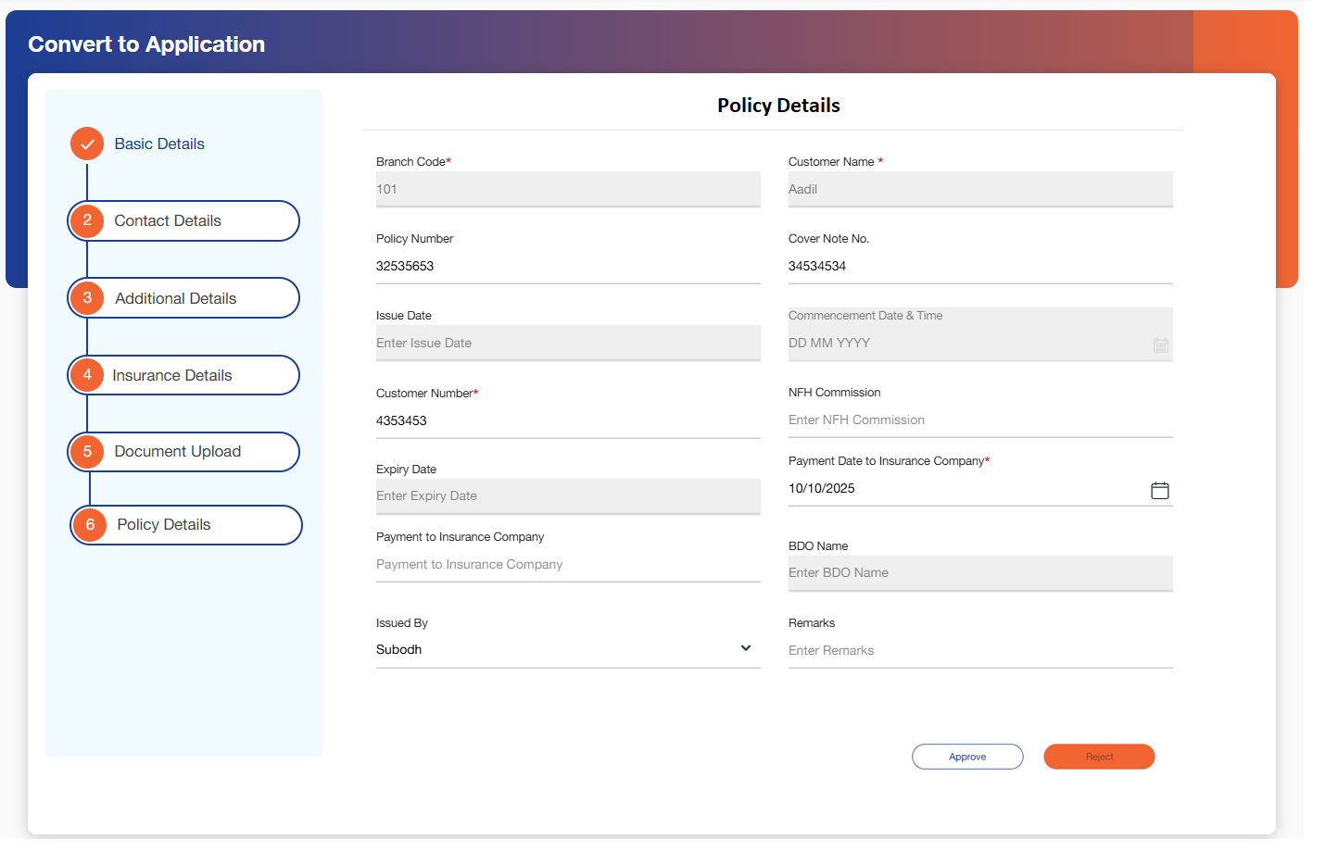

The insurance checker will receive a system-generated notification with the following message:

Notification Message: “Issuance details received for Application Number: [xxx]”

Below mentioned are the details specific to the information being displayed above:

Field Name | Field Type | Mandatory | Data Type | Lookup Key/Master Name | Possible Values | Field Description & Remarks
Branch Code | Read-Only | NA | NA | NA | NA | User will be able to see the data filled by the maker
Customer Name | Read-Only | NA | NA | NA | NA | User will be able to see the data filled by the maker
Policy Number | Read-Only | NA | NA | NA | NA | User will be able to see the data filled by the maker
Cover Note No. | Read-Only | NA | NA | NA | NA | User will be able to see the data filled by the maker
Issue Date | Read-Only | NA | NA | NA | NA | User will be able to see the data filled by the maker
Commencement Date & Time | Read-Only | NA | NA | NA | NA | User will be able to see the data filled by the maker
Customer Number | Read-Only | NA | NA | NA | NA | User will be able to see the data filled by the maker
NFH Commission | Read-Only | NA | NA | NA | NA | User will be able to see the data filled by the maker
Expiry Date | Read-Only | NA | NA | NA | NA | User will be able to see the data filled by the maker
Payment Date to insurance company | Read-Only | NA | NA | NA | NA | User will be able to see the data filled by the maker
Payment to insurance company | Read-Only | NA | NA | NA | NA | User will be able to see the data filled by the maker
BDO Name | Read-Only | NA | NA | NA | NA | User will be able to see the data filled by the maker
Issued By | Read-Only | NA | NA | NA | NA | User will be able to see the data filled by the maker
Remarks | Field | Yes | Alphanumeric/50 | NA | NA | Checker can add their remarks.
Action Buttons
Approve | Action Button | NA | NA | NA | NA | Allow users to approve a request.
Reject | Action Button | NA | NA | NA | NA | Allow users to reject a request.

NFH Due List

This screen allows the user to see the records of the customer which are captured in the post disbursement screen of LO which is only applicable for the customers who have not taken insurance from NFH during the loan application process.
This screen populates all the records of the customers who are due for renewal prior to 1 month (configurable) of the expiry date.

Following screen will be displayed once the user clicks on NFH Due List:

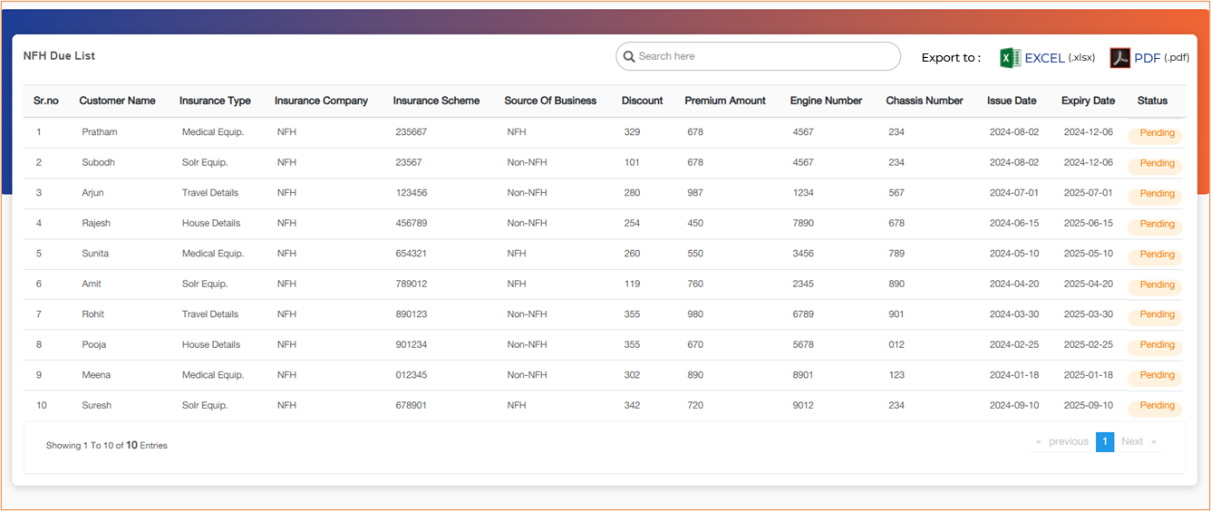

Below mentioned are the details specific to the information being displayed above:

Field Name | Field Type | Mandatory Y/N | Data Type / Length | Lookup Key / Master Name | Possible Values | Field Description
 |  |  |  |  |  | Remarks/ Validation
Search Bar | Text Box | Y | NVARCHAR / 20 | NA | NA | The user will search the customer through any of the fields from the list below
List View
Customer Name | Read Only | NA | NA | NA | NA | Auto populated based on data received through interface.
Insurance Type | Read Only | NA | NA | NA | NA | Auto populated based on data received through interface.
Insurance Company | Read Only | NA | NA | NA | NA | Auto populated based on data received through interface.
Insurance Scheme | Read Only | NA | NA | NA | NA | Auto populated based on data received through interface.
Source of Business | Read Only | NA | NA | NA | NA | Auto populated based on data received through interface.
Discount | Read Only | NA | NA | NA | NA | Auto populated based on data received through interface.
Premium Amount | Read Only | NA | NA | NA | NA | Auto populated based on data received through interface.
Engine Number | Read Only | NA | NA | NA | NA | Auto populated based on data received through interface.
Chassis Number | Read Only | NA | NA | NA | NA | Auto populated based on data received through interface.
Issue Date | Read Only | NA | NA | NA | NA | Auto populated based on data received through interface.
Expiry Date | Read Only | NA | NA | NA | NA | Auto populated based on data received through interface.
Status | Read Only | NA | NA | NA | NA | Auto populated based on data received through interface.
Action Buttons
Download | Button | Y | Button | NA | NA | Allows users to download the NFH due list.
Print | Button | Y | Button | NA | NA | Allows users to directly print the NFH due list.

Policy Update
Once the checker approves the policy issuance request, the approved policies will be displayed under the 'Policy Update Queue'.

The following screen will be presented to the users for further processing or reference

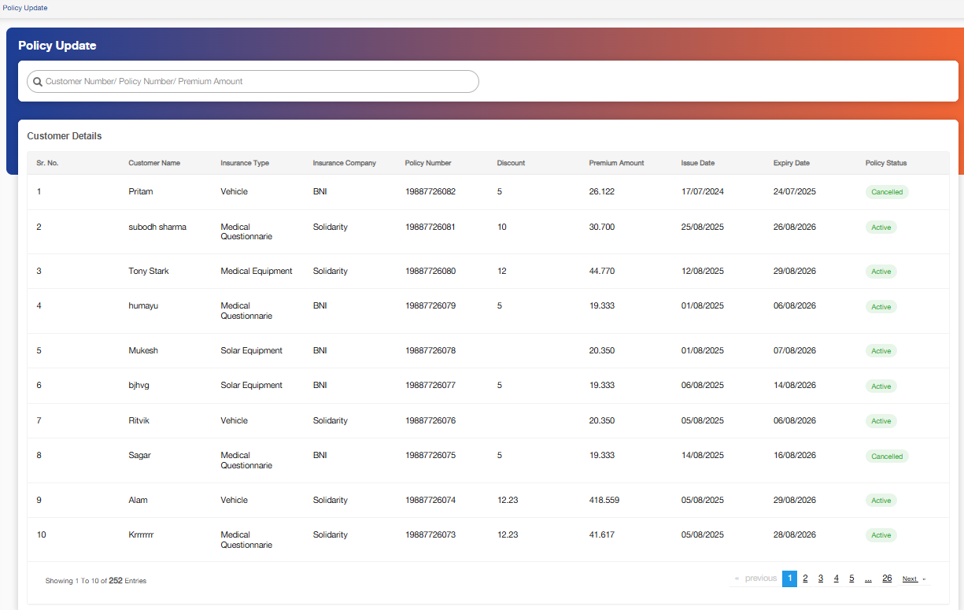

Below mentioned are the details specific to the information being displayed above:

Field Name | Field Type | Mandatory Y/N | Data Type / Length | Lookup Key / Master Name | Possible Values | Field Description
 |  |  |  |  |  | Remarks/ Validation
Search Bar | Text Box | Y | NVARCHAR / 20 | NA | NA | The user will search the customer through any of the fields from the list below
List View
Customer Name | Read Only | NA | NA | NA | NA | Auto populated based on approvals by policy issuance checker.
Insurance Type | Read Only | NA | NA | NA | NA | Auto populated based on approvals by policy issuance checker.
Insurance Company | Read Only | NA | NA | NA | NA | Auto populated based on approvals by policy issuance checker.
Policy Number | Read Only | NA | NA | NA | NA | Auto populated based on approvals by policy issuance checker.
Discount | Read Only | NA | NA | NA | NA | Auto populated based on approvals by policy issuance checker.
Premium Amount | Read Only | NA | NA | NA | NA | Auto populated based on approvals by policy issuance checker.
Issue Date | Read Only | NA | NA | NA | NA | Auto populated based on approvals by policy issuance checker.
Expiry Date | Read Only | NA | NA | NA | NA | Auto populated based on approvals by policy issuance checker.
Policy Status | Read Only | NA | NA | NA | 1.Active  2.Cancelled | Auto populated based on approvals by policy issuance checker.

Claims
The claims process outlines the end-to-end workflow for registering, evaluating, and settling insurance claims submitted by policyholders.
The Claims section will provide users with the following two navigation options:
- Death Claim – Allows users to initiate and manage death claim requests.
- Claim History – Enables users to view the history of all claims associated with a customer or policy.

Death Claim

Upon notification of a customer's death, the user shall update the customer status under the Death Claim section. Once this status is updated, the accrual of interest on the loan will automatically be stopped.
Following the status update, the insurance user will initiate the death claim process outside the system by communicating directly with the insurance company.
- If the insurance claim is approved, NFH will receive an amount equivalent to the outstanding loan balance of the deceased customer. The Teller/Finance user will manually record the received payment in the Loan Management module, resulting in the closure of the loan.
- If the claim is denied, the user must update the claim status in the system along with the reason for denial. The loan will then be transferred to the Collections module.
  - In this scenario, the Collection user will initiate follow-up actions with the customer's heirs.
    - If the heirs agree to settle the outstanding balance, the Teller/Finance user will manually record the payment in the Loan Management module, and the loan will be marked as closed.
    - If the heirs refuse to settle the balance, the Collection user will proceed with legal action as per internal policies.

- Note: The Death Claim screen will also allow users to register and manage claims other than death, providing flexibility to handle different types of insurance claims within the same interface.

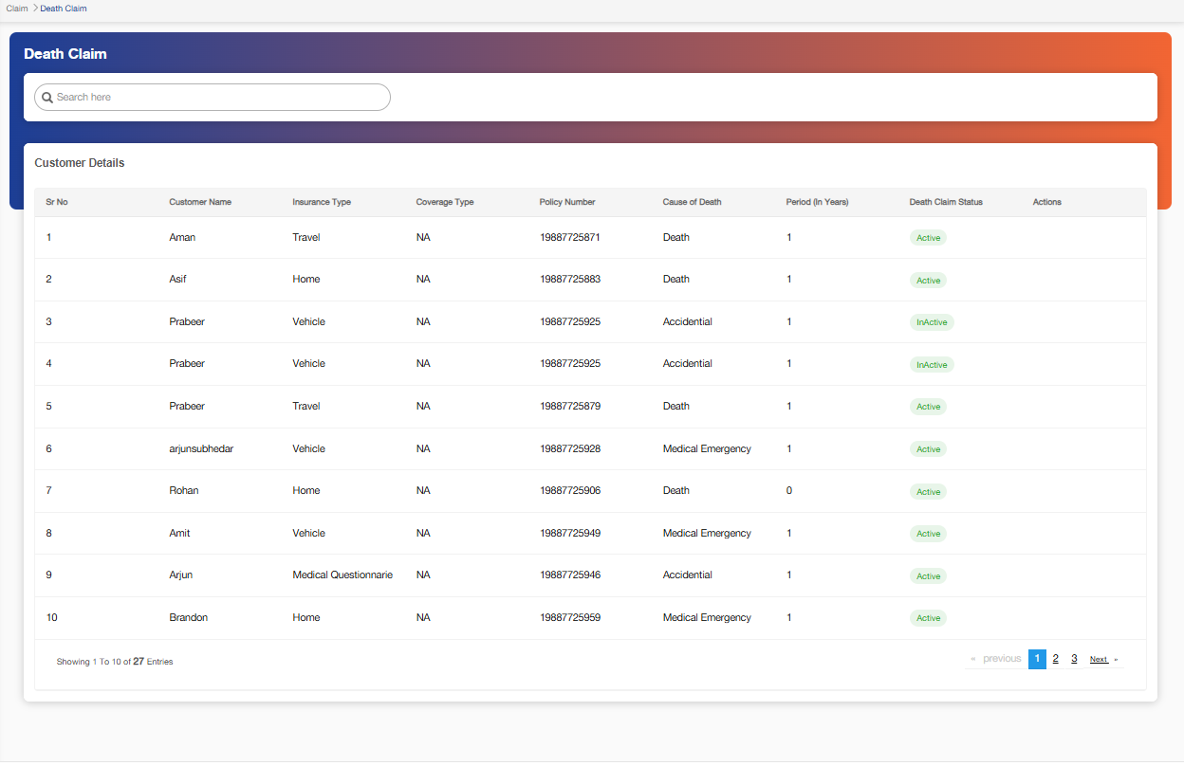

Below mentioned are the details specific to the information being displayed above:

Field Name | Field Type | Mandatory Y/N | Data Type / Length | Lookup Key / Master Name | Possible Values | Field Description
 |  |  |  |  |  | Remarks/ Validation
Search Bar | Text Box | Y | NVARCHAR / 20 | NA | NA | The user will search the customer through any of the fields from the list below
List View
Customer Name | Read Only | NA | NA | NA | NA | Auto populates active policies.
Insurance Type | Read Only | NA | NA | NA | NA | Auto populates active policies.
Coverage Type | Read Only | NA | NA | NA | NA | Auto populates active policies.
Policy Number | Read Only | NA | NA | NA | NA | Auto populates active policies.
Cause of death | Read Only | NA | NA | NA | NA | Auto populates active policies.
Period (In Years) | Read Only | NA | NA | NA | NA | Auto populates active policies.
Death Claim Status | Read Only | NA | NA | NA | NA | Auto populates active policies.
Policy Status | Read Only | NA | NA | NA | NA | Auto populates active policies.
Action Buttons
 | Button | NA | Button | NA | NA | Allow users to edit the record and add claim details.
 | Button | NA | Button | NA | NA | Allow users to delete the record.

Once user clicks on edit button by hovering upon a application, below screen will be displayed:

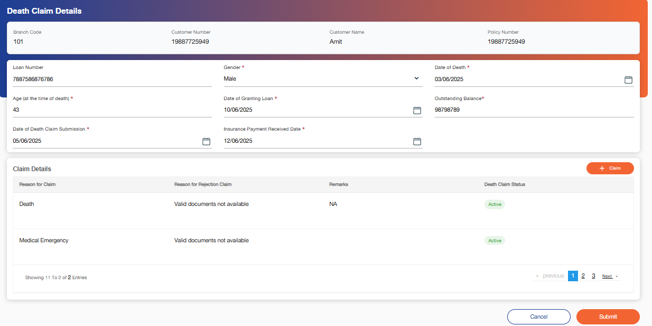

Below mentioned are the details specific to the information being displayed above:

Field Name | Field Type | Mandatory Y/N | Data Type / Length | Lookup Key / Master Name | Possible Values | Field Description
 |  |  |  |  |  | Remarks/ Validation
Branch Code | Read Only | NA | NA | NA | NA | Displays the branch code associated with the application.
Customer Number | Read Only | NA | NA | NA | NA | Displays the customer Number saved at policy update screen.
Customer Name | Read Only | NA | NA | NA | NA | Displays the name of the customer.
Policy Number | Read Only | NA | NA | NA | NA | Displays the policy number saved at policy update screen.
Loan Number | Read Only | NA | NA | NA | NA | Auto populates in case the loan was taken from NFH.  - In scenario where loan was not from NFH, this field will remain empty.
Gender | Dropdown | N | NVARCHAR/15 | NA | 1.Male  2.Female | Auto populates in case the loan was taken from NFH.  - In scenario where loan was not from NFH, the users can manually enter the details.
Date of death | Date | N | Calendar | NA | NA | Users can capture the date of death of the customer.
Age at the time of death | Read Only | NA | NA | NA | NA | Auto populates based on date of birth captured during application process and date of death.
Date of Granting Loan | Read Only | NA | NA | NA | NA | Auto populates in case the loan was taken from NFH.  - In scenario where loan was not from NFH, this field will remain empty.
Outstanding Balance | Read Only | NA | NA | NA | NA | Auto populates in case the loan was taken from NFH.  - In scenario where loan was not from NFH, this field will remain empty.
Date of death claim submission | Date | N | Calendar | NA | NA | Users can capture the date on which the death claim was submitted.
Insurance Payment received date. | Date | N | Calendar | NA | NA | Users can capture the date on which the insurance payment was received.
Claim Details
Reason for Death | Read only-List View | NA | NA | NA | NA | Displays the reason of death captured under “add claim” screen.
Reason for rejection Claim | Read only-List View | NA | NA | NA | NA | Displays the reason of death captured under “add claim” screen.
Remarks | Read only-List View | NA | NA | NA | NA | Displays the reason of death captured under “add claim” screen.
Death Claim Status | Read only-List View | NA | NA | NA | NA | Displays the reason of death captured under “add claim” screen.
Action Button
Claim | Button | NA | Button | NA | NA | Allow users to move to “Add claim: screen and add claim details.
Cancel | Button | NA | Button | NA | NA | Allow users to move to death claim queue
Submit | Button | NA | Button | NA | NA | Allow users to save the data and submit.

Once the user clicks on “Claim” Button, the “Add Claim” screen will pop-up:

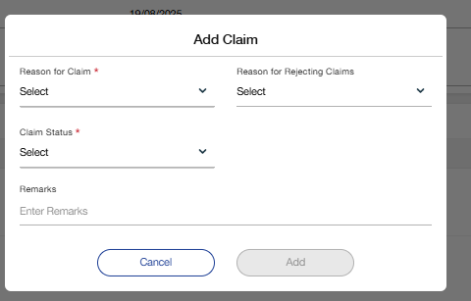

Below mentioned are the details specific to the information being displayed above:

Field Name | Field Type | Mandatory Y/N | Data Type / Length | Lookup Key / Master Name | Possible Values | Field Description
 |  |  |  |  |  | Remarks/ Validation
Reason for Claim | Dropdown | Y | NVARCHAR/15 | NA | 1.Medical Emergency  2.Accidental  3.Death | Users can select the reason for the claim.
Reason for rejecting claim | Dropdown | N | NVARCHAR/15 | NA | 1.Valid documents not available | Users can capture the reason of rejecting the claim.
Claim Status | Dropdown | Y | NVARCHAR/15 | NA | 1.Approved  2.Rejected  3.In-progress | Users can capture the status of the claim.
Remarks | Field | N | NVARCHAR/20 | NA | NA | Users’ can add their comments and remarks if any.
Action Button
Cancel | Button | NA | Button | NA | NA | Allow users to move to death claim details screen.
Add | Button | NA | Button | NA | NA | Allow users to save and add the claim.

Claim History
All claims, including death claims and other types, once settled, will be added to this section. Users can either enter the claim data manually or upload the relevant documents for reference and management

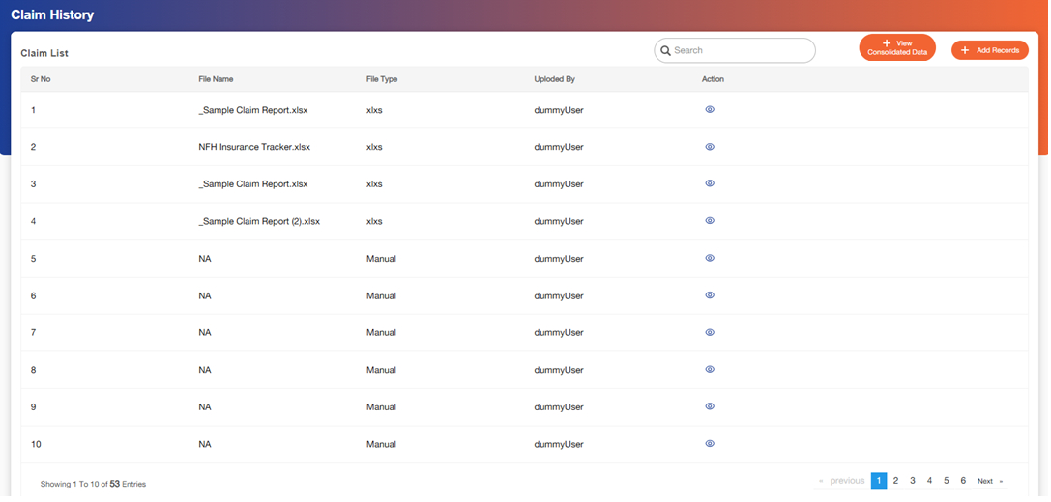

Below mentioned are the details specific to the information being displayed above:

Field Name | Field Type | Mandatory Y/N | Data Type / Length | Lookup Key / Master Name | Possible Values | Field Description
 |  |  |  |  |  | Remarks/ Validation
Search Bar | Text Box | Y | NVARCHAR / 20 | NA | NA | The user will search the customer through any of the fields from the list below
List View
File Name | Read-Only | NA | NA | NA | NA | Displays the name of the file uploaded under records.
File Type | Read-Only | NA | NA | NA | NA | Displays the type of the file uploaded under records.
Uploaded By | Read-Only | NA | NA | NA | NA | Displays the name of the user who uploaded the file under records.
Action Buttons
Add Records | Button | NA | Button | NA | NA | Allow users to add record manually or by uploading.
View Consolidated Data | Button | NA | Button | NA | NA | The system should allow users to view consolidated data comprising both uploaded files and manual entries in a unified interface.  This consolidated view should enable users to easily review, validate, and compare all submitted information in one place.
 | Icon | NA | Icon | NA | NA | Allow users to view the file saved.

Once user clicks on “Add Record” button, below screen will be displayed to showcase the data present in the uploaded file: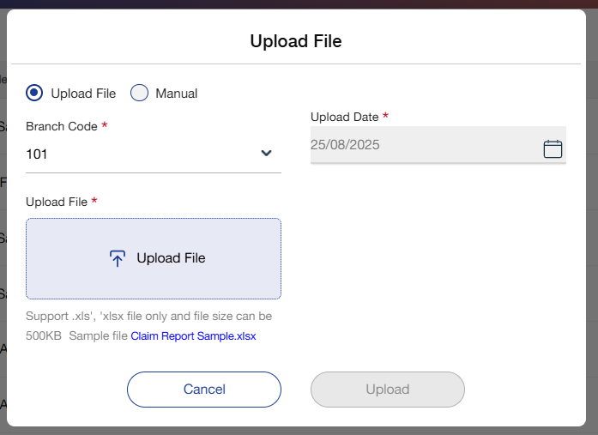
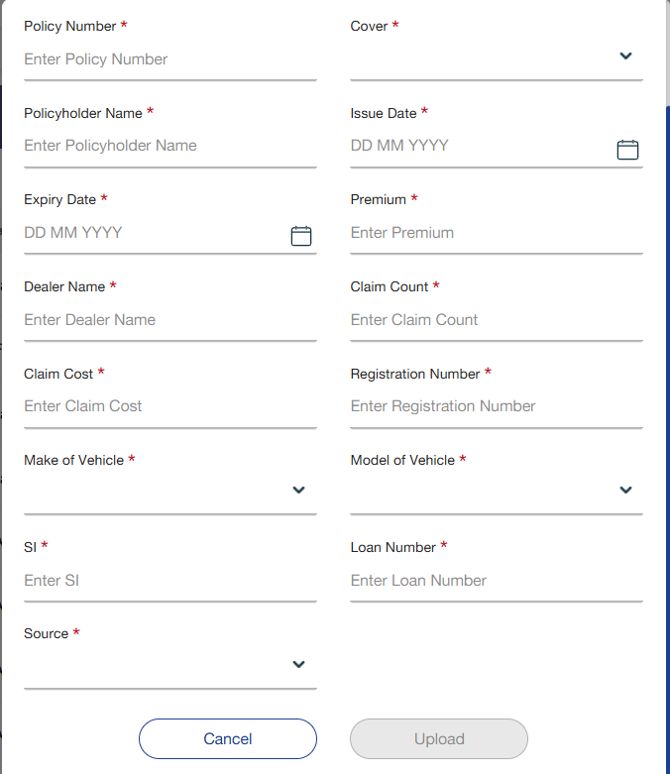

Below mentioned are the details specific to the information being displayed above:

Field Name | Field Type | Mandatory Y/N | Data Type / Length | Lookup Key / Master Name | Possible Values | Field Description
 |  |  |  |  |  | Remarks/ Validation
Entry Type | Radio Button | Y | NVARCHAR/15 | NA | -Manual Entry  -File Upload | Users can select if they want to add the record using a file or manually.
Upload File
Branch Code | Read-Only | NA | NA | NA | NA | Displays the branch code associated with the customer.
Upload Data | Read-Only | NA | NA | NA | NA | Displays the business date.
Upload File | Button | NA | Button | NA | NA | Allow users to upload the file saved in users system.
Manual Entry
Policy Number | Field | Y | NVARCHAR/20 | NA | NA | Allow users to enter the policy number.
Cover | Read-Only | NA | NA | NA | NA | Auto populates based on the policy number.
Policy Holder Name | Read-Only | NA | NA | NA | NA | Auto populates based on the policy number.
Issue Date | Read-Only | NA | NA | NA | NA | Auto populates based on the policy number.
Expiry Date | Read-Only | NA | NA | NA | NA | Auto populates based on the policy number.
Premium | Read-Only | NA | NA | NA | NA | Auto populates based on the policy number.
Dealer Name | Read-Only | NA | NA | NA | NA | Auto populates based on the policy number.
Claim Count | Read-Only | NA | NA | NA | NA | Auto populates based on policy number and previous records.  - Previous records should be saved in DB.
Claim Cost | Read-Only | NA | NA | NA | NA | Auto populates based on policy number and previous records.  - Previous records should be saved in DB.
Registration Number | Read-Only | NA | NA | NA | NA | Auto populates based on the policy number.  - Only applicable for vehicle loan/vehicle insurance.
Make of Vehicle | Read-Only | NA | NA | NA | NA | Auto populates based on the policy number.  - Only applicable for vehicle loan/vehicle insurance.
Model of Vehicle | Read-Only | NA | NA | NA | NA | Auto populates based on the policy number.  - Only applicable for vehicle loan/vehicle insurance.
SI | Field | Y | Numeric/5 | NA | NA | Users can enter the SI.
Loan Number | Read-Only | NA | NA | NA | NA | Auto populates based on the policy number.  - Only applicable for vehicle loan.
Status | Dropdown | Y | NVARCHAR/15 | NA | 1.Settled  2.In-Progress  3.Declined | Users can select the status of the claim.
Action Button
Cancel | Button | NA | Button | NA | NA | Allow users to cancel the record and go back to claim history queue.
Upload | Button | NA | Button | NA | NA | Allow users to save data and upload document.

Once user clicks on view icon on claim history queue, below screen will be displayed to showcase the data present in the uploaded file:

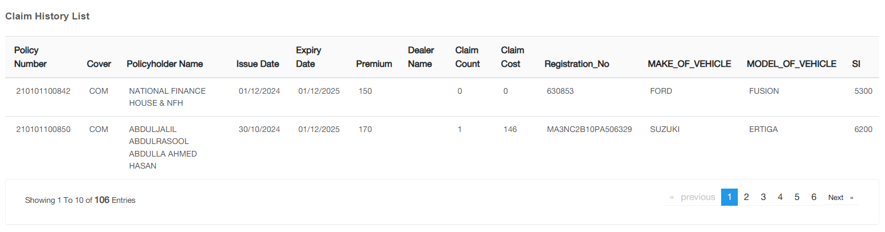

Below mentioned are the details specific to the information being displayed above:

Field Name | Field Type | Mandatory Y/N | Data Type / Length | Lookup Key / Master Name | Possible Values | Field Description
 |  |  |  |  |  | Remarks/ Validation
Policy Number | Read-Only | NA | NA | NA | NA | The system will display the data extracted from the uploaded file.
Cover | Read-Only | NA | NA | NA | NA | The system will display the data extracted from the uploaded file.
Policy Holder Name | Read-Only | NA | NA | NA | NA | The system will display the data extracted from the uploaded file.
Issue Date | Read-Only | NA | NA | NA | NA | The system will display the data extracted from the uploaded file.
Expiry Date | Read-Only | NA | NA | NA | NA | The system will display the data extracted from the uploaded file.
Premium | Read-Only | NA | NA | NA | NA | The system will display the data extracted from the uploaded file.
Dealer Name | Read-Only | NA | NA | NA | NA | The system will display the data extracted from the uploaded file.
Claim Count | Read-Only | NA | NA | NA | NA | The system will display the data extracted from the uploaded file.
Claim Cost | Read-Only | NA | NA | NA | NA | The system will display the data extracted from the uploaded file.
Registration Number | Read-Only | NA | NA | NA | NA | The system will display the data extracted from the uploaded file.
Make of vehicle | Read-Only | NA | NA | NA | NA | The system will display the data extracted from the uploaded file.
Model of vehicle | Read-Only | NA | NA | NA | NA | The system will display the data extracted from the uploaded file.
SI | Read-Only | NA | NA | NA | NA | The system will display the data extracted from the uploaded file.

- Note: The file must be uploaded in the above specified/displayed format to ensure the system can correctly read the file and display the data.

Policy Renewal
This menu allows the user to renew any existing policy. The user can either click on due renewal, see the list of all policies pending for renewal which are populated 1 month (configurable) prior to the expiry date in the list which allows the user to send a reminder to the customers for policy renewal.
The other way is to click on renewal and use the F2 function key to populate customer’s data and then proceed with the policy renewal which is the same as policy issuance process.

NFH Renewal List
This screen allows the user to see the records of the customer who have taken insurance from NFHI in the past. This screen populates all the records of the customers who are due for renewal prior to 1 month (configurable) of the expiry date.

Following screen will be displayed once the user clicks on NFHI Renewal List:

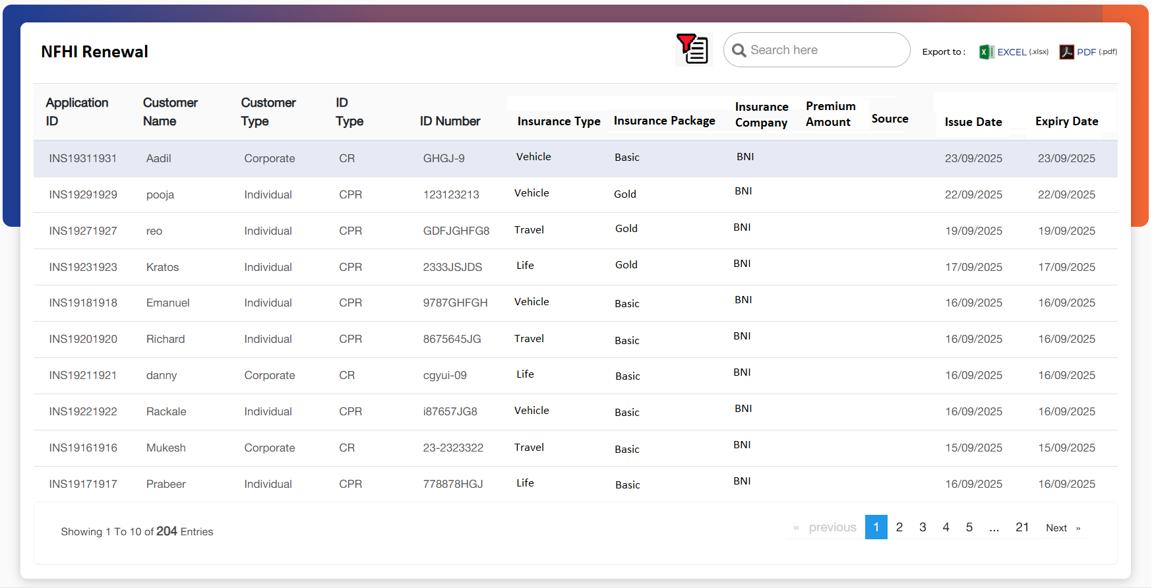

This screen will be similar to the 'Inbox' queue described in Point 7. However, instead of the 'Policy Update' tab, this screen will feature a 'Policy Renewal' tab. Users can click on this tab to initiate the policy renewal process. Upon clicking 'Renew Policy', the following screen will be displayed.
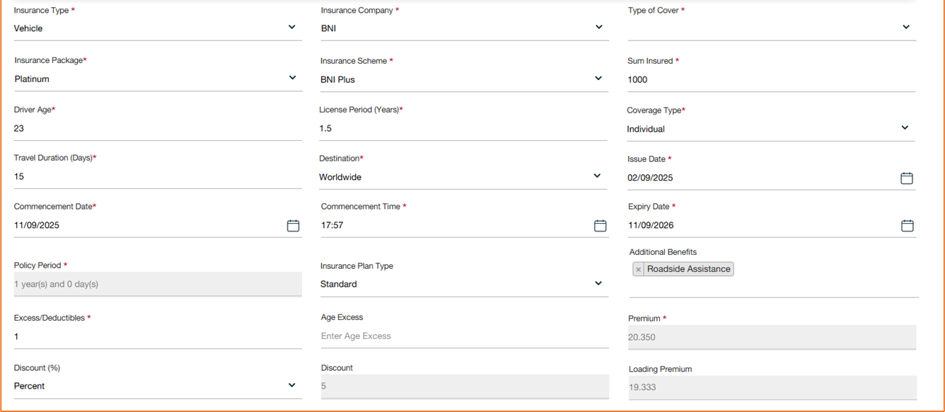

This screen will be similar to the 'Insurance Details' screen and will include the same functionalities as outlined in Point 6.4.

Once the maker clicks on “Next” Button, the case will move to Policy renewal checker.

- Note: For insurance renewals, users should be required to manually enter the Collateral Details in the designated section.
- In the case of insurance renewal, the system must validate that the "Sum Insured" entered is less than or equal to the Sum Insured at the time of original issuance. If the entered value exceeds the original Sum Insured, the system should display an appropriate error message and prevent submission.

Policy Renewal Checker
Upon submission of data from the maker, the application will be forwarded to the insurance renewal checker for review and approval.

The insurance checker will receive a system-generated notification with the following message:

Notification Message: “Renewal details received for Application Number: [xxx]”

The user will review the details added and approve the Insurance renewal.

Policy Extension
Once the user clicks on policy extension and selects the customer number using the F2 function key the customer details would be populated and then the same process as that of a policy issuance follows.

Following screen will be displayed once the user clicks on Policy Extension:

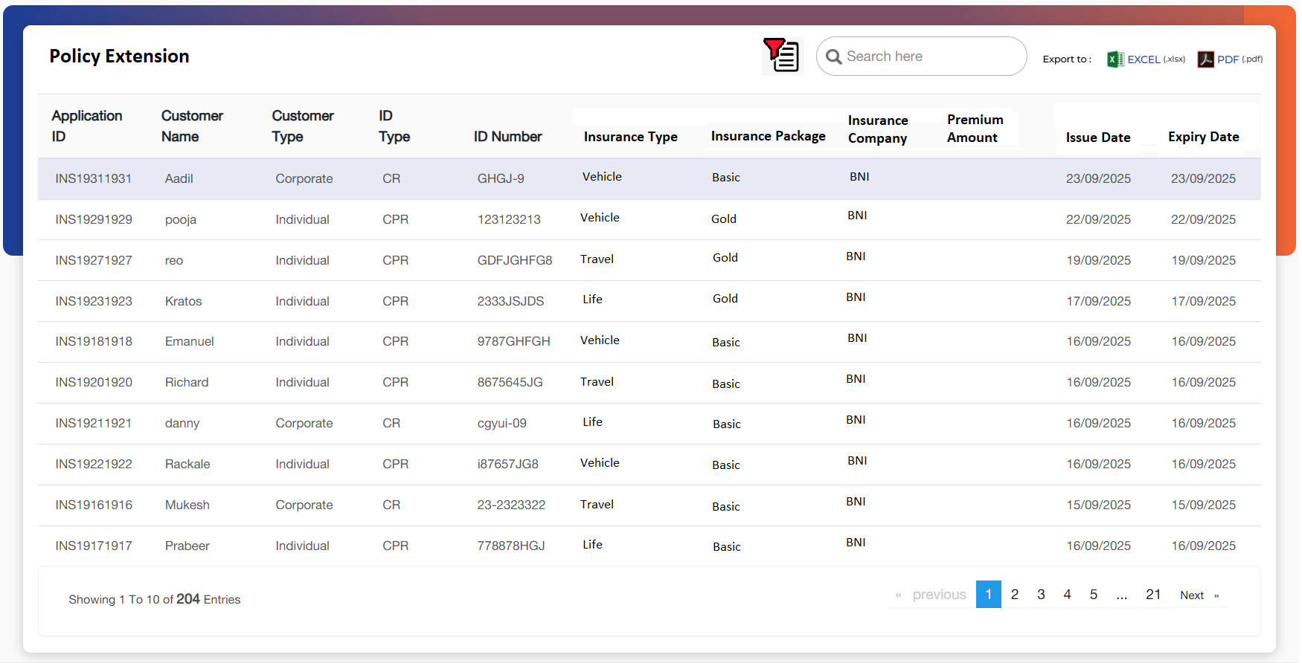

This screen will be like the 'Inbox' queue described in Point 7. However, instead of the 'Policy Update' tab, this screen will feature a 'Policy Extension” tab. Users can click on this tab to initiate the policy renewal process. Upon clicking 'Policy Extension', the following screen will be displayed:
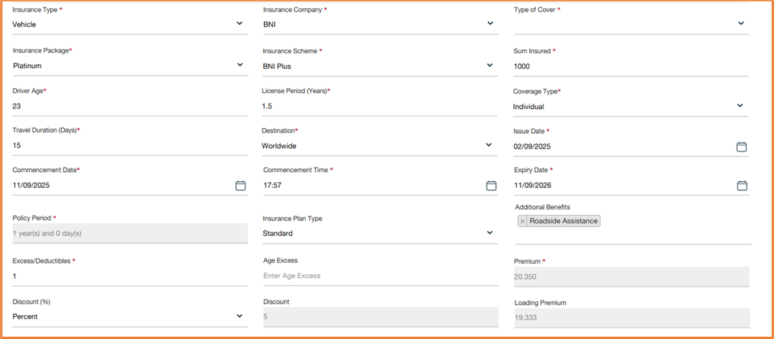

This screen will be like the 'Insurance Details' screen and will include the same functionalities as outlined in Point 6.4.

Once the maker clicks on “Next” Button, the case will move to Policy extension checker.

Policy Extension Checker
Upon submission of data from the maker, the application will be forwarded to the insurance extension checker for review and approval.

The insurance checker will receive a system-generated notification with the following message:

Notification Message: “Insurance Extension details received for Application Number: [xxx]”

Policy Cancellation
This feature allows users to cancel an ongoing policy in the system. Users can initiate the cancellation process for active policies that have not yet been settled or expired. Upon cancellation, the system will update the policy status and ensure that no further premiums are charged. Any refunds or adjustments related to the policy cancellation will be processed in accordance with company policies and regulations. Users will be prompted to provide a reason for cancellation, and the system will capture this information for audit purposes. Once the cancellation is confirmed, a notification will be sent to the customer, and the policy will be removed from the active policy list.
Once user clicks on Policy cancellation, policy cancellation queue will be displayed:
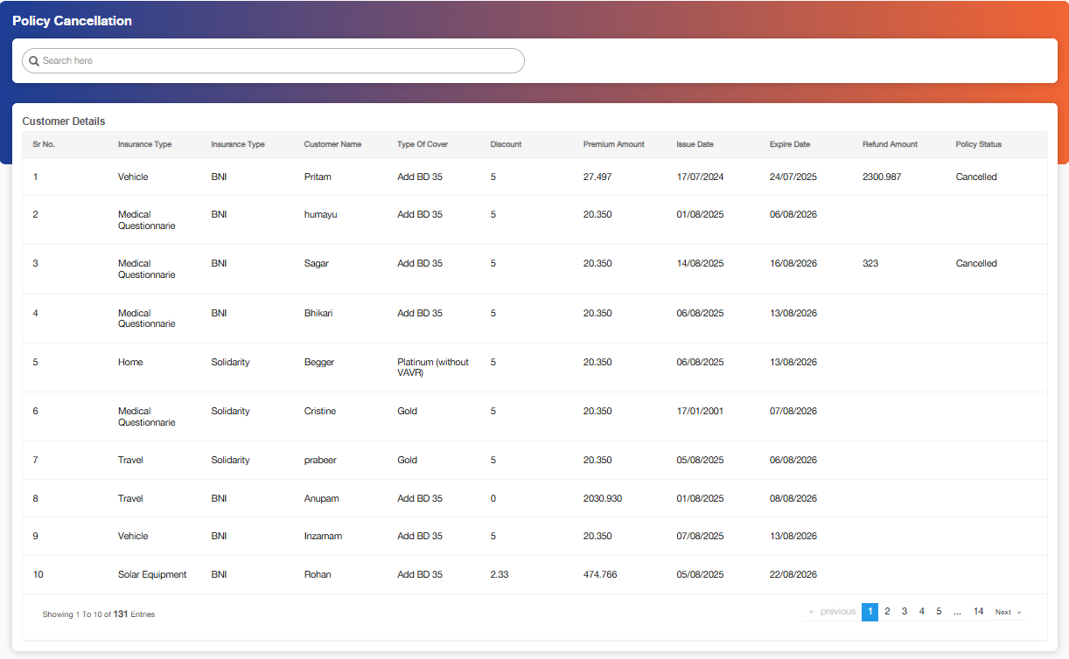

Below mentioned are the details specific to the information being displayed above:

Field Name | Field Type | Mandatory Y/N | Data Type / Length | Lookup Key / Master Name | Possible Values | Field Description
 |  |  |  |  |  | Remarks/ Validation
Search Bar | Text Box | Y | NVARCHAR / 20 | NA | NA | The user will search the customer through any of the fields from the list below
List View
Customer Name | Read Only | NA | NA | NA | NA | Auto populates active policies.
Insurance Type | Read Only | NA | NA | NA | NA | Auto populates active policies.
Insurance Company | Read Only | NA | NA | NA | NA | Auto populates active policies.
Type of cover | Read Only | NA | NA | NA | NA | Auto populates active policies.
Discount | Read Only | NA | NA | NA | NA | Auto populates active policies.
Premium Amount | Read Only | NA | NA | NA | NA | Auto populates active policies.
Issue Date | Read Only | NA | NA | NA | NA | Auto populates active policies.
Expiry Date | Read Only | NA | NA | NA | NA | Auto populates active policies.
Refund Amount | Read Only | NA | NA | NA | NA | Displays the refund amount entered by the user under cancel policy screen.
Policy Status | Read Only | NA | NA | NA | 1. Active  2.Cancelled | Displays the status of Policy

Once Users hover over the application, the “Cancel Policy” button will be displayed:
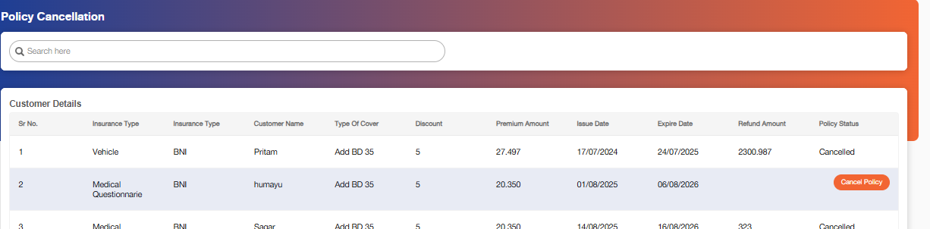

Once the user clicks on this (Cancel Policy) button a new-up screen will be displayed:

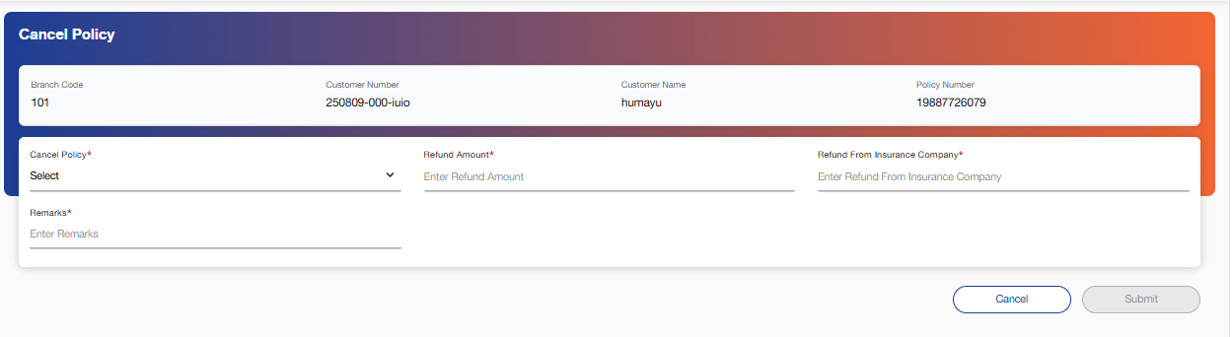

Below mentioned are the details specific to the information being displayed above:

Field Name | Field Type | Mandatory Y/N | Data Type / Length | Lookup Key / Master Name | Possible Values | Field Description
 |  |  |  |  |  | Remarks/ Validation
Branch Code | Read Only | VARCHAR | Yes | Branch Master | 101, etc. | Displays the code of the branch where the cancellation is initiated. Auto populated by system.
Customer Number | Read Only | VARCHAR | Yes | Customer Master | 250809-000-iuio | Displays the unique customer number linked with the insurance policy. Auto populated by system.
Customer Name | Read Only | VARCHAR | Yes | Customer Master | humayu | Displays the customer’s full name. Auto populated by system.
Policy Number | Read Only | VARCHAR | Yes | Policy Master | 19887726079 | Displays the unique policy number for the insurance. Auto populated by system.
Cancel Policy | Drop-down | VARCHAR | Yes | Cancel Policy Master | 1.Yes  2.No | Allows the user to select whether the insurance policy is to be cancelled.
Refund Amount | Text Box | DECIMAL | No | NA | e.g., 150.00 | Allows the user to capture the refund amount to be paid to the customer upon cancellation.
Refund From Insurance Company | Text Box | DECIMAL | No | NA | e.g., 150.00 | Allows the user to capture the refund amount received/receivable from the insurance company.
Remarks | Text Box | VARCHAR | No | NA | Free text | Allows the user to capture remarks or reasons for cancellation.
Action Button
Cancel | Button | NA | Button | NA | NA | Enables user to reset or discard the cancellation process and move back to cancellation queue.
Submit | Button | NA | Button | NA | NA | Confirms and submits the cancellation request for processing.

Payment Summary
The Payment Summary screen provides a comprehensive overview of all active insurance cases within the system, displaying key payment details for each. This includes the payment frequency (e.g., monthly, quarterly, annually) for each policy. Users can view the premium amount, commission, and the policy status for each active case. Additionally, the screen will provide options to view the payment history, including previous transactions, and any adjustments made to the payment schedule. This feature allows users to efficiently track and manage the payment status of policies, ensuring timely processing and identification of overdue payments. Payment frequency and due date details are dynamically updated based on the selected policy and the payment terms configured in the system.

The Payment Summary screen auto-populates payment details directly from the integration with the Loan Management System (LMS). This integration ensures that the latest payment information, including payment frequency, outstanding balances, and due dates, is automatically synchronized and displayed for each active case.

Following screen will be displayed once the user clicks on Payment Summary:

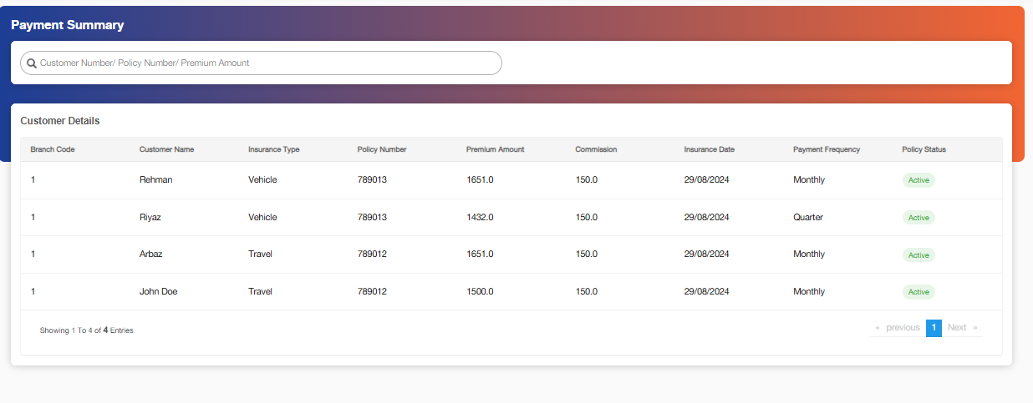

Below mentioned are the details specific to the information being displayed above:

Field Name | Field Type | Mandatory Y/N | Data Type / Length | Lookup Key / Master Name | Possible Values | Field Description
 |  |  |  |  |  | Remarks/ Validation
Search Bar | Text Box | Y | NVARCHAR / 20 | NA | NA | The user will search the customer through any of the fields from the list below
List View
Customer Name | Read Only | NA | NA | NA | NA | Auto populates active policies.
Insurance Type | Read Only | NA | NA | NA | NA | Auto populates active policies.
Policy Number | Read Only | NA | NA | NA | NA | Auto populates active policies.
Premium Amount | Read Only | NA | NA | NA | NA | Auto populates active policies.
Commission | Read Only | NA | NA | NA | NA | Auto populates active policies.
Insurance Date | Read Only | NA | NA | NA | NA | Auto populates active policies.
Insurance Company
Payment Frequency | Read Only | NA | NA | NA | NA | Auto populates active policies.
Policy Status | Read Only | NA | NA | NA | NA | Auto populates active policies.

Once the user hovers on the application in the list “View Payment History” button will be visible”

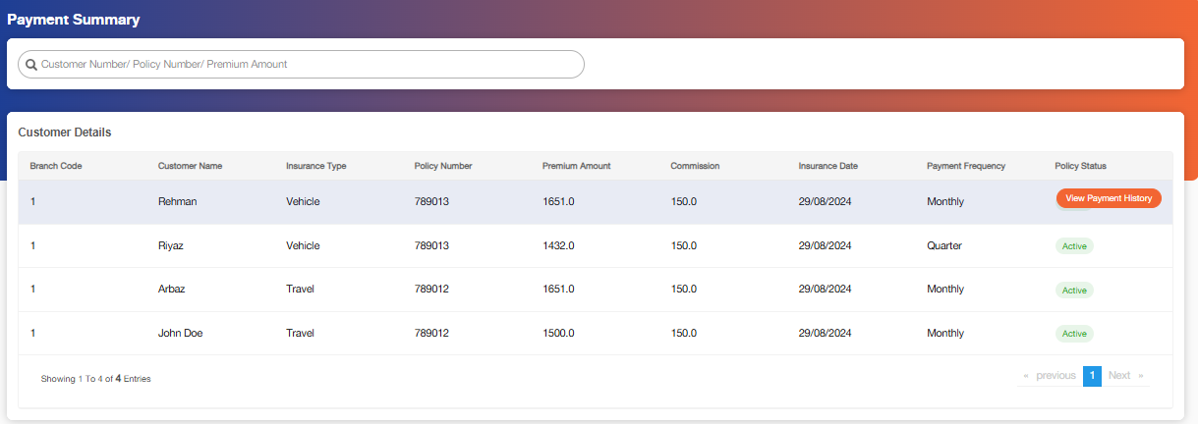

Once the user clicks on this button, below screen will be displayed:

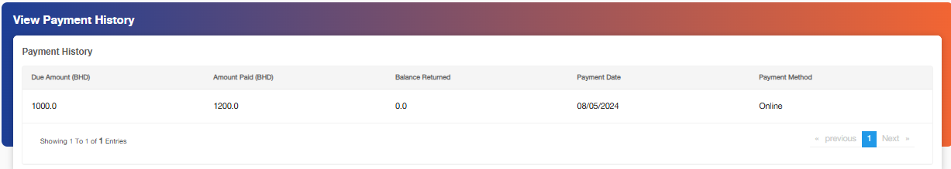

Below mentioned are the details specific to the information being displayed above:

Field Name | Field Type | Mandatory Y/N | Data Type / Length | Lookup Key / Master Name | Possible Values | Field Description
 |  |  |  |  |  | Remarks/ Validation
Due Amount (BHD) | Read Only | NA | NA | NA | NA | The system automatically populates relevant data from the LMS integration.
Amount Paid (BHD) | Read Only | NA | NA | NA | NA | The system automatically populates relevant data from the LMS integration
Balance Returned | Read Only | NA | NA | NA | NA | The system automatically populates relevant data from the LMS integration
Payment Date | Read Only | NA | NA | NA | NA | The system automatically populates relevant data from the LMS integration
Payment Method | Read Only | NA | NA | NA | NA | The system automatically populates relevant data from the LMS integration
Insurance Date | Read Only | NA | NA | NA | NA | The system automatically populates relevant data from the LMS integration
Payment Frequency | Read Only | NA | NA | NA | NA | The system automatically populates relevant data from the LMS integration
Policy Status | Read Only | NA | NA | NA | NA | The system automatically populates relevant data from the LMS integration

Payment Teller Screen – List

Upon completion of the application stage, the Insurance module generates a payment request, which is transmitted via the payment request API to the Insurance FMS module for processing. Tellers will use this screen to receive and process payments. Once the payment is successfully completed, the request status in the Insurance module is automatically updated to “Paid.” And it will also be available in the policy update queue.
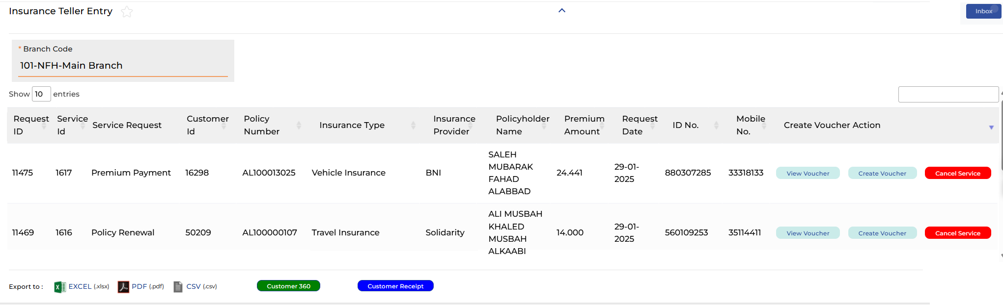

Field Name | Field Type | Mandatory (Y/N) | Data Type / Length | Lookup Key / Master Name | Possible Values | Field Description | Remarks / Validation
Branch Code | Read Only | NA | NA | NA | NA | Displays the main branch. | Auto-populated based on logged-in user’s branch.
Request ID | Read Only | NA | NA | NA | NA | Unique identifier of the request. | System generated.
Service ID | Read Only | NA | NA | NA | NA | Internal service ID. | System generated.
Service Request | Read Only | NA | NA | NA | NA | Displays type of service requested. | Populated from service request master.
Customer ID | Read Only | NA | NA | NA | NA | Displays unique customer ID. | Auto-fetched from Customer Master.
Policy Number | Read Only | NA | NA | NA | NA | Displays policy number linked to request. | Auto-fetched from Policy Master.
Insurance Type | Read Only | NA | NA | NA | NA | Displays the insurance type related to the policy | Auto-fetched based on data filled for the particular customer.
Insurance Company | Read Only | NA | NA | NA | NA | Displays the insurance company providing the policy. | Auto-fetched based on data filled for the particular customer.
Policyholder Name | Read Only | NA | NA | NA | NA | Name of the policyholder. | Auto-fetched from Customer Master.
Premium Date | Read Only | NA | NA | NA | NA | Displays premium due date. | Auto-fetched from Policy Schedule.
Request Amount | Read Only | NA | NA | NA | NA | Amount requested for service (refund, claim, etc.). | Auto-fetched depending on service type.
ID No. | Read Only | NA | NA | NA | NA | Customer identification number. | From ID Type Master (CPR/CR).
Mobile No. | Read Only | NA | NA | NA | NA | Customer mobile number. | Auto-fetched from Customer Contact details.
Create | Button | NA | NA | NA | NA | Creates a new service request. | Enabled only if mandatory details available.
View | Button | NA | NA | NA | NA | View service request details. | Read-only screen.
Cancel | Button | NA | NA | NA | NA | Cancels the request in draft stage. | Not available after submission.

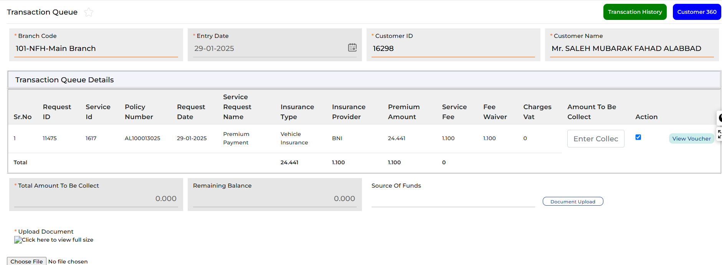
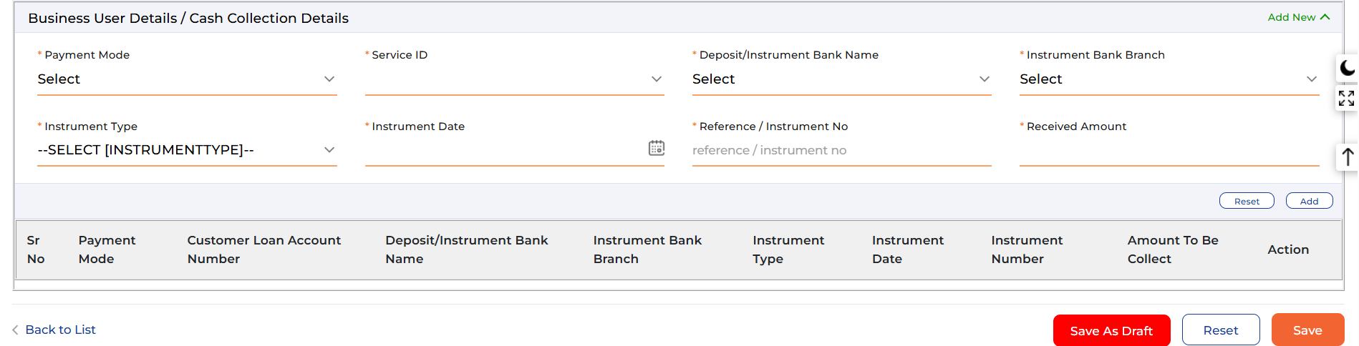

Field Name | Field Type | Data Type / Length | Mandatory (Yes/No) | LookUp Key / Master Name | Possible Values | Description & Remarks
Branch Code | LOV / Dropdown | VARCHAR (50) | Yes | Branch Master | e.g., 101-NFH-Main Branch | Branch where the transaction is being processed. Must select a valid branch.
Entry Date | Date Picker | DATE | Yes | NA | YYYY-MM-DD | Date of entry for the transaction. Auto-populated or user-selectable.
Customer ID | Text / Label | VARCHAR (30) | Yes | Customer Master | Example: 16298 | Unique identifier for the customer. Must exist in the customer master.
Customer Name | Text / Label | VARCHAR (150) | Yes | Customer Master | Example: Mr. SALEH MUBARAK FAHAD ALABBAD | Name of the policyholder. Auto-populated from customer master.
Sr.No | System / Label | INT | Yes | NA | Auto-increment | Row number for display purposes. Auto-generated.
Request ID | System / Label | VARCHAR (30) | Yes | System | Example: 11475 | Unique identifier for the insurance service request. Auto-generated.
Service Id | System / Label | VARCHAR (30) | Yes | Service Master | Example: 1617 | Identifier for the type of insurance service. Must exist in service master.
Policy Number | Text / Label | VARCHAR (30) | Yes | Policy Master | Example: AL100013025 | Policy number linked to the service request. Must exist in policy master.
Request Date | Date / Label | DATE | Yes | NA | YYYY-MM-DD | Date of the service request. Auto-populated.
Service Request Name | LOV / Dropdown | VARCHAR (50) | Yes | Service Request Master | Premium Payment, Policy Renewal, Claim Payment, Fee Waiver | Type of insurance transaction. Must match predefined service request master.
Insurance Type | LOV / Dropdown | VARCHAR (50) | Yes | Insurance Type Master | Vehicle, Health, Life, Travel, etc. | Type of insurance policy. Must select valid insurance type.
Insurance Provider | LOV / Dropdown | VARCHAR (50) | Yes | Insurance Provider Master | BNI, Allianz, MetLife, etc. | Insurance provider for the policy. Must select a valid provider.
Premium Amount | Number / Label | DECIMAL (12,2) | Yes | NA | e.g., 24.441 | Total premium amount due for the policy. Auto-calculated from policy schedule.
Service Fee | Number / Label | DECIMAL (12,2) | No | NA | e.g., 1.100 | Service fee applied for processing the transaction. Optional, may be auto-calculated.
Fee Waiver | Number / Label | DECIMAL (12,2) | No | NA | e.g., 1.100 | Waiver applied to service fee if any. Optional, system-calculated or manual entry.
Charges VAT | Number / Label | DECIMAL (12,2) | No | NA | e.g., 0.00 | Tax applied on service fee. Auto-calculated if applicable.
Amount To Be Collect | Number / Input | DECIMAL (12,2) | Yes | NA | e.g., 24.441 | Amount to be collected from the customer. Editable by user for cash collection. Must not exceed premium + fees.
Action | Button / Multi | NA | Yes | NA | Enter Collect Amount, View Voucher | Actions available for each row in the transaction queue. Button triggers respective function.
Total Amount To Be Collect | Number / Label | DECIMAL (12,2) | Yes | NA | e.g., 0.000 | Total of all amounts to be collected. Auto-calculated.
Remaining Balance | Number / Label | DECIMAL (12,2) | Yes | NA | e.g., 0.000 | Remaining balance after payments. Auto-calculated.
Source of Funds | Text / Input | VARCHAR (100) | No | NA | e.g., Cash, Bank Transfer | Source of funds for the premium payment. Optional field.
Document Upload | File | NA | No | NA | PDF, JPG, PNG | Upload supporting document (receipt/proof). Optional; max file size validation recommended.
View Document | Button | NA | No | NA | NA | Button to view uploaded document in full size.
Payment Mode | LOV / Dropdown | VARCHAR (30) | Yes | Payment Mode Master | Cash, Cheque, Bank Transfer, Card | Mode of payment for the premium. Must select valid payment mode.
Service ID (Payment) | LOV / Dropdown | VARCHAR (30) | Yes | Service Master | Example: 1617 | Service ID associated with the payment. Must exist in service master.
Deposit/Instrument Bank Name | LOV / Dropdown | VARCHAR (50) | Conditional | Bank Master | Bank A, Bank B | Bank through which payment is made. Mandatory if payment is not cash.
Instrument Bank Branch | LOV / Dropdown | VARCHAR (50) | Conditional | Branch Master | Main Branch, Branch 2 | Branch of the bank. Mandatory if payment is not cash.
Instrument Type | LOV / Dropdown | VARCHAR (30) | Conditional | Instrument Type Master | Cheque, Draft, Slip | Type of instrument used for payment. Mandatory if payment is not cash.
Instrument Date | Date Picker | DATE | Conditional | NA | YYYY-MM-DD | Date of cheque/draft/slip. Mandatory if instrument type selected.
Reference / Instrument No | Text | VARCHAR (50) | Conditional | NA | Cheque No, Transaction ID | Reference number for instrument. Mandatory if instrument type selected.
Received Amount | Number / Input | DECIMAL (12,2) | Yes | NA | e.g., 24.441 | Actual amount received from customer. Must not exceed Amount To Be Collect.
Action (Payment) | Button / Multi | NA | Yes | NA | Add, Reset | Actions for each payment row. Button triggers Add or Reset operation.
Back to List | Button | NA | Yes | NA | NA | Navigate back to transaction queue list.
Save As Draft | Button | NA | Yes | NA | NA | Save current payment entry as draft.
Reset | Button | NA | Yes | NA | NA | Reset all fields in the payment entry section.

Customer 360

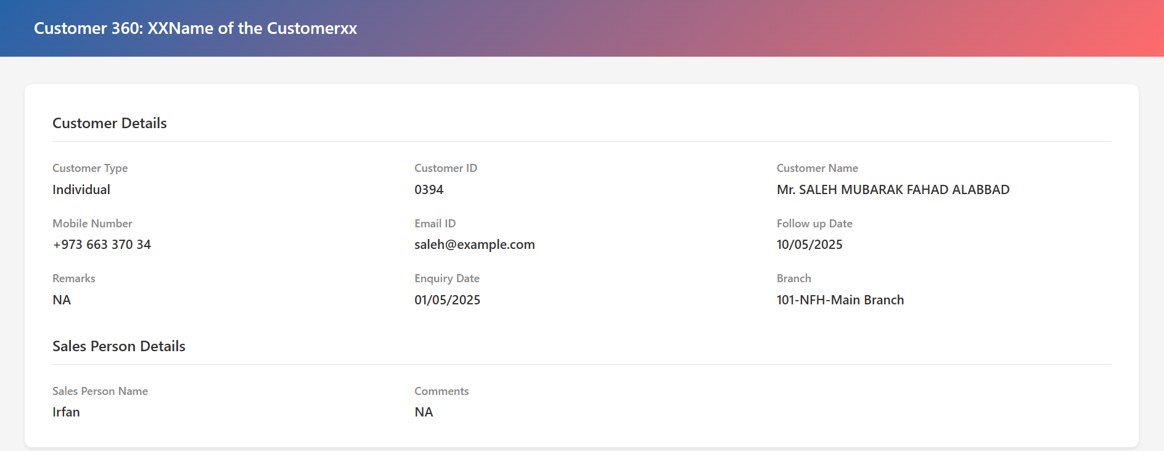

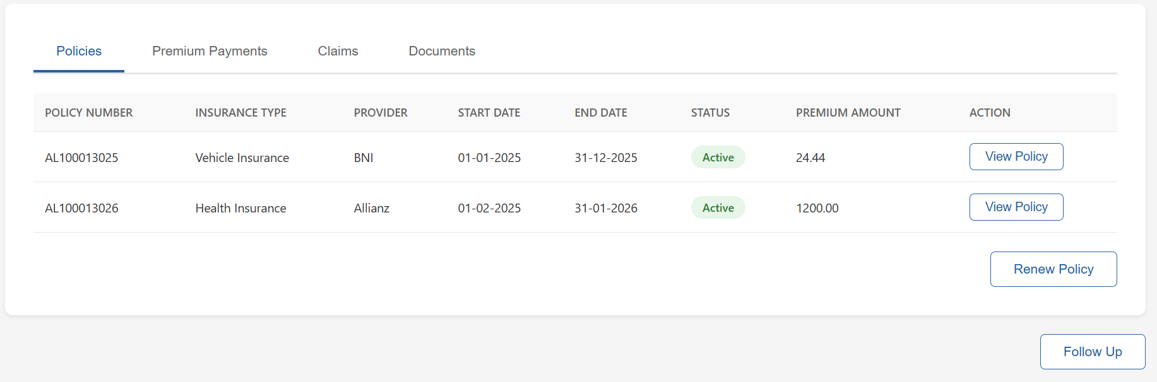
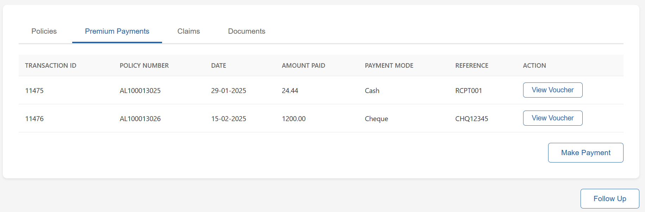
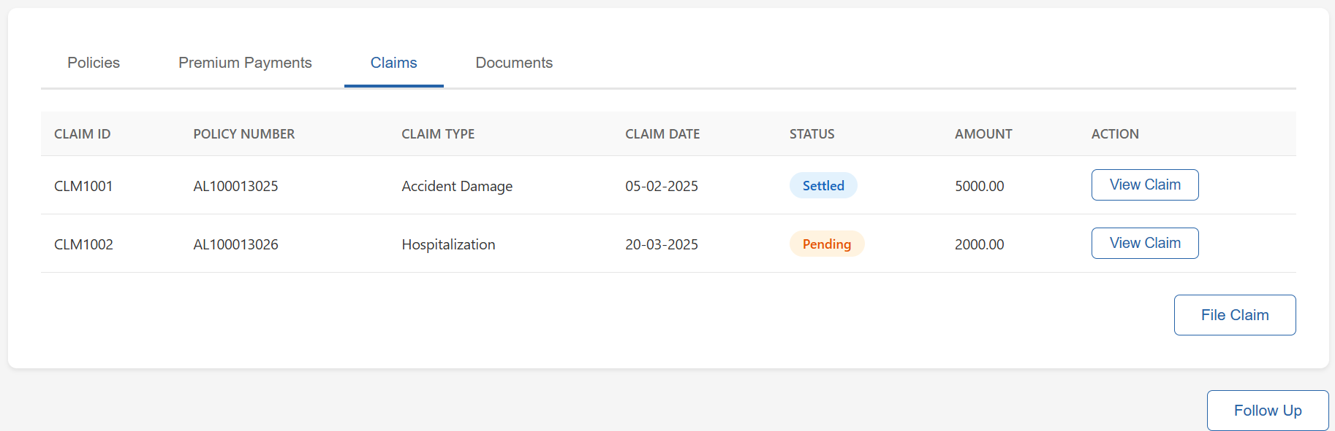
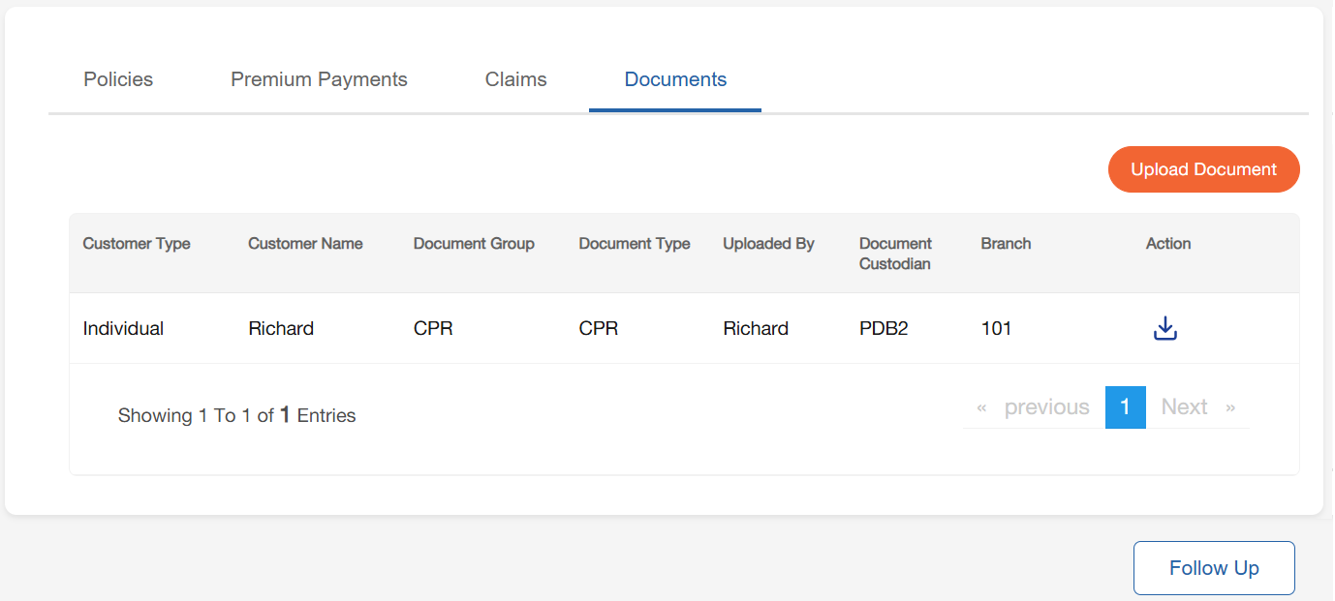

Field Name | Field Type | Data Type / Length | Mandatory (Yes/No) | LookUp Key / Master Name | Possible Values | Field Description / Remarks
Customer Name | Text | VARCHAR(100) | Yes | N/A | N/A | Displays full customer name; shown on header and details section.
Customer ID | Text | VARCHAR(20) | Yes | N/A | N/A | Unique system identifier for the customer.
Customer Type | Text | VARCHAR(20) | Yes | CUSTOMER_TYPE_MASTER | Individual / Corporate | Defines whether customer is an individual or corporate entity.
Mobile Number | Text | VARCHAR(20) | No | N/A | N/A | Primary contact mobile number.
Email ID | Text | VARCHAR(50) | No | N/A | N/A | Customer’s email address.
Follow up Date | Date | DATE | No | N/A | N/A | Next scheduled follow-up date for sales/relationship manager.
Remarks | Text | VARCHAR(200) | No | N/A | N/A | Remarks related to customer or enquiry.
Enquiry Date | Date | DATE | No | N/A | N/A | Initial enquiry date recorded in CRM/Insurance module.
Branch | Text | VARCHAR(50) | Yes | BRANCH_MASTER | List of branches | Branch associated with the customer.
Sales Person Name | Text | VARCHAR(50) | Yes | USER_MASTER | User List | Name of salesperson/agent managing the customer.
Sales Person Comments | Text | VARCHAR(200) | No | N/A | N/A | Comments entered by salesperson.
Policies Section
Policy Number | Text | VARCHAR(30) | Yes | POLICY_MASTER | Auto-generated Policy IDs | Unique identifier for insurance policy.
Insurance Type | Text | VARCHAR(30) | Yes | INSURANCE_TYPE_MASTER | Vehicle, Health, Life, etc. | Defines type of insurance product.
Provider | Text | VARCHAR(50) | Yes | PROVIDER_MASTER | Allianz, BNI, AXA, etc. | Insurance provider company.
Start Date | Date | DATE | Yes | N/A | N/A | Policy effective start date.
End Date | Date | DATE | Yes | N/A | N/A | Policy expiry date.
Status | Badge / LOV | VARCHAR(20) | Yes | STATUS_MASTER | Active, Lapsed, Expired, Cancelled | Current status of the policy.
Premium Amount | Number | DECIMAL(18,2) | Yes | N/A | N/A | Premium amount associated with policy.
View Policy | Button | N/A | Yes | N/A | View Policy | Provides navigation to detailed policy document. To be confirmed with NFH for linkage to be done with which document.
Payments Section
Transaction ID | Text | VARCHAR(30) | Yes | N/A | System generated | Unique identifier for premium payment transaction.
Policy Number | Text | VARCHAR(30) | Yes | POLICY_MASTER | Policy IDs | Links payment to a specific policy.
Date | Date | DATE | Yes | N/A | N/A | Payment date.
Amount Paid | Number | DECIMAL(18,2) | Yes | N/A | N/A | Amount received towards premium.
Payment Mode | LOV Dropdown | VARCHAR(20) | Yes | PAYMENT_MODE_MASTER | Cash, Cheque, Online, Bank Transfer | Payment mode used.
Reference | Text | VARCHAR(50) | No | N/A | N/A | Reference number (receipt, cheque no, transaction ref).
Action | Button | N/A | Yes | N/A | View Voucher | Allows viewing of voucher/receipt.
Payments Section
Claim ID | Text | VARCHAR(30) | Yes | CLAIM_MASTER | Auto-generated Claim IDs | Unique identifier for insurance claim.
Policy Number | Text | VARCHAR(30) | Yes | POLICY_MASTER | Policy IDs | Links claim to a specific policy.
Claim Type | LOV Dropdown | VARCHAR(50) | Yes | CLAIM_TYPE_MASTER | Accident Damage, Hospitalization, etc. | Type of claim filed.
Claim Date | Date | DATE | Yes | N/A | N/A | Date of claim submission.
Status | Badge / LOV | VARCHAR(20) | Yes | CLAIM_STATUS_MASTER | Pending, Settled, Rejected | Current status of claim.
Amount | Number | DECIMAL(18,2) | Yes | N/A | N/A | Claim settlement/claimed amount.
Action | Button | N/A | Yes | N/A | View Claim | Opens detailed claim view.
Documents Section
Customer Type | Read-only | NA | NA | NA | NA | Displays the customer type based on submitted application.
Customer Name | Read-only | NA | NA | NA | NA | Displays the customer’s name based on submitted application.
Document Custodian | Read-only | NA | NA | NA | NA | Displays the unique number generated by the system to map the documents to an application.
Document Group | Dropdown | Y | NVARCHAR /10 | NA | 1.POI  2.POA  3.Proof of income | Users can select the document group.
Document Type | Dropdown | Y | NVARCHAR /10 | NA | 1.Driving License  2.Proposal Form  3.NCD or NCB | Users can select the document type.
Upload | Icon | NA | NA | NA | NA | Users can click on this icon and upload any document available in their system.

Insurance Chart of Account

Reports & Templates

Required Document Checklist

System Assumptions and Pre-requisites
This section of the document explains the system assumptions and prerequisites related to any particular screen or for the Insurance Module in general which are as follows:
- The customer has an existing and valid CPR/CR Number.
- For Policy Benefits – The benefits that are already a part of any policy specific to any insurance company will be shown in the template for policy as received from NFH and additional benefits that are added to the policy will affect the premium calculation as per defined in the metrics as received from NFH.
- For Vehicle Insurance – The customer has an existing and valid Driving License.
- For Travel Insurance – The customer has an existing and valid Passport.

Digital Integration

Stage Completion Rules

Interface Touchpoints

SMS Templates

